THE ARK

An Illustrated Anatomy
  - The wooden vessel, the lengthwise tower,
and the countries beneath the mountains
  - BRIAN CHAPMAN SR MSP A+ CIW
A fictional architectural atlas
Measured plans · room register · landscape cutaways
Expanded edition with 61 CAD studies

How to read the drawings
Feet and inches describe the design. Verbatim KJV quotations retain their original words, including cubits. The selected conversion is one cubit = eighteen inches. Plan, section, and schematic are different drawing types: only stated dimension arrows establish measurements on a schematic.

Coordinate prefixes
Prefix | Origin and use
H | Original hull: stern datum; x forward, y across, z upward.
C | Carrier: stern vestibule; x 0–780 ft, y ±72 ft, z 0–144 ft.
S01–S24 | The twenty-four forward addresses corresponding to tower Floors 1–24.
K / F / C / H / L / G | Carrier deck codes: Keel / Foundry / Commons / Homes / Learning / Gardens.
D7 | A bounded spatial annex with a separately measured interior.
D10 | Route identity and branch registry; not an unlimited time-travel license.
The letter C can mean a carrier coordinate prefix or the Commons deck. A hyphenated address such as S12-C identifies a deck; “C-x 375 ft” identifies a coordinate.

Contents
About this atlas
1 | One building, one wooden prototype, one remote system
2 | After the Flood: the hub beneath America and Alaska
3 | The shape that stays the same
4 | The measuring book
5 | The ordinary wooden interior
6 | The side door and the first impossible seam
7 | The wooden answer to a magnetic world
8 | What the grounded house contributed
9 | The tower before it lies down
10 | The same tower, turned lengthwise
11 | A cross-section one can inhabit
12 | The twenty-four addresses
13 | Seventh-dimensional rooms: the outward gardens
14 | The harbor beyond a household door
15 | Tenth-dimensional registry: the destinations stay put
16 | Light, water, air, and the rooms behind the rooms
17 | The world before the stone
18 | The time plate beneath the world
19 | The pyramid complex and its six buried miles
20 | The magnetic storm, the ships, and Noah's warning
21 | The Amalgamation and the laying down
22 | How a body becomes an unrecognizable mountain
23 | The city under the ribs
24 | The channel houses and the giant horizon
25 | Routes, distances, and the view around each turn
26 | Chronology and the continuity ledger
27 | The last view: a ship that contains a way
Sources and drawing register

Principal measurements
Element | Established fictional dimension
Original wooden hull | 450 × 75 × 45 ft outside (300 × 50 × 30 cubits at 18 in).
Ordinary hull width / nominal length inside | 72 ft / 447 ft before rounded end reductions.
Hull finished floor elevations | 1 ft 6 in; 16 ft 6 in; 31 ft 6 in.
Hull / standard annex doorway | 12 ft wide × 10 ft high; doorway size is fictional.
North Terrace grounded refuge | Approx. 1,023 ft 7 in × 236 ft 3 in × 164 ft 1 in.
Standing tower module zone | 24 floors × 30-ft pitch = 720 ft; plan 144 × 144 ft.
Lengthwise carrier | 780 × 144 × 144 ft, including two 30-ft vestibules.
Carrier station zone | 24 stations × 30 ft = 720 ft.
Carrier deck elevations | K 0; F 12; C 24; H 36; L 48; G 60 ft.
Garden Annex | 1,200 × 600 ft; 180-ft sky volume.
Harbor basin | 1,800 × 900 ft; separate 120 × 72 ft transfer berths.
Him-a-Lan / Himland | 72-mile principal body axis / approximately 8-mile hand district.
Avar / Sereth | 22,000 ft standing / 1,800 ft standing.
Rib Court / giant exit | 6,000 × 1,800 × 900 ft cavity / separate 2,400-ft-high giant opening.
Metal-free Ark domain: structural members, joints, hinges, conduits, and fixed fittings contain no metal. Ancient magnetic ships and pyramid machinery remain outside this domain.

Grounded level → mobile deck
Grounded refuge level | Mobile carrier deck | Continuing function
G Gardens | G · 60 ft | Planting, cultivation, roof observation
L Learning | L · 48 ft | Teaching, archive, care
H Homes | H · 36 ft | Private households and common courts
C Commons | C · 24 ft | Receiving, meals, community rooms
F Foundry | F · 12 ft | Making, deliveries, repair
K Keel | K · 0 ft | Separated utilities and stores
This is a functional correspondence. It does not make the larger grounded refuge and the mobile carrier identical buildings.

About this atlas
This is the architectural companion to the fictional Ark stories: a book of places, dimensions, surfaces, connections, and sight lines. Its aim is to make the world drawable. Noah’s wooden vessel is the original Ark; the other structures, inhabited carriers, dimensional galleries, and buried giants belong to the invented continuation. Biblical quotations are reproduced from the King James Version. The dimensional mechanism and the Amalgamation are fictional additions, not explanations supplied by those verses.
Throughout the drawings, one cubit is taken as eighteen inches. This is the measuring convention chosen for this atlas; descriptions and design schedules use feet and inches. Dimensions explicitly given by Scripture remain in cubits within quotations. The building dimensions that follow are the atlas’s established fictional design, not newly discovered measurements of an archaeological vessel.
The Ark and its transferred mobile interiors are metal-free wooden constructions. The ancient complex and its magnetic ships are the separate technological system destroyed by the storm. The original technological hub, the wooden prototype, the Alaskan protective pyramid, and the later North Terrace refuge are distinct related structures. The hub is the pre-Flood parent building; the Ark is its mobile wooden remote outpost. The pyramid later shelters the returned outpost above the surviving buried hub. North Terrace is a later refuge informed by that inherited architecture. This hierarchy is the key to the entire book.

1 | One building, one wooden prototype, one remote system
The main installation is a building before it is a ship. Its central inhabited and control structure is the twenty-four-floor tower: a fixed technological hub with a 144-foot-square plan and a 720-foot numbered module zone. It contains the active reference equipment, the distant-route machinery, and the means of reading a remote outpost's position. The Ark is the mobile wooden prototype made from its ordering design. The tower is not an unexplained future building invented after the ship has already departed.
Noah's wooden craft imitates the hub by turning the sequence of floors into a forward sequence of station addresses. What the hub calls Floor 1, the outpost calls Station S01; Floor 24 becomes S24. The enlarged lengthwise interior is linked space, while the physical wooden hull remains 450 feet long. The ordinary ship and its dimensional interior are not two competing hull measurements. The architecture is a remote branch of the original building, arranged to move rather than requiring the whole central installation to be carried into a flood.
The parent building's extraordinary technology requires a wooden outpost in this fantasy because its remote reading field uses the craft's ordered nonmetallic lattice as a passive reference. Wood grain, spacing, peg position, and the relation between frames form its physical address pattern. Metal in that pattern creates false coupling with the ancient magnetic transport network. The wood is therefore a working component of the fictional system, not a cosmetic covering over machinery. No conventional magnetic engine, copper wire, steel frame, or metal fastener is hidden inside the Ark to perform the same task by an unmentioned method.
Remote control has two sides. The active machinery remains at the fixed hub; the wooden craft supplies the readable structure and the nonmetallic route controls. A person aboard can choose a registered destination, close a door, or decline travel. The hub's field then couples to the outpost's wooden reference structure. The story's operator does not need to smuggle a metal radio into the hull. Wood and nonmetallic interface elements are the remote craft's design language; the vast machinery that makes this possible is a building elsewhere.
Loss of the hub link does not remove ordinary buoyancy from a wooden vessel. The craft can float as a bounded ship while remote functions are unavailable. Its separate local reference can hold a safe closed condition without making it a second complete power station. Water, food, and finite stores still matter. This separation is why the prototype can be a refuge when the civilization's magnetic vehicles become dangerous: its continued physical shelter does not depend on those vehicles' guidance vanes or the same failed metallic control path.
The prototype program envisages more wooden outposts. The construction register reserves additional berths and frame-pattern identifiers, but the atlas records only Noah's first completed craft as an established vessel. Other planned units are shown as unbuilt outlines rather than quietly added to the biblical story. Their purpose is broader than a flood: isolation during magnetic catastrophes, shelter from falling metal craft, departure from a damaged complex, and return to a surviving protected hub. The Flood is the prototype's great use, not the only hazard its architecture anticipates.

Measured plate · Parent hub, wooden outpost, protective pyramid
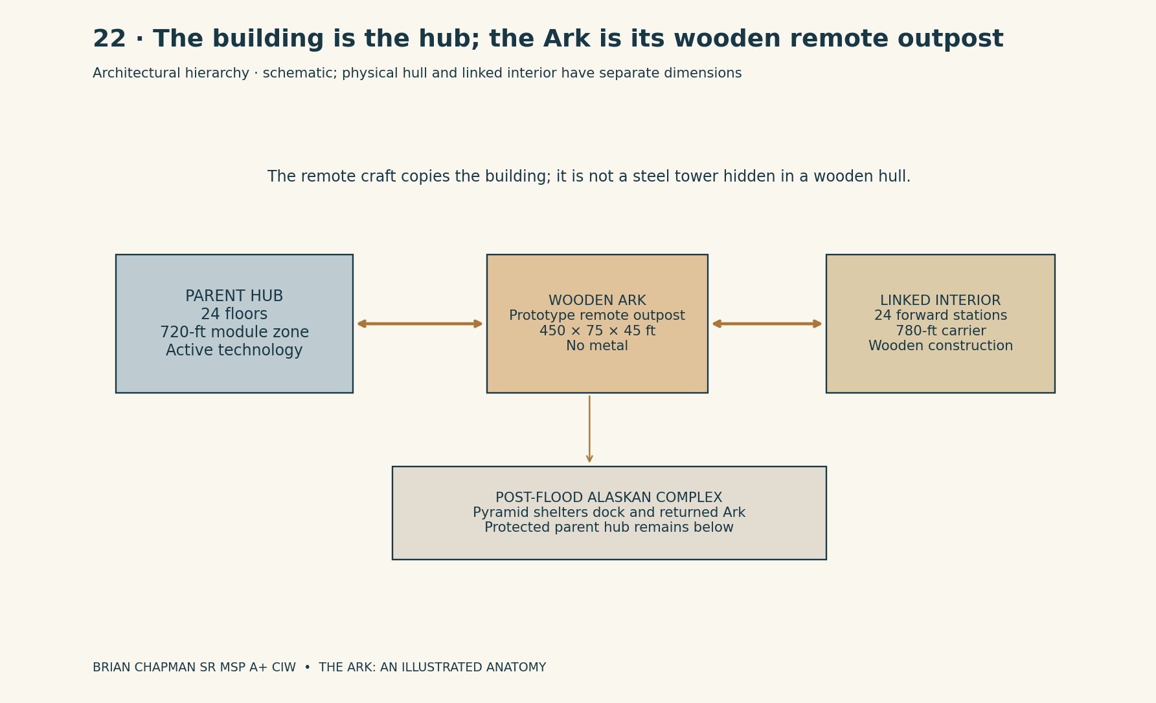
BRIAN CHAPMAN SR MSP A+ CIW

2 | After the Flood: the hub beneath America and Alaska
In this fictional geography, the protected core of the main installation survives the catastrophe beneath the region later mapped as the United States and Alaska. Those are present-day atlas locators, not ancient country names placed in Noah's mouth. The six-mile underground survey is the local Alaskan complex. Longer connections beneath other parts of the United States belong to the registered remote network; they are not misrepresented as six continuous miles stretching across an entire continent.
The upright parent tower now stands within a buried structural chamber. Its lowest registered floor is 960 feet below the Alaskan court datum; its 720-foot module zone ends 240 feet below that datum. A 60-foot separation remains between the parent tower’s crown and the dock basin’s lowest plane. Independent stone and field-boundary supports surround its older frame. The catastrophe destroys exposed installations and interrupts many timing nodes, but does not erase this protected core. Later survivors can reach a building that already existed before the Flood. They do not have to build the central technology from nothing after their wooden outpost returns.
The Ark's return is a water journey followed by a bounded transfer into the underground approach. Genesis gives its resting upon the mountains of Ararat; the subsequent departure and Alaskan journey are additions of this fantasy. A registered water connection joins the receding-water route to the western coastal approach. From there, the wooden hull floats through the Alaskan receiving channel toward the protected dock. Its remote field guides a wooden ship through a water route; the craft is not driven through solid ground or reduced to a metaphor for a building.
The receiving channel has a nominal 120-foot clear width and a 72-foot air clearance above its operating water line. The physical Ark, 75 feet wide and 45 feet high, fits within that envelope without borrowing its carrier annex's larger dimensions. A bend is given a 900-foot centerline radius in the fictional local plan. The route remains closed when the measured water level or return identity falls outside its registered state. The diagram is a layout for the story, not a real navigation or buoyancy design.
The permanent Ark dock is a chamber 600 feet long and 180 feet wide, with 96 feet of clear height above its quays. A 450-foot hull can lie inside it with a combined 150 feet of end allowance. The quays stand 6 feet above the basin's operating water level. The water is 36 feet deep in the dock basin. The old court datum is 144 feet above that water level, so the wet approach is not required to lift a sea-sized volume through an unexplained 900-foot shaft. The shaft to the lower timing galleries is a separate vertical connection.
A later post-Flood protective pyramid is built above the dock and surviving installation, using the earlier complex's anchor geometry. It is the Alaskan pyramid of the present discovery branch. The old disaster complex and the rebuilt protective phase are recorded as two construction phases at the linked site, not as one monument that is simultaneously destroyed and newly untouched. The current-condition survey shows the damaged state of the surviving protective phase: missing cap, broken casing, collapsed apron, obstructed galleries, and the retained fragments of the earlier ship disaster.
Within that pyramid, the Ark is encountered as a wooden building in a dock: the same mobile remote outpost, now housed rather than sailing. Its side door faces an ordinary quay. Its lengthwise rooms remain a branch of the main tower. The main technological hub is reached through registered links and protected access routes below, not by pretending that the wooden Ark and the pyramid's stone walls are the same object. A surveyor can point to each: the pyramid enclosing the site, the old tower beneath it, the dock chamber, and the wooden prototype resting within that chamber.

Measured plate · The Alaskan return route and underground dock
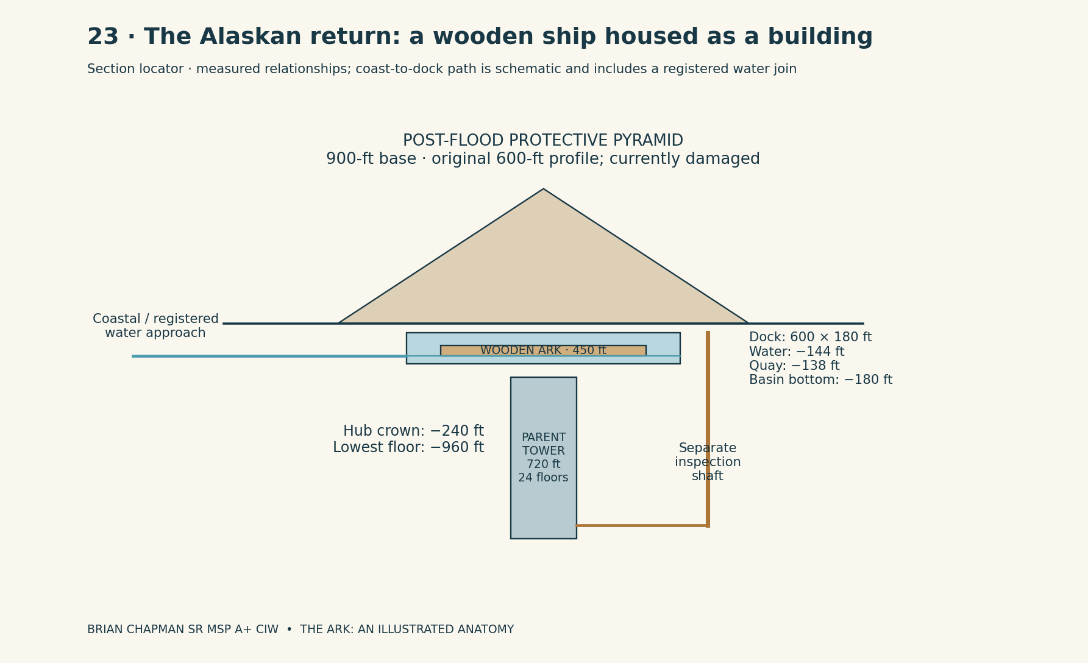
BRIAN CHAPMAN SR MSP A+ CIW

CAD study 43 Ark cutaway and timber hull
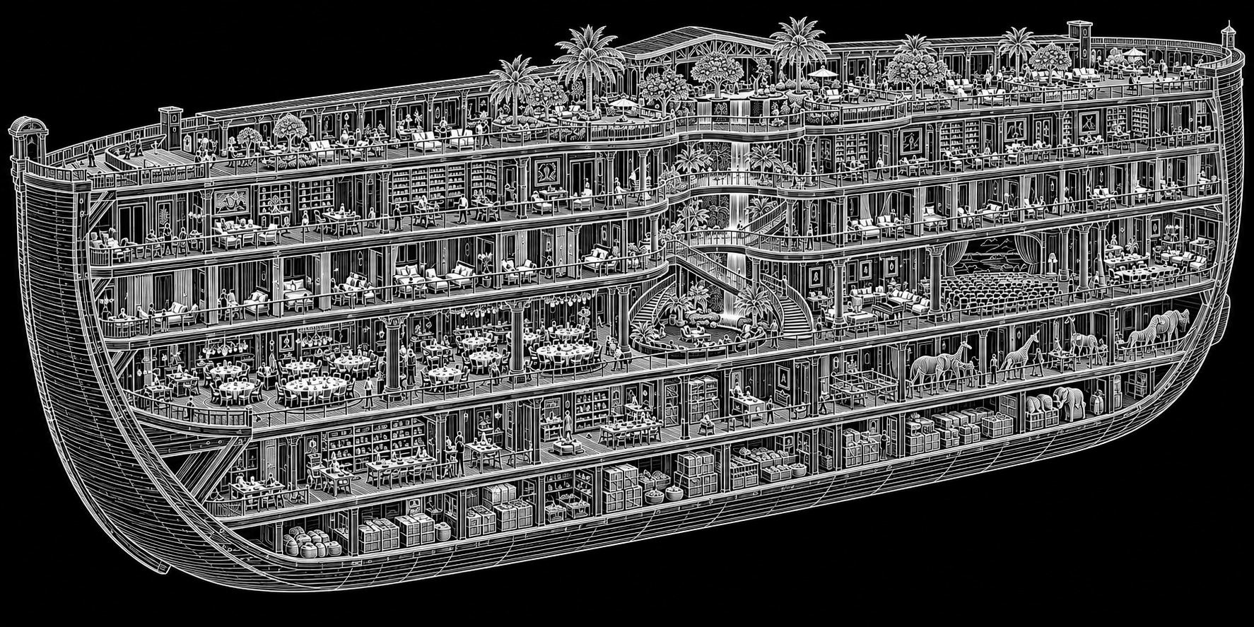
BRIAN CHAPMAN SR MSP A+ CIW
Concept study. Written dimensions, floor names and nonmetallic Ark construction rules in the atlas govern.
CAD study 49 Ark and pyramid connection
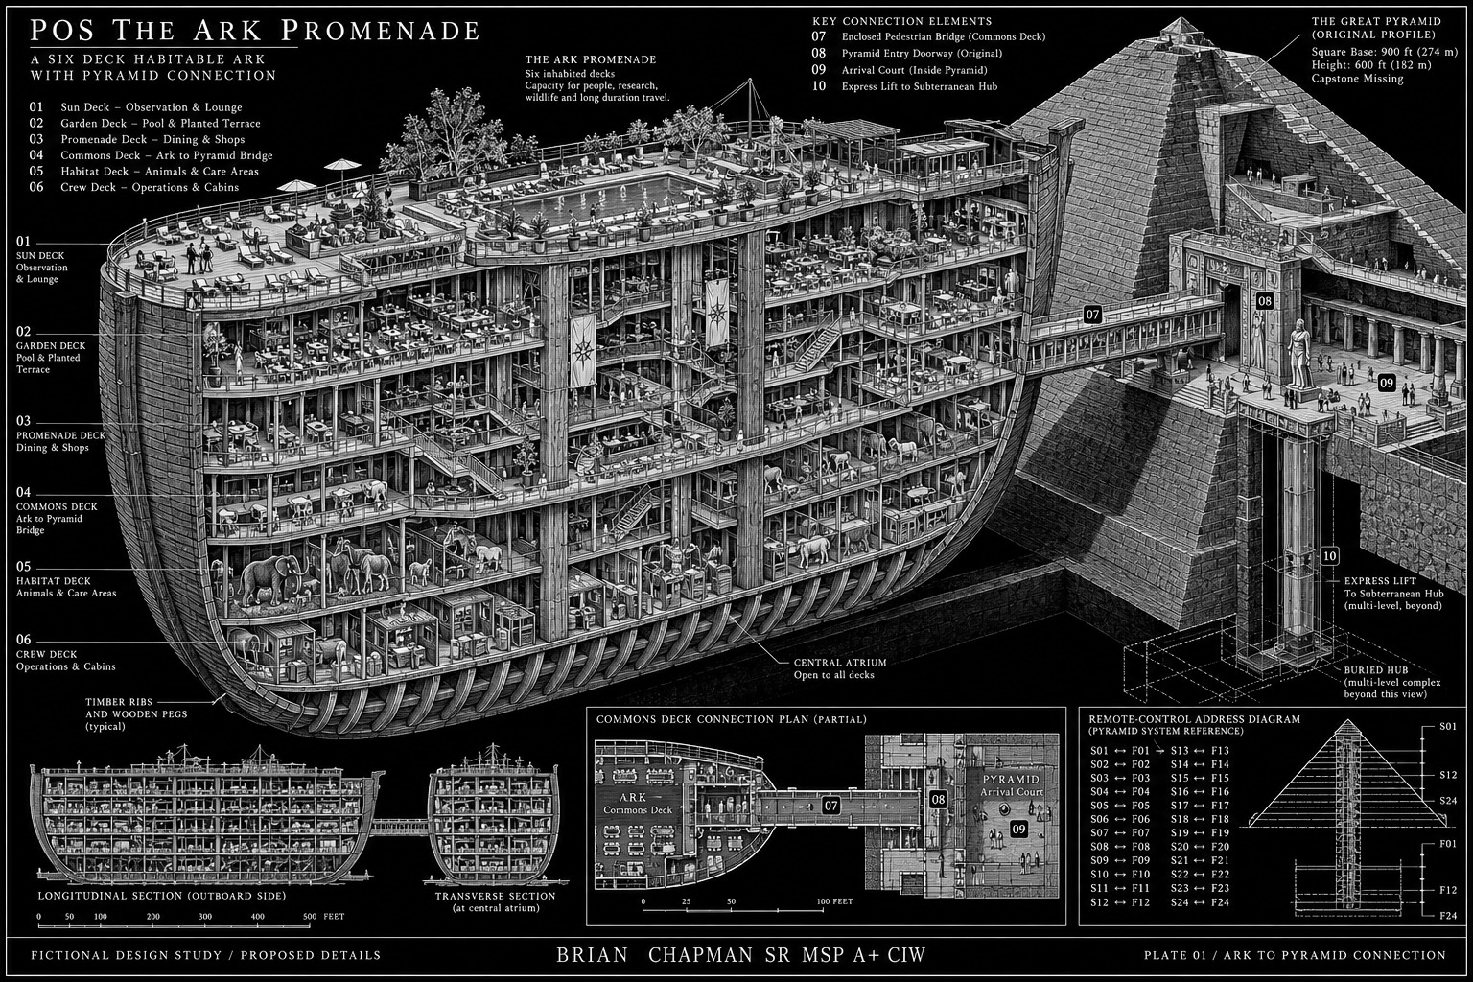
BRIAN CHAPMAN SR MSP A+ CIW
Concept study. Written dimensions, floor names and nonmetallic Ark construction rules in the atlas govern.

3 | The shape that stays the same
Genesis 6:15 — “And this is the fashion which thou shalt make it of: The length of the ark shall be three hundred cubits, the breadth of it fifty cubits, and the height of it thirty cubits.”
Imagine the Ark from the side before imagining anything inside it. Its length is 450 feet. Its maximum width is 75 feet. Its maximum height is 45 feet. These are outside dimensions. A person standing beside its middle sees a timber wall rising approximately four ordinary house stories, although the vessel itself contains the three stories named in Genesis. The roof line is quiet and long. It does not bristle with castle towers, engines, glass domes, or the ends of trees from a supposedly larger interior. Those things belong to spaces connected beyond the hull.
For this fictional reconstruction of the physical prototype, the bow and stern are bluntly rounded in plan, with a shallow upward turn beneath their ends. The Bible supplies the overall dimensions, not this particular end profile. From a distance the vessel resembles an immense covered chest softened at its corners. From close beside the wall, the length is difficult to take in: parallel courses of dark wood disappear toward both ends, interrupted by iron-colored shadows at frames and by the one great side opening.
The outer timber surface is not polished furniture. Across each broad plank, the grain rises in long ridges, and the dark coating gathers in the lower edges of seams. On the shaded side the coating is almost black; at a sunlit corner it warms to brown. Where a hand can reach the wall, the texture is irregular enough for a fingernail to find a joint. Above head height, repeated structural ribs make the wall’s enormous length legible. They are counted, not merely described as countless.
Every structural joint in the hull uses wood: pegged tenons, timber keys, and wedges rather than metal fasteners. The atlas sets a transverse frame every 15 feet, producing thirty principal lengthwise bays. Frame lines are labeled H00 at the stern datum through H30 at the bow datum. The middle line H15 is therefore 225 feet from either end. The side door is centered at H05, 75 feet from the stern. A visitor can return to the same doorway in every later illustration, even when the connected country changes.
The roof has a low, continuous crown within the stated 45-foot height. Its shoulders bend down toward the side walls. Light does not pour through a modern glass ceiling. The upper opening is drawn as a protected roof-level band whose interpretation belongs to this reconstruction. Rain darkens the wood beneath its hood. At night, when the dimensional passages are closed, the hull presents the silhouette of a ship at rest, not a city trying to escape its outline.

Measured plate · The wooden hull
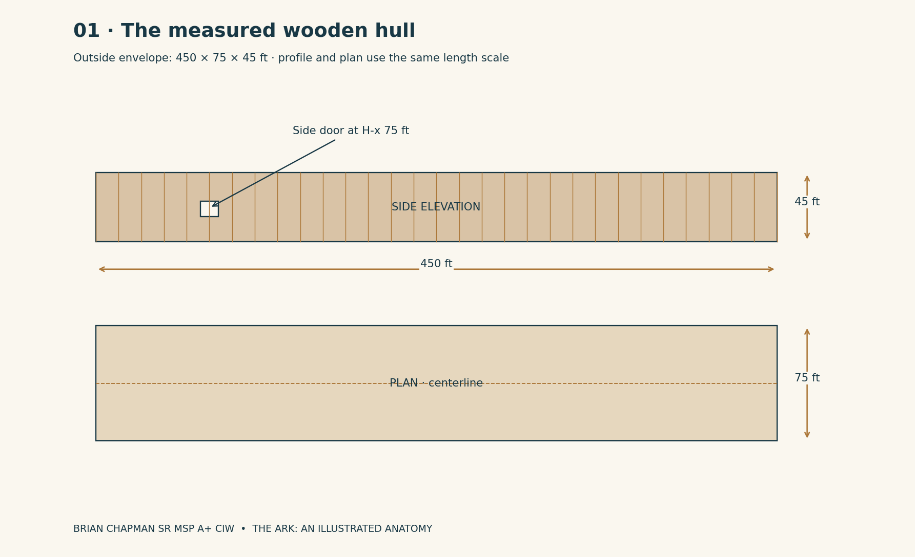
BRIAN CHAPMAN SR MSP A+ CIW

4 | The measuring book
A measurement is useful only when its starting point is known. Hull coordinates begin at the outside face of the stern: H-x increases toward the bow. H-y is measured across the vessel from the centerline, with negative numbers on the entrance side. H-z rises from the bottom of the outer envelope. Nothing on a later tower drawing silently adopts this same origin. The letter before a coordinate tells the reader which space contains the ruler.
The design allowance for each long side is 1 foot 6 inches. Between those inner faces, the ordinary hull is therefore 72 feet wide. The end allowance is also 1 foot 6 inches at each end, leaving a nominal 447-foot interior length before the rounded corners reduce usable space. This allowance is a fictional architectural thickness. It is not a claim that Genesis specifies a particular plank, rib, or wall assembly.
The lower finished floor lies at H-z 1 foot 6 inches. The second finished floor lies at 16 feet 6 inches. The third lies at 31 feet 6 inches. The two intermediate floor assemblies occupy 1 foot 6 inches each. This produces 13 feet 6 inches of clear height on the lower and middle stories. At the roof centerline the upper story has 12 feet of clear height to the underside of the roof allowance. That central upper clearance diminishes toward the curved shoulders.
Use the long centerline as the first organizing mark. The public aisle is 12 feet wide, extending 6 feet to either side of it. On a full-width section, a 30-foot band remains outside each edge of this aisle before the inner wall. Those bands contain rooms, pens, stores, service strips, and posts. The aisle itself is never quietly consumed by an enlarged room. At a frame, posts can stand at its margins, but a bed, cart, or gate cannot reduce the registered clear passage.
A human silhouette on these plates is 5 feet 6 inches high. Lazara is used as the scale witness, standing still beside a jamb, railing, or wall. Her height is a drawing convention for this volume, not a new account of an earlier scene. Beside a 10-foot door she reaches slightly above its midpoint. Beside the wooden hull she is small but visible. Beside the elder giant she must be represented by a locator circle, because a human figure drawn to the same scale would vanish into the ink.
All room dimensions are clear internal dimensions unless they are called an envelope, pitch, or gross dimension. A 24-foot room excludes its walls. A 30-foot module pitch includes the boundary assembly between adjacent modules. Measurements are rounded only where the schedule says “approximately.” A route’s walking time is an estimate, not a promise that a hurt person or a frightened family will move at the atlas’s unladen pace.

5 | The ordinary wooden interior
Genesis 6:14 — “Make thee an ark of gopher wood; rooms shalt thou make in the ark, and shalt pitch it within and without with pitch.”
The lower story is the darkest and most materially ordinary part of the Ark. Its ceiling is a procession of transverse beams. At the center aisle a lamp gives enough light to see the next frame, while the undersides of the side rooms remain brown and black. Boards underfoot have a slightly raised grain across their width. At a room threshold, a change in wear shows where a gate or removable partition has repeatedly stood. The atlas does not identify gopher wood with a modern species; the visible wood is described as the fictional reconstruction presents it.
Two protected stair enclosures stand near H-x 30 feet and H-x 420 feet. They are separate routes, not one ceremonial stair that everyone must use. Their ordinary doors are 4 feet wide and 7 feet high. The stairs rise between stories around landings where two people carrying a bundle can pass without leaning over an open shaft. The diagrams locate these enclosures; detailed structural sizing is outside the fictional design record.
The middle story receives the great side door and therefore has the strongest sense of arrival. Its aisle begins with a rectangle of external daylight falling across dark boards. Dust appears in that rectangle and becomes invisible beyond it. On the entrance side, a recessed receiving bay keeps arriving people out of the through route. Opposite it, a water bench and a low table make waiting physical: cups, a folded cloth, a place to set down an animal basket. None of these furnishings is an extra chamber in the biblical quotation. They are the architectural language of the present story setting.
The upper story is warmer in color. Light from the roof-level opening falls across sloped surfaces and catches suspended dust beneath the crown. The side rooms have lower outer ceilings than the aisle. A tall cupboard belongs against an inner partition, not beneath the lowest roof shoulder. Sleeping spaces use fabric screens and narrow built-in shelves. Privacy is made from repeated small decisions rather than from an unexplained palace behind every door.
The physical hull retains these three levels after the larger network becomes accessible. It is still possible to close every added threshold and walk through a wooden building whose length can be measured with a line. Food in a disconnected pantry stays in that pantry. The timber does not stretch because someone opens a garden. There is no point where an ordinary external observer sees a 780-foot corridor pushing through the ship’s bow.

Measured plate · Three physical stories
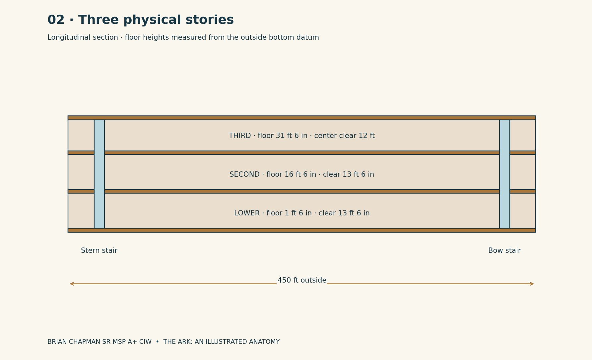
BRIAN CHAPMAN SR MSP A+ CIW

CAD study 44 Ark promenades and open central court
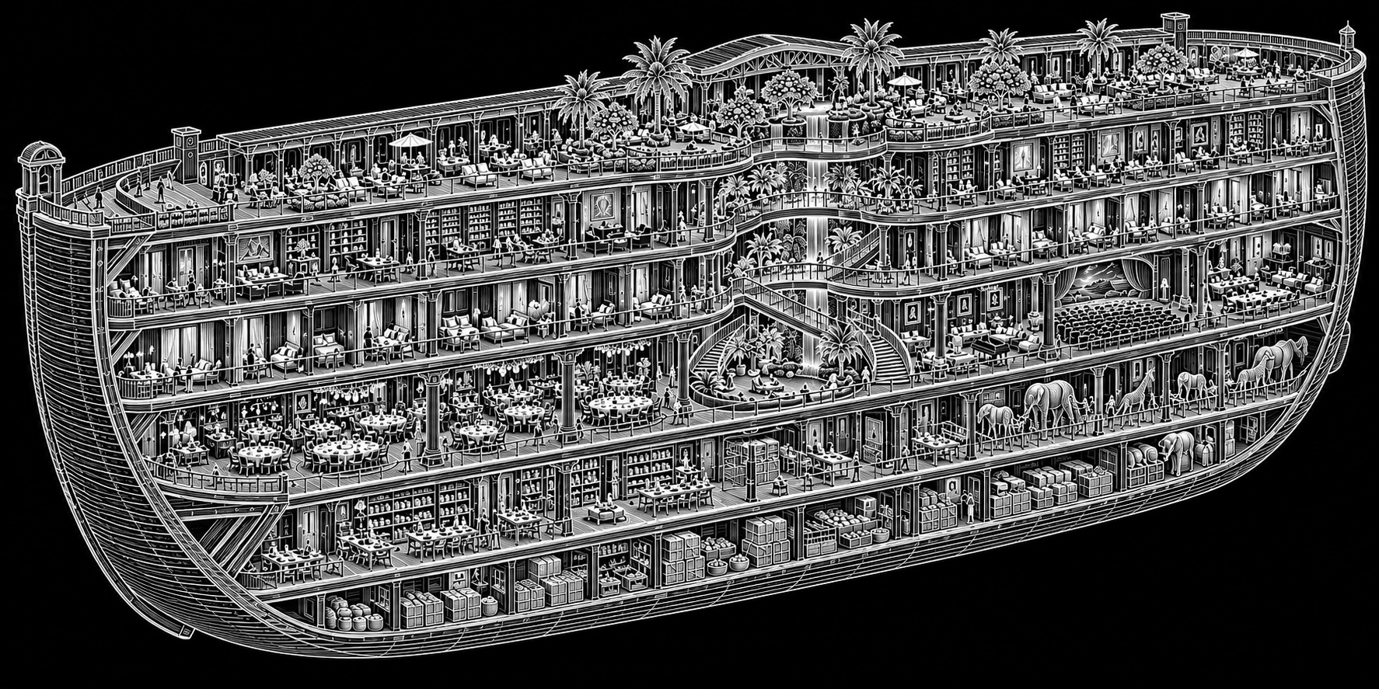
BRIAN CHAPMAN SR MSP A+ CIW
Concept study. Written dimensions, floor names and nonmetallic Ark construction rules in the atlas govern.

6 | The side door and the first impossible seam
Genesis 6:16 — “A window shalt thou make to the ark, and in a cubit shalt thou finish it above; and the door of the ark shalt thou set in the side thereof; with lower, second, and third stories shalt thou make it.”
The reconstructed side opening is 12 feet wide and 10 feet high, centered at H-x 75 feet. Its lower edge meets the middle finished floor at H-z 16 feet 6 inches. The width, height, position along the side, and opening hardware are atlas inventions. Genesis places the door in the side and specifies three stories; it does not provide this doorway schedule.
From outside, the door has a broad timber leaf divided by vertical battens. Its bottom edge is scarred where loads have crossed. The jambs are deep enough to create two separate bands of shadow. Just inside, the receiving vestibule measures 24 feet along the hull, 18 feet across it, and 10 feet clear above its floor. A person can stand within that space, turn, and still see the daylight she entered through. This ordinary view is deliberately retained when the next threshold is active.
The added dimensional jamb is set into the vestibule’s forward partition, not into the outside planking. Its opening is also 12 feet wide and 10 feet high. Three material lines identify it. The first is a dark wooden surround belonging to the hull. The second is a 6-inch honey-resin reveal, flush rather than ornamented. The third is a black interval no wider than a knife cut when closed. When the route opens, that interval becomes a view into another room. The resin-covered wood stays at the same temperature to the hand; the scene beyond it changes.
No vortex needs to fill the receiving bay. In the stable state, a bucket placed on the far floor looks like a bucket seen through a doorway. The impossible quality appears when the visitor compares directions: a ship’s short vestibule is followed by a long passage that cannot fit between the visible jamb and the bow. There is no gradual enlargement of boards. One plane is the last ordinary surface, and the next visible floor belongs to another registered coordinate system.
A 3-foot-deep red-brown mat lies on the hull side of the seam. Beyond it is a 6-foot strip of pale wood. The color change locates the boundary even when no lettering can be read. A wall plate names the destination, local date, and return doorway. The return view shows the same water bench and the same outside daylight. A threshold that shows no verified return identity remains a wall in the atlas, whatever attractive landscape appears beyond it.

Measured plate · The first impossible seam
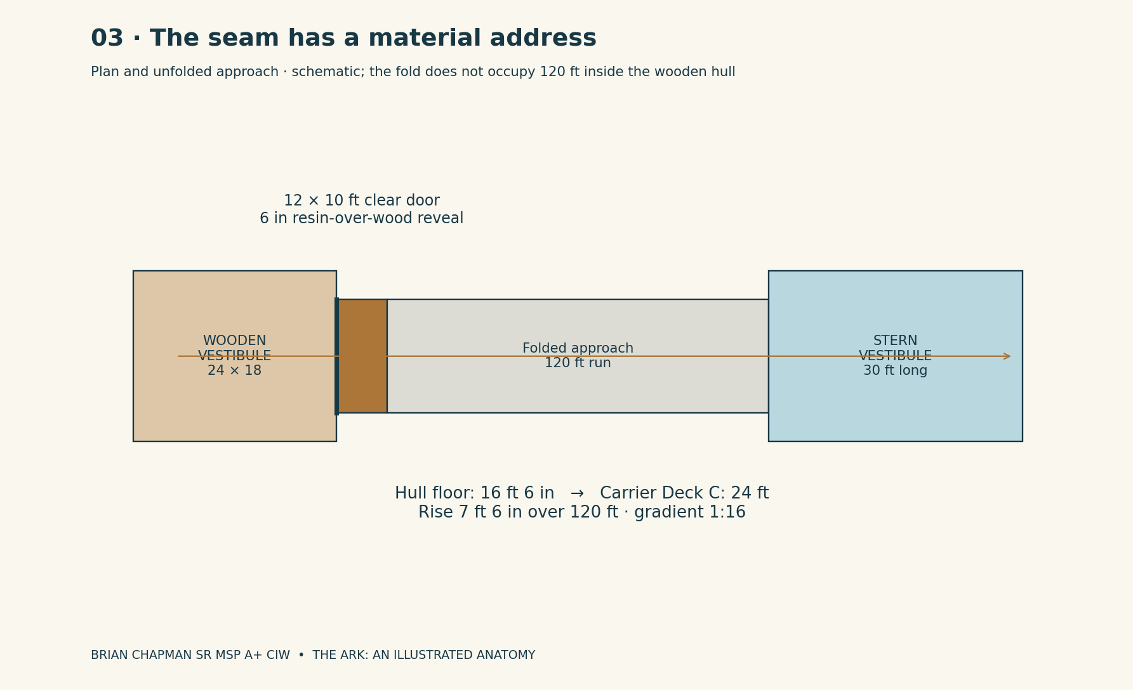
BRIAN CHAPMAN SR MSP A+ CIW

7 | The wooden answer to a magnetic world
The old civilization fills its sky with ships that depend on magnetic guidance, metal frames, and shared timing fields. In this fictional history, Noah can see their instability before the final storm: compass plates refuse a steady direction, the high transit lanes shimmer, and magnetic reference instruments disagree at installations that once answered together. His alarm belongs to a world using magnetics far beyond the present reader's ordinary technology. The architecture answers that danger by refusing the vulnerable system at its foundation.
The command to build the wooden vessel is the biblical anchor; the technological reason developed here is the fantasy's interpretation. Genesis names gopher wood and pitch. It does not explicitly supply a no-metal specification or describe Noah's peg schedule. This atlas makes those details part of the fictional continuation: Noah's craft is built without metal, joined with wooden pegs, and kept independent of the civilization's failing magnetic infrastructure.
The metal-free rule applies throughout the Ark domain, including the later tower design after its transfer into the vessel's linked spaces. The carrier does not hide a steel skyscraper behind a wooden door. Its primary members are laminated timber in the fiction's extraordinary woodworking tradition. Its repeat frames are deep interlocked wooden lattices. Pegs, splines, keys, wedges, hinges, rails, and lock pins are wood. Pitch, resin, fiber, clay, glass, and stone may serve as nonmetallic seals, surfaces, or contained contents; none is a concealed metal structure. “Wood only” describes the craft's structural and joining system, with no metal hardware anywhere inside it.
The characteristic joint is a housed timber shoulder with a through-tenon. On the explanatory detail, the post is 24 inches square, the beam is 18 inches wide and 30 inches deep, and the through-tenon is 8 inches wide. Two 2-inch-diameter wooden pegs cross the tenon at staggered positions. A separate 3-inch-thick hardwood key resists withdrawal. These are fictional illustrative dimensions, not a rated real structural connection. The pegs' end grain remains visible as two dark circles on the post face. There are no disguised nail heads between them.
A visitor's hand can follow the difference. The doorway's honey-colored reveal is polished resin over wood, not brass. The floor's dark strips are contrasting hardwood, not metal inlay. Hinges turn on replaceable wooden pins within dry wooden bearing blocks. A door latch is a sliding hardwood tongue entering a deep keeper. At the outside leaf, woven lifting tackle runs over grooved wooden sheaves. Its sound is the dry creak of timber and fiber, not the ring of a chain.
The rule extends into the rooms behind the rooms. Water runs through bored and lined wooden conduits with nonmetallic seals. Storage tanks are stave-built or timber-framed with contained nonmetallic liners. There are no copper wires behind a wall, steel reinforcement inside a member, or magnets disguised as door catches. The fantasy's light and route indicators use finite nonmetallic crystal-and-resin elements; ordinary electronic control equipment stays in the external contact houses. Carrier-side registry panels are mechanical address shutters with nonmetallic light elements and copied paper records. Their fantastic operation is part of the world design, not a claim that real wooden electronics exist.
Before a transferred module joins the Ark, it is rebuilt to this material register. The grounded refuge remains a different building, but its mobile descendant cannot bring incompatible machinery aboard under the excuse that it has the right floor number. The receiving vestibule has an outside holding room for metal cargo and personal metal objects. Nothing requiring a conventional magnetic drive crosses the Ark's inner boundary. Contemporary metal tools or electronic instruments mentioned in an earlier scene must remain on the external survey side under this revised continuity.
Wood is not claimed here as a real shield against every magnetic or atmospheric hazard. Within the fantasy, survival comes from both material independence and the Ark's separate timing reference. The wooden craft refuses the common magnetic guidance network that fails at the complex. Its independence is visible in every peg and every frame, making Noah's foresight an architectural fact the reader can see rather than an explanation added after the storm.

Measured plate · The wooden peg and through-tenon
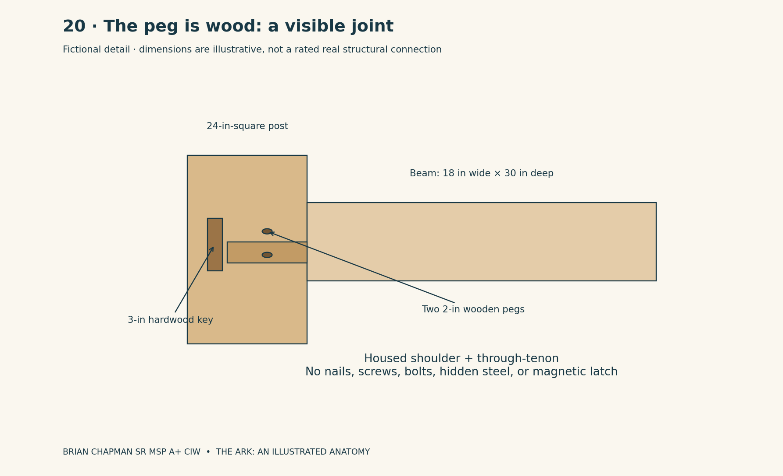
BRIAN CHAPMAN SR MSP A+ CIW

Measured plate · Two technologies: magnetic complex and wooden Ark
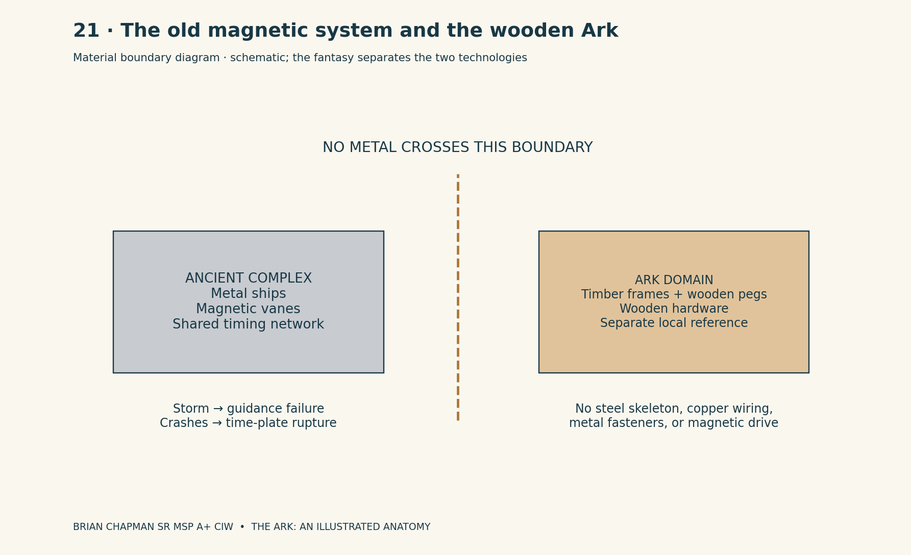
BRIAN CHAPMAN SR MSP A+ CIW

8 | What the grounded house contributed
North Terrace, the refuge described in The Ark of Hidden Rooms, remains a building on a rock terrace. Its recorded conceptual envelope is 312 meters long, 72 meters wide, and 50 meters to the crown. In this volume’s feet-and-inches convention, those are approximately 1,023 feet 7 inches, 236 feet 3 inches, and 164 feet 1 inch. These rounded equivalents identify the earlier building; they do not replace the Ark’s 450-by-75-by-45-foot hull.
Its six occupied levels have persistent names. K is Keel: separated utilities and stores. F is Foundry: workshops and receiving. C is Commons: meals, assembly, and reception. H is Homes: household courts and resident-controlled rooms. L is Learning: school, archive access, and care. G is Gardens: cultivation and roof observation. These functional relationships are the inheritance carried into the mobile design. Exact floor areas are not inherited merely because a name is reused.
The refuge’s long elevation has a heavy lower edge and a lighter crown. At the terrace, rainwater meets real drains and real ground. The planting level has a roof above it. A delivery enters the service route before it reaches a kitchen. The wall separating experimental boundary equipment from household services remains visible as a blue line on the fieldbook section. That line is architectural: it prevents a reader from mistaking a mysterious mechanism for the pipe that supplies a child’s sink.
The mobile tower arrangement originates in the pre-Flood parent building, not in a skyscraper first invented after Noah’s journey. North Terrace later reuses the six functional relationships preserved in that inheritance. The original designers begin with a vertical city: repeated square floors around a central core. The six functional names are kept, but every movable unit is given the same service attachment points. A home can be planned alongside a school without giving the school authority over the home’s door. A maintenance room can be reached from the service spine without passing through someone’s bed space.
The essential continuity correction is a hierarchy and a sequence. The technological parent tower precedes the wooden Ark prototype. The Ark copies its floor order in a lengthwise mobile remote form. The protected parent core survives the Flood; the Ark returns by a registered water route to the Alaskan dock, and a protective pyramid is built above the surviving site. North Terrace is a much later grounded refuge inspired by the inherited shelter design. All four can exist in the same story world without forcing the wooden ship to become a 1,023-foot concrete building or claiming that North Terrace itself once floated through the Flood.

9 | The tower before it lies down
The standing tower’s organizing envelope is 144 feet square in plan. It contains twenty-four major floor modules, each with a 30-foot gross vertical pitch. The stacked module zone is therefore 720 feet high. A separate ground vestibule and a separate crown transfer chamber belong to the site arrangement and are not counted as a twenty-fifth occupied floor. On the diagram, the numbered stack is drawn plainly enough to count every module.
From the street the tower is read as a succession of deep golden timber bands. Each band marks a floor module rather than an ordinary 10-foot office story. Within a band, finer mullions indicate intermediate occupied platforms. The corners are heavier than the centers of the faces. Behind the central bays, a 12-foot-square timber-framed circulation core rises continuously. Along another face, service risers remain distinct, with panels accessible from maintenance landings rather than from the middle of a private room.
At street level, the entrance is recessed 24 feet from the outer edge of the upper frame. Four square piers divide the covered approach. The floor is pale timber with a darker strip following the core’s axis. A visitor standing under the porch sees the first ceiling above her and the repetition of distant structural frames through a glazed shaft. The tower’s height is communicated by the smallness of that distant top light, not by an unlimited cloud of decorative balconies.
The Ark’s prototype copies the tower’s organization into a lengthwise architectural system. The fixed parent tower remains in place; it is not physically tipped while people cling to its walls. In the prototype design, each copied module’s independent attachment grid can receive decks on either of two perpendicular orientations. The parent’s standing state uses one gravity direction. The traveling copy locks a second set of wooden floor supports into its frame and declares its own local down. Cabinets, pipes, drains, stairs, and occupied platforms are rebuilt or rotated onto that second grid before residents enter.
A floor number is preserved even when its old horizontal slab becomes a transverse boundary. The slab that once separated Floor 8 from Floor 9 becomes the forward boundary between Station S08 and Station S09. The old elevator axis becomes the long route through successive stations. The scheme is a transformation of ordering: twenty-four levels become twenty-four addresses along a ship. It is not a claim that ordinary concrete can ignore gravity.

Measured plate · Tower-to-station correspondence
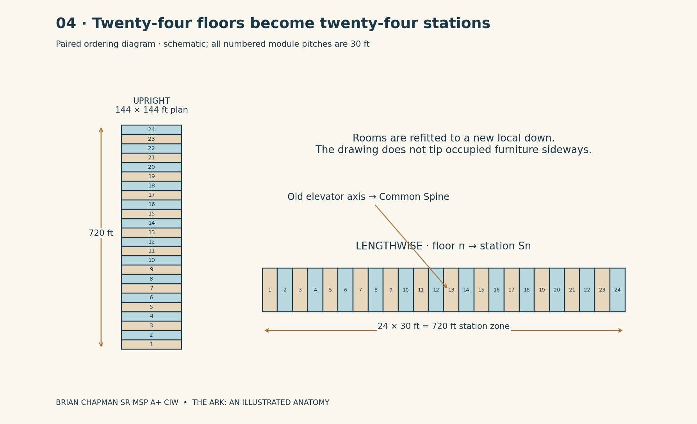
BRIAN CHAPMAN SR MSP A+ CIW

CAD study 50 Twenty four floor parent hub
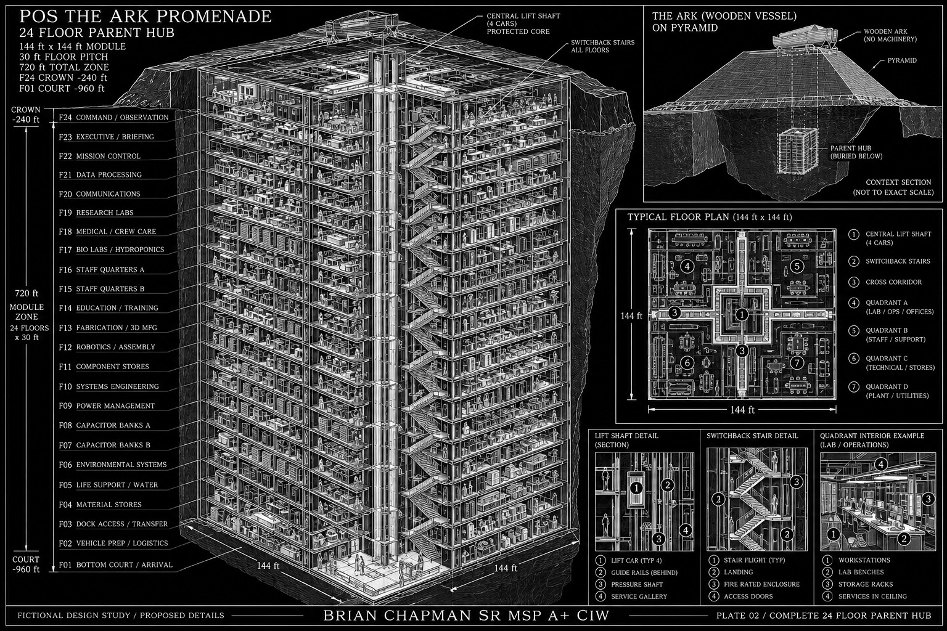
BRIAN CHAPMAN SR MSP A+ CIW
Concept study. Written dimensions, floor names and nonmetallic Ark construction rules in the atlas govern.

10 | The same tower, turned lengthwise
The lengthwise carrier has a registered central length of 780 feet: a 30-foot stern vestibule, twenty-four 30-foot station modules, and a 30-foot bow vestibule. Its outside cross-section is 144 feet wide by 144 feet high. These are dimensions in carrier space, labeled C, not an object somehow compressed into the Ark’s ordinary 72-foot interior width. The wooden seam connects spaces; it does not turn the carrier’s timber lattice into miniature furniture.
Station S01 extends from C-x 30 to 60 feet. Station S24 extends from 720 to 750 feet. The stern vestibule occupies 0 to 30; the bow vestibule occupies 750 to 780. Each former tower floor maps to the station with its number. S08 has the same identity whether the whole carrier is docked, traveling, or connected through a different outer door. Its inhabitants do not wake in a different house because a destination has changed.
Six longitudinal decks are installed within the cross-section. Their finished-floor elevations are K at 0 feet, F at 12 feet, C at 24 feet, H at 36 feet, L at 48 feet, and G at 60 feet. Each deck has a 12-foot pitch to the one above, with a 1-foot-6-inch floor assembly where another occupied deck follows. Most rooms therefore have a 10-foot-6-inch clear ceiling. Above G, the shared roof volume extends toward the 144-foot outer crown. It is a service and light volume, not another seventy ordinary stories.
The old elevator axis, now horizontal, forms the Common Spine on Deck C. It is 12 feet wide and 12 feet gross high, giving 10 feet 6 inches clear below the next deck assembly. Repeated interlocked timber portal frames occur every 30 feet. From the stern end one sees a diminishing series of rectangles, each with a low white number at the right jamb. The farthest door is a small pale upright. A person in S12 stands beneath the twelfth frame rather than inside an unmeasurable hall.
The ceiling does not rotate under someone crossing the original Ark threshold. A 120-foot articulated approach, registered outside the station zone, rises 7 feet 6 inches from the hull’s middle-floor level to the Common Spine’s 24-foot level. Its gradient is 1 in 16. The approach belongs to folded transfer space and is not added to the 780-foot station-spine dimension. At its top, the visitor turns once and meets the stern vestibule. The wooden doorway remains behind the return turn, visible through the approach when the route is open.

Measured plate · The registered carrier spine
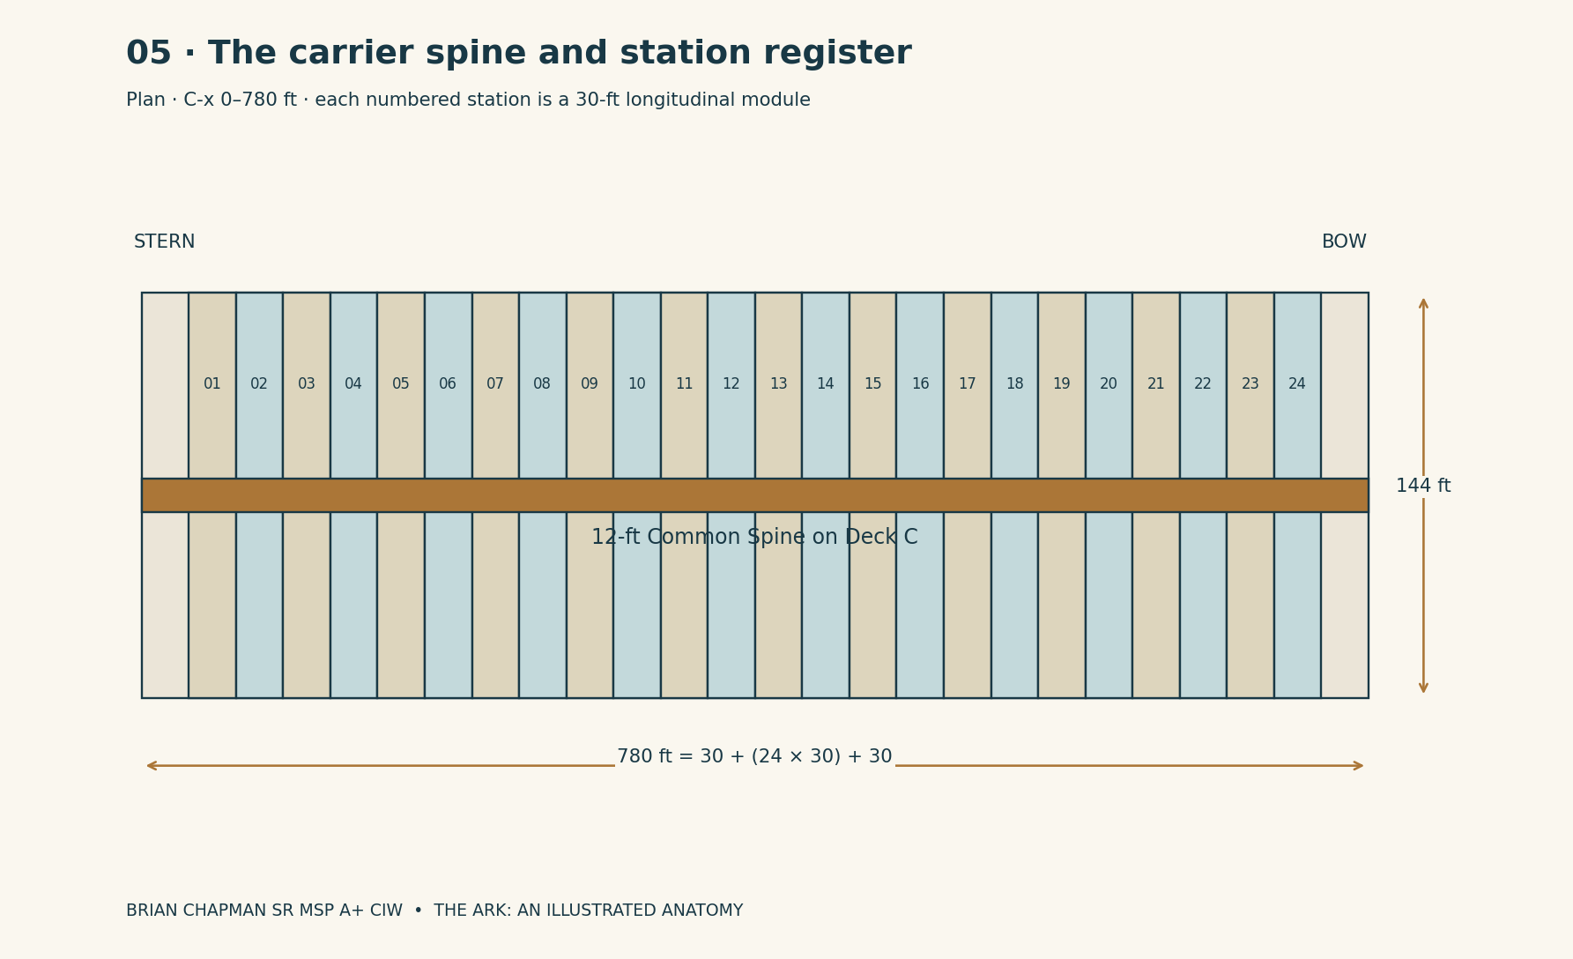
BRIAN CHAPMAN SR MSP A+ CIW

CAD study 45 Ark inhabited decks and planted terrace
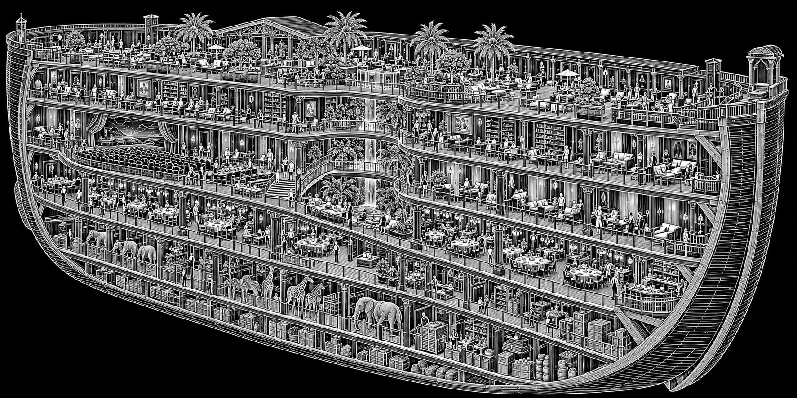
BRIAN CHAPMAN SR MSP A+ CIW
Concept study. Written dimensions, floor names and nonmetallic Ark construction rules in the atlas govern.

11 | A cross-section one can inhabit
Stand on Deck C at Station S12 and face toward the bow. The passage floor is dark gray hardwood broken by honey-colored timber strips at the station boundaries. A 4-inch cove of indirect light runs along each side at ankle level. Above, acoustic panels are pale and fibrous, with narrow service covers between them. The passage smells different at each station because nearby doors are used, but cooking exhaust is not the corridor’s ventilation system.
On either side, the occupied cross-section is divided by reference lines at C-y minus 66, minus 6, plus 6, and plus 66 feet. The outer 6-foot strip on each side of the 144-foot envelope contains frame, insulated wall, and service access. Between that strip and the central aisle lies a 60-foot usable band. A normal planning cell in that band is 24 feet deep from the aisle, with another 36 feet available for deeper courts, stores, circulation, and specialized rooms.
Deck H is directly above. Its floor is 12 feet above the Common Spine’s floor. The sound of ordinary footsteps is muted by the assembly, but an unsecured cart can still be heard at a station crossing. A stair rises inside each protected enclosure at S02 and S23. Intermediate lifts stand at S08 and S17. There is therefore a front route and a rear route for ordinary vertical movement, with additional assisted access near the thirds of the carrier. The atlas shows locations, not a certification of a real building’s evacuation strategy.
A private cabin typically measures 12 by 18 feet, with a 4-by-6-foot washroom counted separately from that main room. Its door is 3 feet 6 inches clear. The window does not automatically look through the carrier’s exterior skin. Some cabins open to planted internal courts; some have an exterior viewing panel; some have a plain wall. A person’s economic or moral worth is not coded by whether a room happens to face the stars.
At the upper garden deck, the scale changes. The occupied floor lies at C-z 60 feet, and trellises rise to 78 feet in selected courts. Beyond them, maintenance bridges cross the upper volume at 96 feet. The highest service structure remains below the crown. The garden’s visible blue is produced by light surfaces and selected dimensional views, not by the claim that an atmospheric sky physically fits under every roof panel. A bird entering a closed court can fly to a definite net or screen.

Measured plate · Six inhabited deck positions
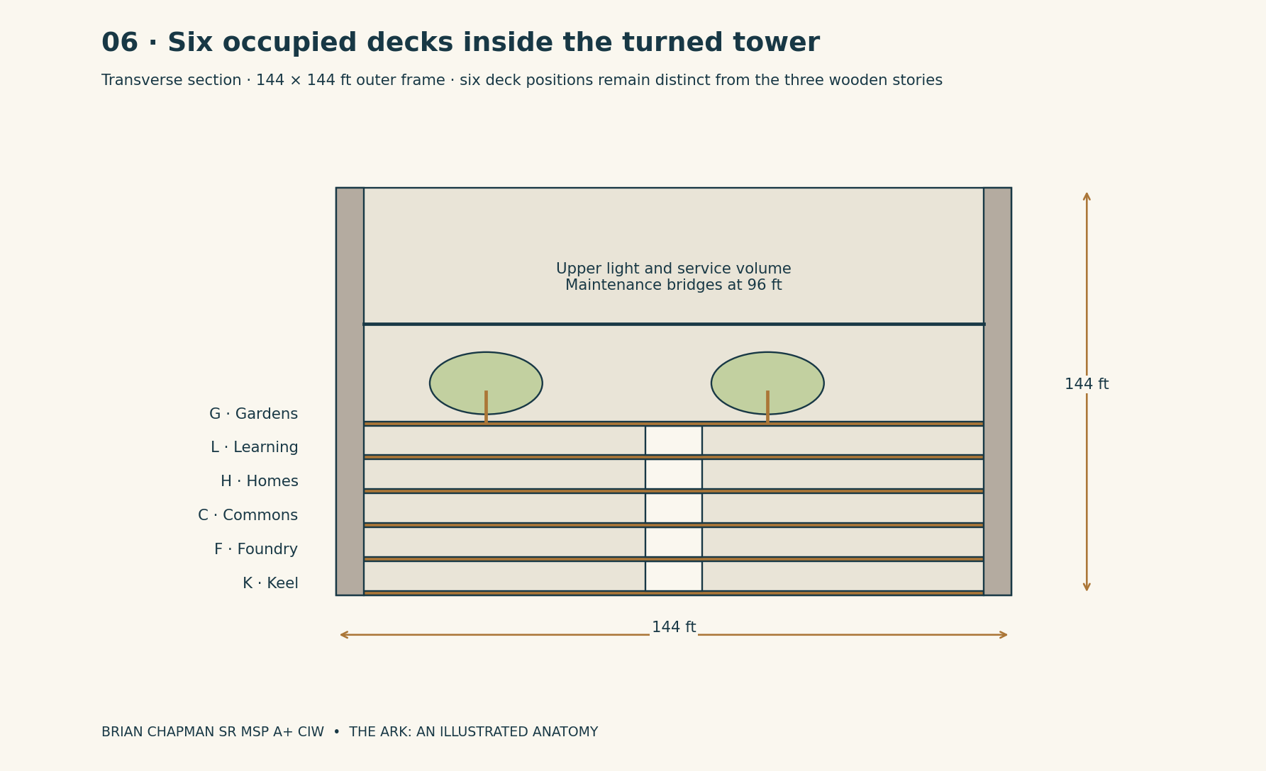
BRIAN CHAPMAN SR MSP A+ CIW

CAD study 46 Ark rooms and circulation galleries
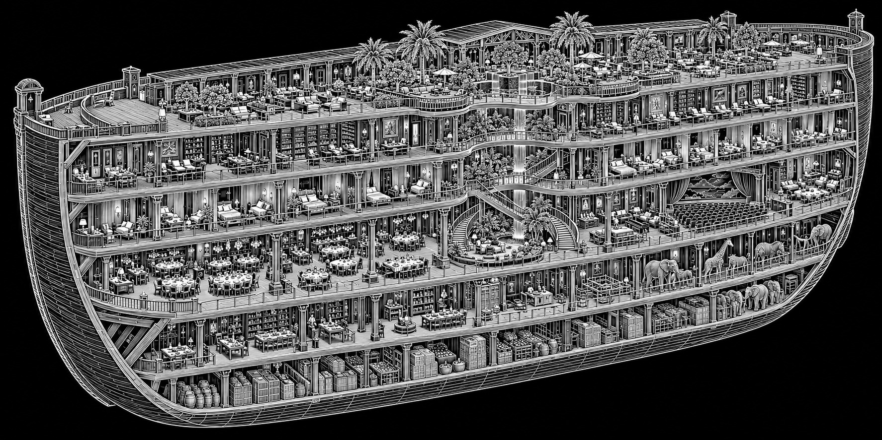
BRIAN CHAPMAN SR MSP A+ CIW
Concept study. Written dimensions, floor names and nonmetallic Ark construction rules in the atlas govern.

12 | The twenty-four addresses
The following station register is the spine’s room-by-room index. Every station has all six deck positions even where a given position is reserved for service, planted void, or an unoccupied volume. A named room is a particular address, not the whole cross-section. The 30-foot station pitch is longitudinal; side-to-side dimensions belong to the individual room descriptions.

S01 · Arrival and return
Tower Floor 1 → S01 · C-x 30–60 ft · primary room S01-C
Representative clear room: 24 × 24 ft.
The common passage opens from the stern vestibule into a receiving room on its north side. Its pale floor has a darker 6-foot waiting strip beside the wall, leaving the line between doors clear. A bench 18 feet long faces the route plate. Above it, a shallow window looks into the vestibule rather than into an invented external city. The return desk is at the forward corner, where an attendant can see both the numbered spine frame and anyone waiting by the bench. A small baggage room behind the desk has a 4-foot-wide door.

S02 · Stern stair and lift
Tower Floor 2 → S02 · C-x 60–90 ft · primary room S02-C
Representative clear room: 24 × 30 ft.
Two doors at the spine margin lead to the protected vertical enclosure. The stair occupies the western half; the assisted lift occupies the eastern half. On each occupied deck, the landing opens onto the same station number, so a person stepping out at H does not acquire a new address along the ship. The lift door is recessed 6 feet beyond the landing's through route. A glazed upper panel lets a waiting person see whether the landing is occupied without exposing the private rooms reached beyond it. The enclosure is a route, not a storage alcove.

S03 · Receiving and examination
Tower Floor 3 → S03 · C-x 90–120 ft · primary room S03-L
Representative clear room: 24 × 18 ft.
The examination room has a 4-foot door offset from its central axis. Inside, a movable couch stands with working space on three sides. A 10-foot counter runs along the rear wall beneath closed cupboards; the wash basin is at the counter's western end. A high internal window admits borrowed light without turning the room into a corridor display. The adjoining waiting room is 18 by 18 feet, with chairs spaced around a planted light well. It is distinct from the ship's contact-channel examination equipment and can function while dimensional travel is shut.

S04 · Cargo reception
Tower Floor 4 → S04 · C-x 120–150 ft · primary room S04-F
Representative clear room: 48 × 24 ft.
A wide service door faces the parallel maintenance route. Yellow-brown floor bands mark a 12-foot cart lane and two 12-by-12-foot holding rectangles. The public spine does not run through those rectangles. Along the outer wall, a 3-foot-high weighing platform sits flush with a recessed working floor so heavy baskets need not be lifted onto a pedestal. The ceiling shows numbered lifting points as fictional fittings, with no implied real load rating. A glazed office looks across the receiving floor; its occupant can see a delivery without standing among carts.

S05 · Dry provisions
Tower Floor 5 → S05 · C-x 150–180 ft · primary room S05-K
Representative clear room: 48 × 24 ft.
Storage ranks stand perpendicular to the entry wall, creating 4-foot aisles between 2-foot-deep shelves. Their ends carry large inventory plates, readable before a person enters an aisle. No shelf crosses the marked path to the second service door. At the room's southern edge, a sealed partition separates food stores from reservoir inspection access. The visible surfaces are pale, hard, and easy to examine; the room has no ornamental exposed earth. From its doorway one sees the repeating shelf ends, a clear center route, and the low lamps above the stock labels.

S06 · Clean-water inspection
Tower Floor 6 → S06 · C-x 180–210 ft · primary room S06-K
Representative clear room: 24 × 24 ft.
This room is the accessible edge of the distributed reservoir group beneath S05–S08. It contains the inspection manifold and record desk, not the entire seven-day water supply. Blue-white pipe supports follow the rear wall above a wooden grated drip strip. Each branch is numbered for the reservoir it serves. A central clear square 12 feet across gives access to panels without stepping over pipes. The waste-service route lies behind a separate wall and has its own entrance. A transparent sample chamber at eye level makes the water visible without opening the main system to the room.

S07 · Repair workshop
Tower Floor 7 → S07 · C-x 210–240 ft · primary room S07-F
Representative clear room: 48 × 24 ft.
Four 8-foot benches face inward around a 12-foot working lane. Their tops are scarred wood on dark timber bases. Lockable tool panels line the north wall; the south side has wash and cleanup counters behind splash screens. A 6-foot-wide double door opens to the service spine, while a separate 3-foot-6-inch door serves ordinary pedestrian entry. A narrow borrowed-light strip near the ceiling gives a view of the neighboring maintenance gallery. No machine's required clearance is silently borrowed from the public passage outside.

S08 · Intermediate lift and quiet room
Tower Floor 8 → S08 · C-x 240–270 ft · primary room S08-C
Representative clear room: 24 × 18 ft.
The lift is paired with an 18-by-18-foot waiting landing. Beside it, the quiet room is entered through a short offset passage, so the lift's opening doors do not face a resting person's chair. Its ceiling is soft gray, its floor warm brown, and its light comes from a dimmable wall cove. Two chairs and a low table occupy the room without making it a dormitory. An 8-foot strip of shallow shelving holds blankets and ordinary household supplies. This small pause in the route belongs to people who cannot move at the atlas's reference walking pace.

S09 · School and making room
Tower Floor 9 → S09 · C-x 270–300 ft · primary room S09-L
Representative clear room: 48 × 24 ft.
The main learning room has two 24-foot-square halves divided by a folding partition. One half contains movable tables; the other has sinks, low work counters, and covered storage for materials. Windows overlook an internal planted court rather than a machinery shaft. Children's low hooks line the entry recess at heights suited to their use. A separate adult-height rail holds bags above them. The floor near the sinks is visibly different from the dry teaching floor, making the room's activities legible even when the partition is open.

CAD study 52 Research and fabrication floors
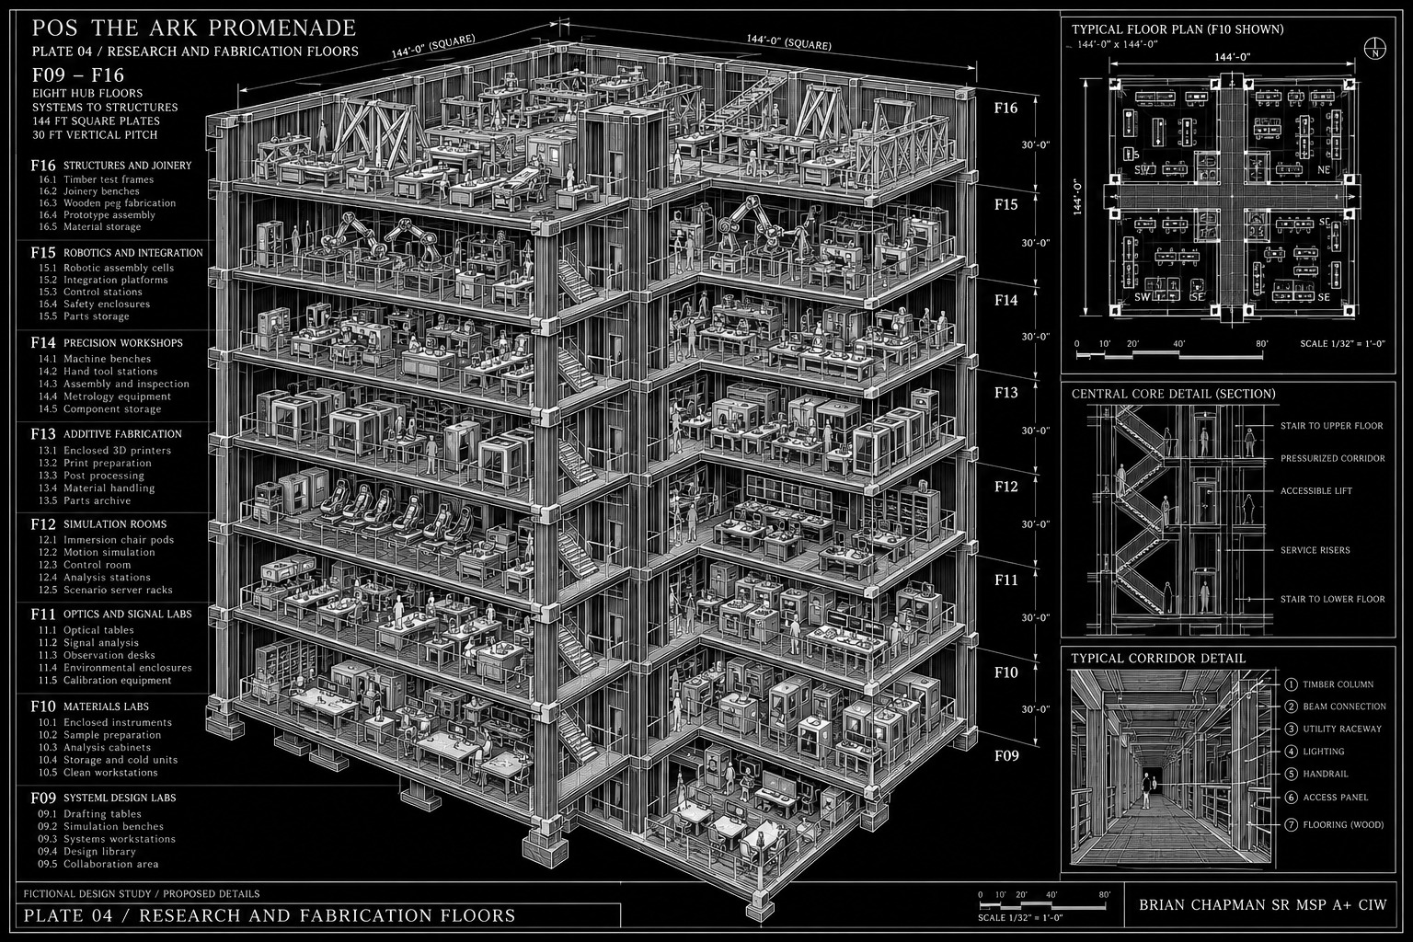
BRIAN CHAPMAN SR MSP A+ CIW
Concept study. Written dimensions, floor names and nonmetallic Ark construction rules in the atlas govern.

S10 · Garden entrance
Tower Floor 10 → S10 · C-x 300–330 ft · primary room S10-G
Representative clear room: 36 × 24 ft.
A pale-wood landing stands between the upper deck and the D7 Garden Annex. Its door frame has the same 6-inch honey-resin reveal as the original transfer seam. Two benches face one another across the 12-foot clear approach. A planting trough beside the left bench contains ordinary rooted shrubs, so the visitor sees real leaves before the much larger garden opens ahead. The route plate names Garden West, local date, and return S10-G. If the annex is shut, this remains a pleasant bounded room with a blank forward panel rather than a black hole.

S11 · Household courts
Tower Floor 11 → S11 · C-x 330–360 ft · primary room S11-H
Representative clear room: 48 × 24 ft.
Two courts are set on opposite sides of the private residential passage. Each begins with a 12-by-18-foot shared sitting bay and doors to individual cabins. The central court light is warm and indirect. Residents can close their own room doors while the common passage stays open. Cupboards are recessed into the inner wall so laundry does not become an obstacle. A planted square 12 feet across provides a view from interior windows; its roots occupy a contained bed with an accessible drainage edge, not the ceiling of the commons below.

S12 · Common table hall
Tower Floor 12 → S12 · C-x 360–390 ft · primary room S12-C
Representative clear room: 60 × 24 ft.
This is the largest ordinary dining room on the Common Spine. Four long tables run across the room's width, with their ends stopping short of a 6-foot perimeter route. The entry opens near one corner so an arriving person can see available places without interrupting a table's center. Serving hatches occupy the aft wall. A high band of translucent panels borrows light from an internal court. The room is large enough for a shared meal, not for the entire nominal population to eat simultaneously; its schedule assumes several meal sittings and other local dining rooms.

CAD study 47 Ark common tables and central promenade
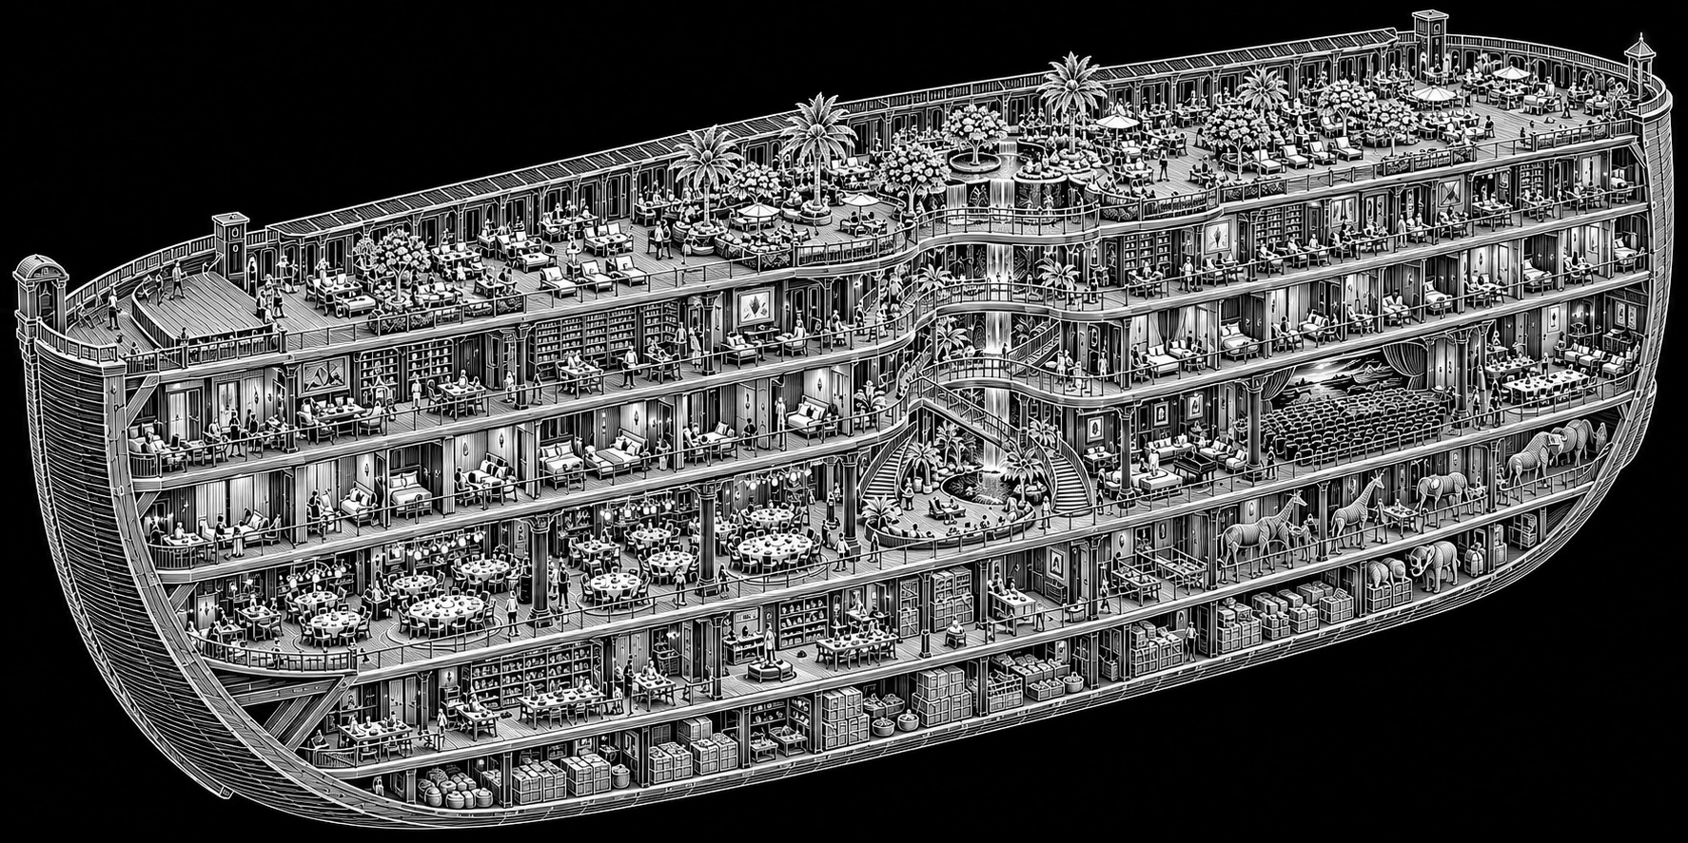
BRIAN CHAPMAN SR MSP A+ CIW
Concept study. Written dimensions, floor names and nonmetallic Ark construction rules in the atlas govern.

S13 · Kitchen and washing
Tower Floor 13 → S13 · C-x 390–420 ft · primary room S13-C
Representative clear room: 48 × 24 ft.
The kitchen lies directly forward of the table hall. Preparation, cooking, serving, and return washing form separate visible bands. A 12-foot serving counter meets the shared wall with S12, while used dishes return through a different opening. Behind the cooking line, a captured exhaust canopy rises to the service connection without crossing a household room. The floor is slightly darker around the washing zone, where a recessed drain strip follows the work edge. Food stores arrive by the service route, so incoming crates do not travel through the room among seated diners.

S14 · Laundry and bathing
Tower Floor 14 → S14 · C-x 420–450 ft · primary room S14-F
Representative clear room: 48 × 24 ft.
The wet-service room has a dry entry with benches and individual storage compartments. Beyond a full-height partition, fictional nonmetallic laundry drums and wash sinks line the outer wall. Bathing cubicles occupy a separately entered band, each with its own door and simple changing recess. The public route never looks straight into a shower. Pale tile reaches the ceiling only in the wet bays; outside them, washable wall panels and warmer floor strips make the changing area less institutional. Drain access is reached from the maintenance side without opening a cubicle occupied by a resident.

S15 · Family rooms
Tower Floor 15 → S15 · C-x 450–480 ft · primary room S15-H
Representative clear room: 24 × 24 ft.
A representative family suite contains two 12-by-18-foot main rooms linked by an internal 4-foot door, with wash and storage rooms arranged alongside rather than deducted invisibly from those clear dimensions. One room can serve as a sitting and study space; the other holds beds. Built-in shelves stop below the ceiling so the upper light band remains unobstructed. A 6-foot-wide internal window faces a household court. Its blind closes from inside. The suite's address belongs to the rooms, not to a single owner whose departure would make the place disappear from the map.

S16 · Archive and reading
Tower Floor 16 → S16 · C-x 480–510 ft · primary room S16-L
Representative clear room: 48 × 24 ft.
Low shelves divide the public reading room into three bays without hiding the exit. A 12-foot table stands near the entry, with local task lamps instead of a dazzling central light. The controlled record room is behind a glazed partition. Its door is 4 feet wide and names the responsible archive desk. Personal records are not displayed on the public shelves because they happen to concern extraordinary events. The room's quiet is material: soft ceiling panels, separated equipment, and door seals reduce spine noise without requiring the building to become supernaturally silent.

S17 · Forward intermediate lift
Tower Floor 17 → S17 · C-x 510–540 ft · primary room S17-C
Representative clear room: 24 × 30 ft.
This repeats the assisted vertical route at S08 but uses a different landing color, a muted green, to distinguish the forward third. The station number remains the primary identifier. A 12-foot-wide clear route crosses the landing to a sheltered return stair. On Deck G, the lift opens into a 24-by-24-foot roof observation lobby beneath the upper service volume. A person can reach the garden level without climbing an exposed ladder or traversing a research room. The lift's service machinery is accessed from the protected maintenance strip.

S18 · Animals and care court
Tower Floor 18 → S18 · C-x 540–570 ft · primary room S18-F
Representative clear room: 48 × 24 ft.
The care room has a washable central floor, low animal enclosures along one wall, and examination counters on the other. A 6-foot-wide door admits carriers and wheeled crates. A separate isolation room, 12 by 18 feet, has its own controlled air route and an observation pane. The adjacent exercise court is bounded and supervised; it is not the entire Garden Annex. Animals can be housed without assuming that every species thrives under the same light, sound, temperature, or handling. This room keeps their architectural presence tangible: doors, drains, bedding stores, and places for frightened people to sit beside them.

S19 · Contact preparation
Tower Floor 19 → S19 · C-x 570–600 ft · primary room S19-L
Representative clear room: 24 × 24 ft.
The preparation room precedes the controlled channel suite. A long bench faces a display that shows the current external observation site. The floor contains no decorative seal that must be solved to leave. On the south wall, a 6-foot counter holds local communications equipment and a paper route register. Staff enter the equipment side through a separate service door. A visitor can wait here without hearing an unfiltered contact signal. The wall plate describes whether the far channel is active, translating, delayed, or unavailable, rather than promising contact whenever someone feels ready.

S20 · Harbor entrance
Tower Floor 20 → S20 · C-x 600–630 ft · primary room S20-C
Representative clear room: 36 × 24 ft.
This landing repeats the garden entrance's measured threshold but substitutes a darker blue-gray floor. Its 12-by-10-foot doorway opens into the Harbor Annex receiving hall. The local waiting bay lies to the side, so a departing family does not block arrivals. A low luggage rail keeps bags out of the passage. When the route is open, reflected water light moves across the far wall, but the carrier-side floor remains dry. The small door's route plate identifies Harbor South Receiving; it does not claim to be one of the annex's huge ship berths.

S21 · Route registry
Tower Floor 21 → S21 · C-x 630–660 ft · primary room S21-L
Representative clear room: 24 × 18 ft.
The registry is described in the D10 chapter. At its entry, a small directory makes the distinction between a room's address and a route's current destination explicit. The same S21-L room can supervise different active doors without moving itself. Its twelve route panels face two desks and an independent record cabinet. The visitor rail leaves a 6-foot standing band before the benches. Above the door, a plain clock reports the room's local time. A second displayed time belongs to a named remote route and is not allowed to masquerade as the first.

CAD study 53 Remote control and upper hub
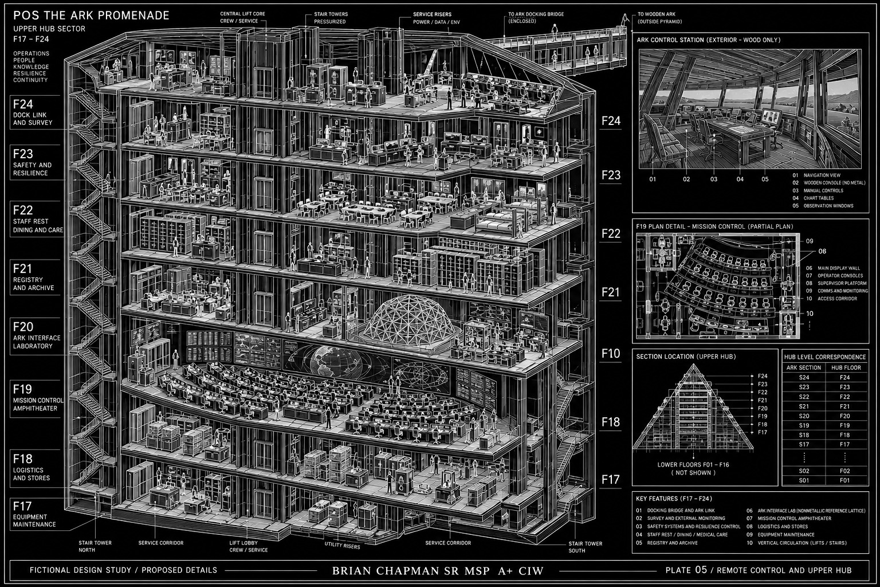
BRIAN CHAPMAN SR MSP A+ CIW
Concept study. Written dimensions, floor names and nonmetallic Ark construction rules in the atlas govern.

S22 · Reserve rooms
Tower Floor 22 → S22 · C-x 660–690 ft · primary room S22-H
Representative clear room: 48 × 24 ft.
The reserve accommodation is a divided room capable of several ordinary arrangements. Folding partitions create four 12-by-24-foot bays, but those are temporary sleeping bays rather than four fully equipped apartments. Washrooms and supplies have their own named adjoining rooms. The bay walls reach high enough for visual privacy while the designed air route remains above. Daytime storage cabinets take folded bedding. Overflow admission is limited by working water, care, and sanitation; the presence of unused floor area does not establish unlimited residential capacity.

S23 · Bow stair and service separation
Tower Floor 23 → S23 · C-x 690–720 ft · primary room S23-C
Representative clear room: 24 × 30 ft.
The forward protected enclosure repeats S02's connection among occupied decks. Along its service side, the blue separation line turns down the wall and continues across the threshold of the boundary-equipment approach. A visitor can follow the ordinary stair without entering that approach. The corridor remains 12 feet wide at the junction. Two door recesses face different directions to avoid a crowd of waiting people meeting head-on with someone leaving the stair. The deck directory is fixed to the wall opposite the landing, where it can be read before choosing a route.

S24 · Forward observation room
Tower Floor 24 → S24 · C-x 720–750 ft · primary room S24-C
Representative clear room: 48 × 24 ft.
The last numbered station contains a room looking into the bow vestibule and a separately controlled exterior viewing panel. A continuous bench follows the inner wall. The floor pattern ends at a transverse hardwood strip marking the station boundary at C-x 750 feet. Beyond it is the 30-foot bow vestibule, not a twenty-fifth station. With every remote view shut, the room still has a definite wall, a local lamp, and a way back down the spine. Its grandeur lies in the long view toward the stern: twenty-four addresses, repeated frames, and inhabited doors that stay where they were built.

13 | Seventh-dimensional rooms: the outward gardens
“Seventh-dimensional” is the builders’ name for a family of spatial joins. It does not mean that someone sees seven mutually perpendicular directions with ordinary eyes. The visible effect is simpler and stranger: a small registered doorway can open to a large bounded place whose dimensions are not contained by the carrier around its jamb. The atlas calls such a place a D7 annex and gives it its own coordinates beginning at its entrance threshold.
The principal Garden Annex opens from S10-G. Its carrier-side door is 12 feet wide and 10 feet high. Immediately beyond it, a 24-foot-long vestibule widens from 12 feet to a 36-foot central walk. Its planting country is a rectangle 1,200 feet long and 600 feet wide, surrounded by a wall whose inside face is 24 feet high. The door is at the center of the west short side. The garden’s sky volume rises 180 feet above the central walk. No measurement is inferred from the color of the painted or projected horizon beyond the boundary.
From the doorway, six terraces descend eastward. Each terrace is 180 feet deep, and five intervening water steps occupy 12 feet apiece; a 60-foot receiving terrace completes the total length. Each major terrace drops 2 feet. The main walk uses a gentler route with landings, so a wheeled cart need not descend the water stairs. At the east end, a reflecting basin 120 by 60 feet lies level with the lowest planting terrace. Its water is 2 feet deep except at protected service sumps outside the visitor’s edge.
The outer planting bands contain orchard trees on 24-foot centers. Their trunks are not identical columns: some lean, some fork early, and some stand within circular grates because the soil has settled around them. On the north side are high, silver-backed leaves whose moving shadows cross the path. On the south side, low warm walls hold herbs and climbing fruit. A person looking back from the basin sees the entire descending garden and, at its high western end, one ordinary dark doorway.
The garden’s boundary has a thickness and a service route. Behind the 24-foot wall lies a 12-foot perimeter passage connecting four pump and lighting houses. At the corners, gates for staff remain locked to their own route, rather than opening into a mysterious endless exterior. Water, soil, air, and heat remain finite. A shut entrance does not stop leaves from using water or make a failed pump irrelevant. This annex is a place with maintenance, not a synonym for inexhaustibility.

Measured plate · Garden West
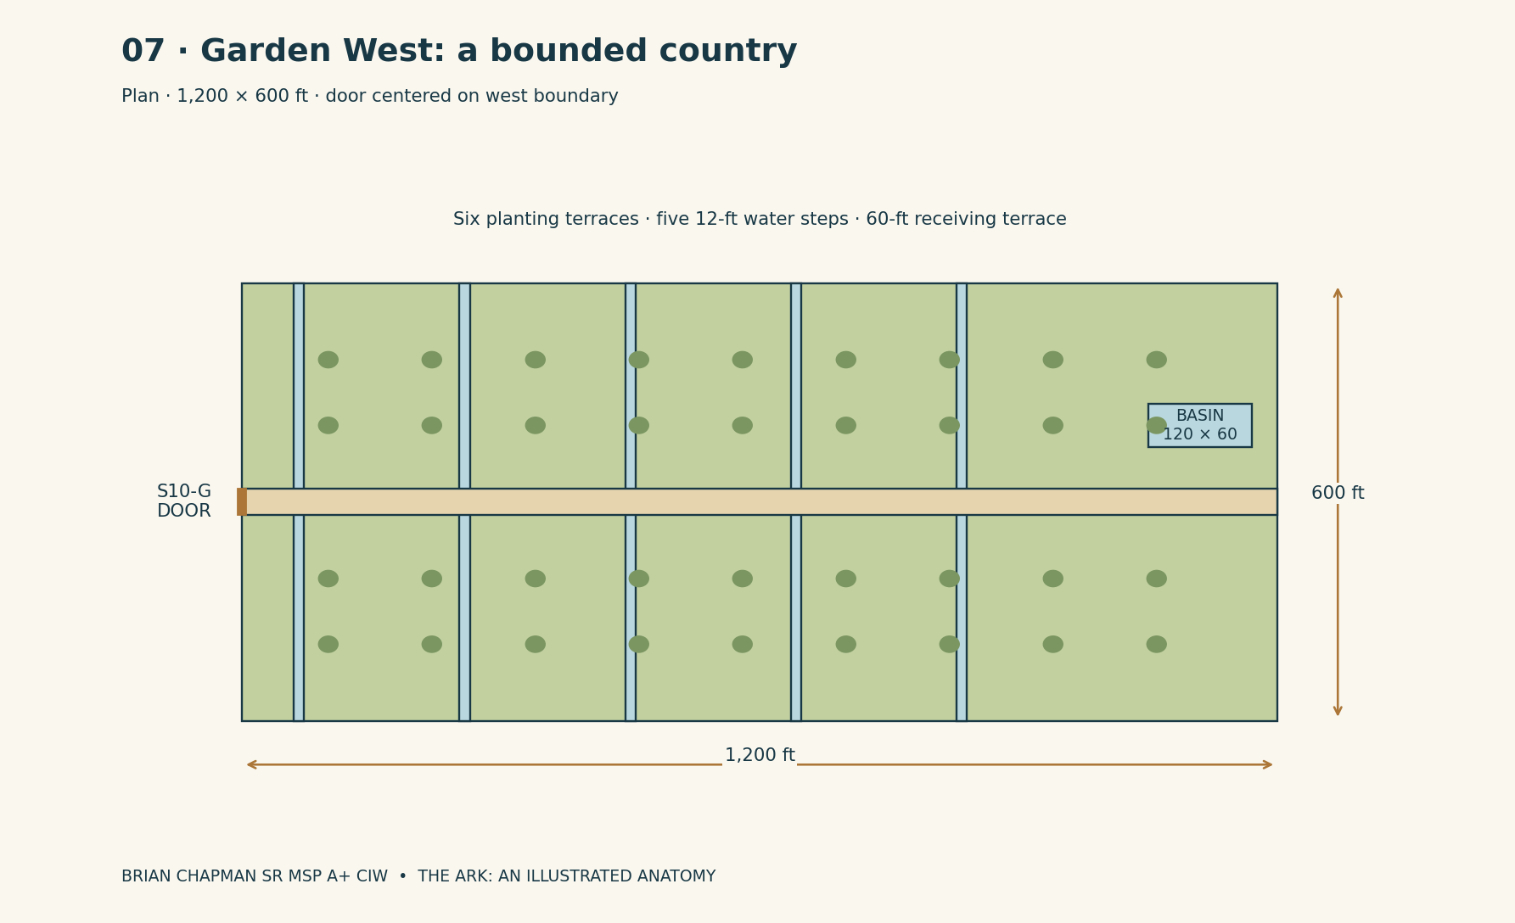
BRIAN CHAPMAN SR MSP A+ CIW

14 | The harbor beyond a household door
The Harbor Annex opens from S20-C through the standard 12-by-10-foot doorway. This doorway admits people and modest cargo. It does not admit a 60-foot-wide ship. The harbor’s large craft are assembled in its own yards or reach it through separately registered large berths on the annex’s far wall. The distinction prevents an attractive picture of a huge vessel from quietly changing the size of a door shown earlier beside Lazara.
Inside the receiving building, the floor widens to a 36-by-60-foot hall. Low windows face the water. Their sills are 3 feet above the floor, so seated adults can see across the near quay. A double door 12 feet wide opens from the hall onto a paved apron. Beyond it, the harbor basin is 1,800 feet long and 900 feet wide. The apron extends 60 feet between the receiving building and the water edge, except at the two planted rain courts where the building recesses by another 24 feet.
Three finger piers project 240 feet into the basin from its south quay. Each is 24 feet wide, with its walking center kept clear. Their ends carry squat lamps rather than theatrical towers. The first pier serves small local boats; the second serves service craft; the third is for arrivals from a registered outer berth. Along the opposite quay, yard sheds have 30-foot-wide doors and 36-foot clear work bays. Their roof ridges rise 48 feet above the quay. The difference in scale is visible across the water.
The basin’s central dredged channel is 24 feet deep in the design record, while the near visitor edge has a separate shallow shelf behind a barrier. These are fictional working dimensions, not navigational advice. Water color changes from green-gray at the shelf to nearly black over the channel. Mooring lines tremble against their fittings. Sounds carry across the basin: a wooden latch struck on a resonant post at the far quay can arrive more clearly than a quiet voice from the room behind the receiving hall.
The annex’s north boundary holds the two large transfer berths, each 120 feet wide and 72 feet high. They open to identified carrier docks, never to an unnamed sea. A carrier too large for this envelope must dock outside and send a smaller tender. The Ark’s original hull remains a local entrance behind the small receiving door. From the basin, one cannot look down an enormous tunnel and see the biblical ship stretched around the water like a wooden warehouse.

Measured plate · Harbor South
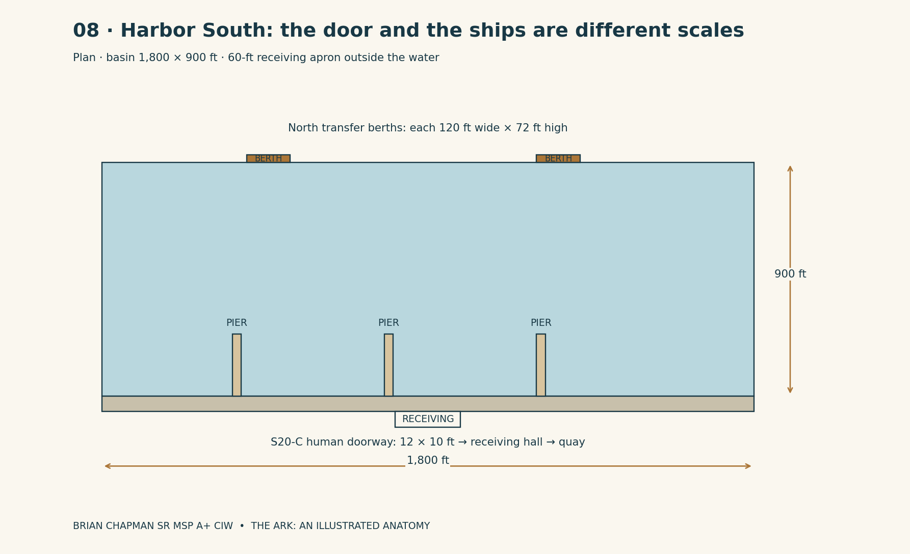
BRIAN CHAPMAN SR MSP A+ CIW

15 | Tenth-dimensional registry: the destinations stay put
Where D7 extends the size of a connected place, D10 names the system that keeps separated places from exchanging identities. It is fictional registry architecture. Each live connection carries four labels: source address, destination address, local time record, and return address. The labels can be read beside the door. The mechanism does not require a character to understand an equation before knowing whether the far room is the room she intended to enter.
The metal-free registry room occupies S21-L. Its route panels use wooden address shutters and nonmetallic light elements; ordinary electronic control equipment remains at external channel houses. It is 24 feet long across the station’s transverse room direction and 18 feet deep from its entry, with a 10-foot-6-inch clear ceiling. Along its far wall, twelve inset panels show routes as paired address plates. Their light is steady in normal operation. A route that is shut is represented by a dark panel with its name still readable. The absence of light is not a deletion from history.
A polished timber rail divides the visitor standing zone from the operator benches. The rail is 3 feet 6 inches high. Beyond it are two desks, each 8 feet long, facing the address wall. At the room’s west end, a separate log cabinet records a route’s state without depending on the luminous display. Labels are copied onto paper and retained. The fantasy is large; the room in which people take responsibility for it is small enough to sweep.
A route is never an unqualified statement that a door goes “to yesterday.” The record specifies which branch of the story world is connected and what its local clock reports. An archive channel can deliver a document without establishing that a person can cross. A recorded voice is not identified as a living speaker merely because it sounds familiar. A different person cannot be substituted for a missing one by changing the inscription on a room. These are continuity rules as well as operating rules.
D10 does not grant resurrection, unlimited retrospective repair, or a way to walk into every dream described by a character. If an earlier book contains an unexplained temporal event, that event must receive a particular registered route before it appears on the atlas map. An unverified rumor remains outside the diagram. This restriction makes the geography more powerful: when a door opens to a real inhabited room, the reader knows its floor will still be there in the next chapter.

Measured plate · Space and route identity
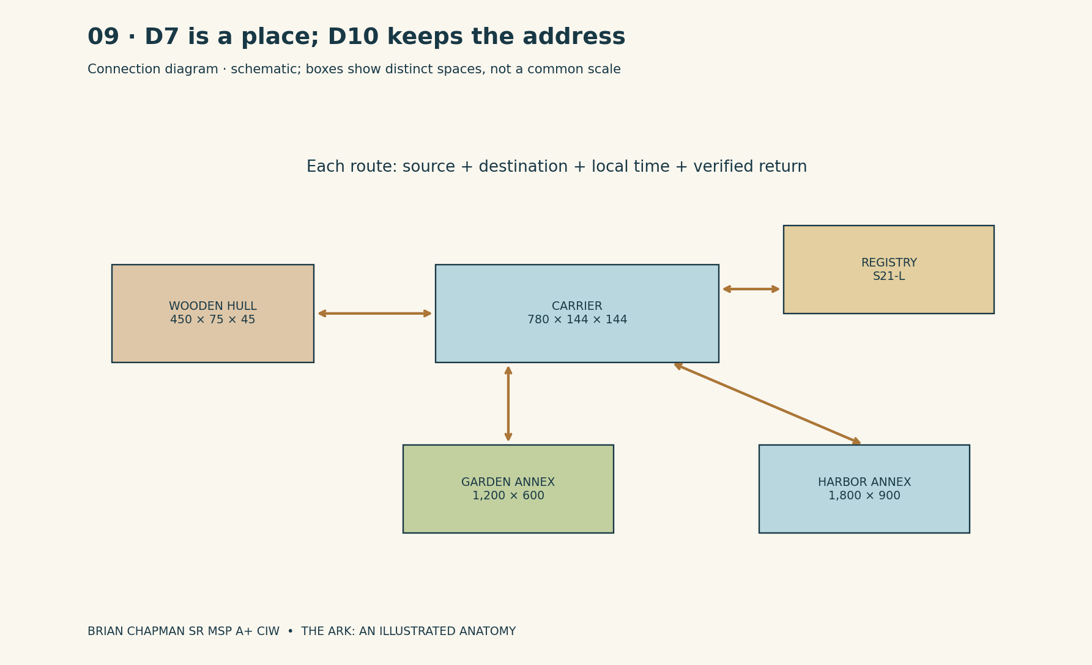
BRIAN CHAPMAN SR MSP A+ CIW

16 | Light, water, air, and the rooms behind the rooms
The inhabited decks have a daily cycle recorded by local clocks. The spine is never completely dark: ankle-level route lights remain visible below the larger ceiling panels. Household rooms can be darkened independently. A corridor’s night state therefore looks like a long line of low amber marks passing beneath shut domestic doors. It does not look like every family being ordered to sleep beneath the same white laboratory ceiling.
Clean water enters the occupied system through isolated reservoirs on Deck K. The main reservoir group is distributed beneath S05 through S08, rather than concentrated beneath one family’s room. Deck K has a 12-foot pitch like the other lower decks; low tanks fit beneath access walkways and do not fill a whole 144-foot-high cross-section. The water schedule uses 900 occupants as the carrier’s nominal residential planning population, with a narrative budget of 20 gallons per person per day. That gives 18,000 gallons per day and 126,000 gallons for seven days before reserves, losses, or special care are considered. It is a story allowance, not a real emergency standard.
Wastewater occupies a physically different service route. On a cross-section, clean-water pipe supports are light-colored and the waste route is marked dark green. The drawing does not permit a waste line to disappear into the same dimensional seam that supplies drinking water. Treatment, storage, and inspection continue when the main door closes. A visitor on Deck C does not see these pipes, but a service corridor shows their route above accessible panels and beside numbered valves.
Air moves through local occupied zones before returning to plant rooms. Gardens are not assumed to provide all breathing air merely because leaves are visible. Kitchen exhaust has a separate nonmetallic captured route. Clinic rooms can be isolated from the household return. Heat-producing equipment has a path to a bounded heat-rejection system, represented by service panels along the upper unoccupied volume. There is no unmentioned magical “somewhere” that accepts every waste product forever.
The recurring blue line separates household services from boundary equipment. It appears on the Keel plan, at the service-room door, and in the registry drawings. A boundary failure can close travel without cutting a drinking-water pipe. A kitchen fault can stop cooking without forcing a giant contact channel open. Mechanical rooms are arranged so that the story can give a particular failure a particular consequence rather than treating every flickering lamp as the imminent death of the entire universe.

Measured plate · Separate service systems
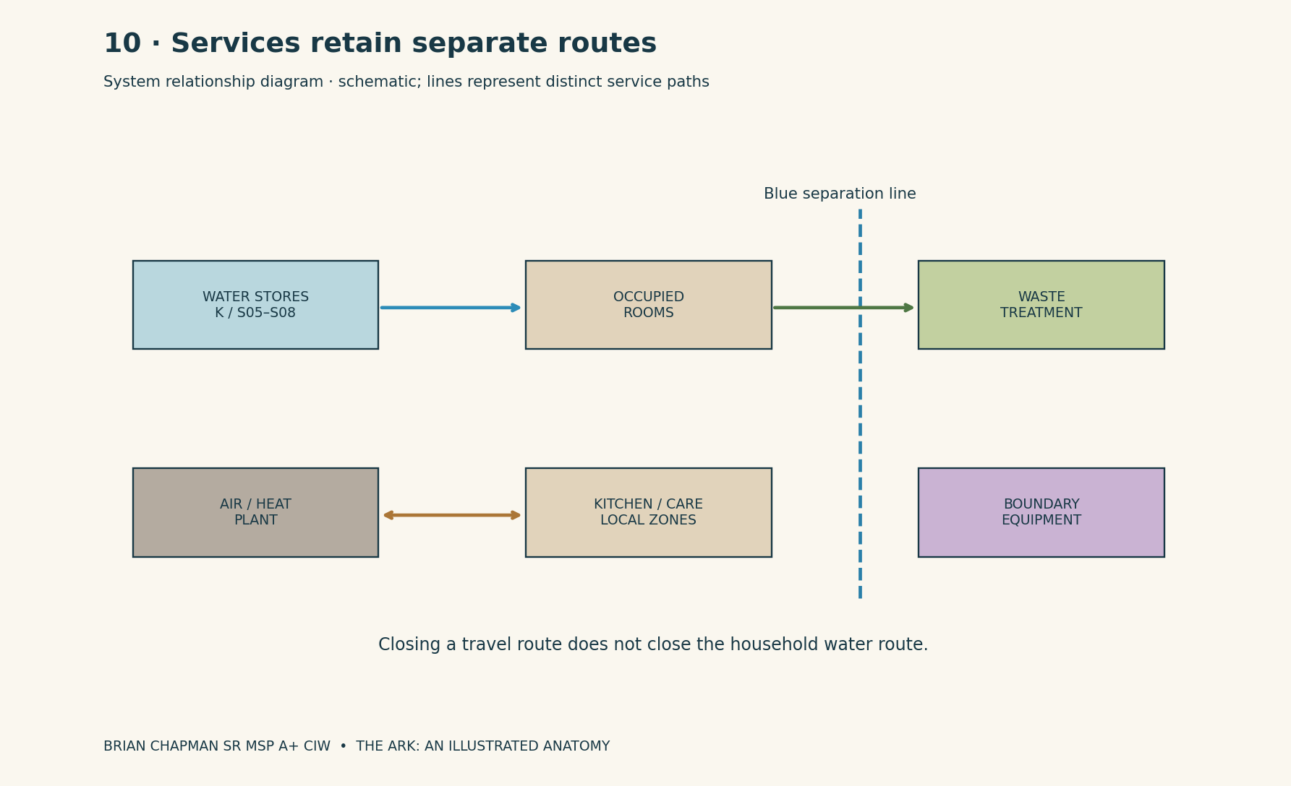
BRIAN CHAPMAN SR MSP A+ CIW

CAD study 51 Power and compute floors
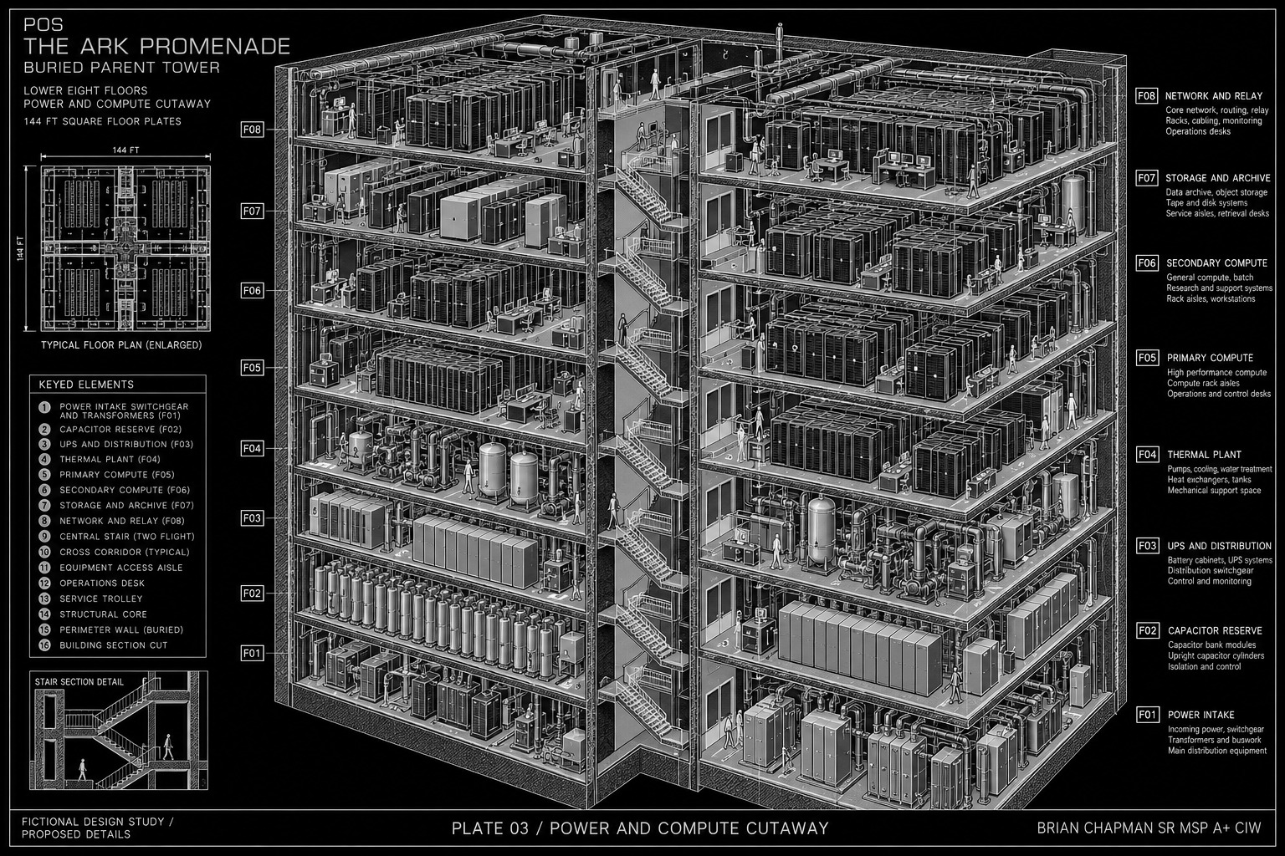
BRIAN CHAPMAN SR MSP A+ CIW
Concept study. Written dimensions, floor names and nonmetallic Ark construction rules in the atlas govern.

17 | The world before the stone
Genesis 6:4 — “There were giants in the earth in those days; and also after that, when the sons of God came in unto the daughters of men, and they bare children to them, the same became mighty men which were of old, men of renown.”
The atlas’s giants are an extravagant fictional development around the verse’s image. Their mountain-sized bodies, mineral transformation, dimensional organs, and relationship to the carrier network are the invention of the stories. Their post-destruction anatomy must nevertheless remain consistent from plate to plate. The Genesis quotation is a literary anchor for giants, not a claim that the verse describes this invented enlargement mechanism. A hand cannot be a three-day country in one drawing and a room-sized sculpture in the next unless the drawing identifies two different individuals or two different projection scales.
Before the destruction, the people later recognized as mountain bodies were ordinary-sized human beings. The time-plate rupture enlarged their boundary-linked bodies, changed them into colossal mineral forms, and cast them down across the terrain. The resulting posture is the shape the mountain takes. The person now called Him-a-Lan lies along a 72-mile body axis. His head is at the western end of the principal survey; his feet are toward the east. The left arm bends southward, and the left hand occupies an approximately 8-mile district outside the shoulder-to-foot axis. The districts called Himland in the pilgrimage story lie across parts of that hand and wrist. “Himland” is the inhabitants’ country name in this fictional setting; “Him-a-Lan” is the elder’s recorded personal name. Neither name is presented as the real etymology of the Himalayas.
Before the rupture, Him-a-Lan stands approximately 6 feet high. His hand can close around an ordinary cup. His wrist is a wrist, with folds measured in fractions of an inch, not a country. The transformation does not merely coat that unchanged person with a mountain of rubble: the timing failure unfolds the connected body into an enormously expanded physical volume. Its outer form retains the relationships of head, hand, limbs, and torso, while the expansion and mineral arrest make its original human scale irrecoverable. Farms and settlements arrive much later, after the body has fallen, its surface has consolidated, and ground cover has accumulated.
Him-a-Lan’s scale differs from the still-mobile Avar. Her standing height is registered here as 22,000 feet; Sereth’s is 1,800 feet. Their different sizes record different exposures to the rupture. They are not a naturally mountain-sized species and the difference is not a normal growth sequence. These incompletely arrested survivors remain mobile because part of their living state persists across a delayed time boundary. Their continued life is another fantastic consequence of the same disaster, while Him-a-Lan is chiefly a mineralized mountain body. Avar can stand beyond a mountain valley and create weather-sized disturbances. Sereth can move through a giant’s large internal opening, but neither can step through the Ark’s standard human doorway.
The principal ranges in this fantasy world are the vast petrified giant bodies exposed and reshaped beneath later cover. The elder’s eyes are not open lakes full of ordinary human emotion. On the exposed west face, an eye region is a long closed stone contour. A snowfield catches in the upper fold. Only when a map gives the observer an orientation does the ridge become legible as a lid. At ground level a traveler sees a hard weathered wall. The atlas’s cutaway restores the whole figure to the reader while preserving the characters’ limited view from the road.

Measured plate · Him-a-Lan regional locator
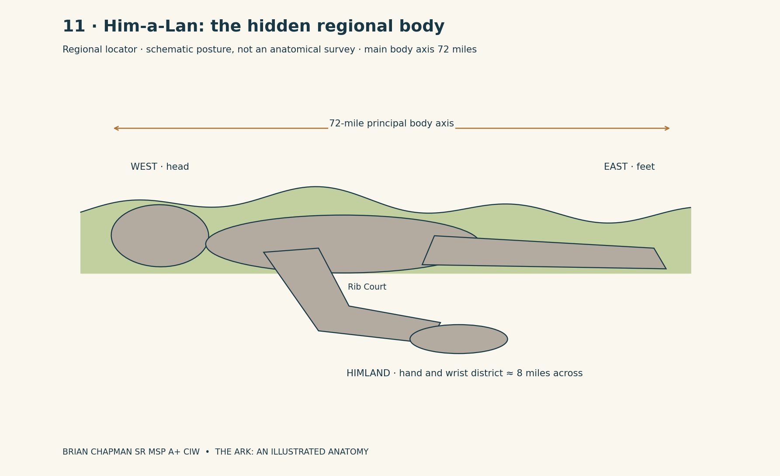
BRIAN CHAPMAN SR MSP A+ CIW

18 | The time plate beneath the world
In the revised fictional history, the mountain giants are the bodies caught in a time-plate rupture. The rupture, not a slow ordinary chemical accident, is the initiating cause of their petrification. The Amalgamation names the resulting union of living giant matter with mineral structure when adjacent parts of a body no longer occupy the same moment. The principal mountain ranges on this fantasy world's map have giant body cores; soil, broken stone, transported sediment, and subsequent terrain conceal their outlines.
A time plate is not a tectonic plate with a new name. In this setting it is an engineered timing surface beneath the ancient transit network. It keeps joined spaces at a shared local present while ships cross their transfer lanes. Its visible structure resembles a low, black crystalline pavement under the pyramid complex. Narrow white seams divide it into panels 120 feet long and 60 feet wide. Each panel is 6 feet thick. Beneath it, a 24-foot-deep inspection void carries suspended timing conductors on bronze-colored frames.
Six ancient magnetic regulating nodes stand along the main underground spine. Each node is a cylindrical chamber 180 feet in diameter and 120 feet high. An annular gallery 12 feet wide circles its inner wall at three levels, 36 feet apart. The central instrument is not a clock with hands. It is an upright translucent ring, 96 feet across, whose moving edges appear as several nearly coincident circles. When the system is aligned, those circles lie upon one another. When the timing separates, a person can see two edges belonging to the same ring.
The mechanical distinction is between position and moment. A ship can be in the correct lane and still be catastrophically wrong in time. The complex's record shows its receiving hall answering seven seconds behind the outbound hall during the terminal rupture. The seven-second offset is a fictional event value, not a general property of higher dimensions. In a corridor, the first symptom looks like a doorway showing the room as it was a moment earlier. Dust falls twice in the same view. A hanging chain occupies two slightly different curves.
When the rupture reaches the giants' boundary-linked tissue, the living parts lose their shared timing with the immense mineral-support lattice. Some areas cease to move while neighboring areas remain alive. As the ordinary people expand, their increasingly mineralized forms acquire an overwhelming physical weight. The rupture throws or collapses them across the terrain; they do not calmly select mountain-shaped beds. Their later forms preserve the attitudes of the fall: a turned face, a bracing palm, a bent arm around a protected inner space. These are the architectural consequences of the timing disaster, not random mountain shapes retrospectively given names.
A human-size-before / mountain-size-after scale strip accompanies the plate sequence. It is a discontinuous transformation: the two silhouettes are not drawn on one misleading common ruler. The plate rupture therefore has a geographical map. The buried time network marks the deepest line. Above it are the complex's constructed rooms. Farther out are the giants whose linked spaces share its reference. The rupture travels through those joins without making every nearby human body mineralize. The affected system has a defined connection, not an unexplained contagious curse. The later Ark network uses isolated local references precisely because one broken timing surface must never again become the clock for an entire inhabited world.

Measured plate · The time plate and six regulating nodes
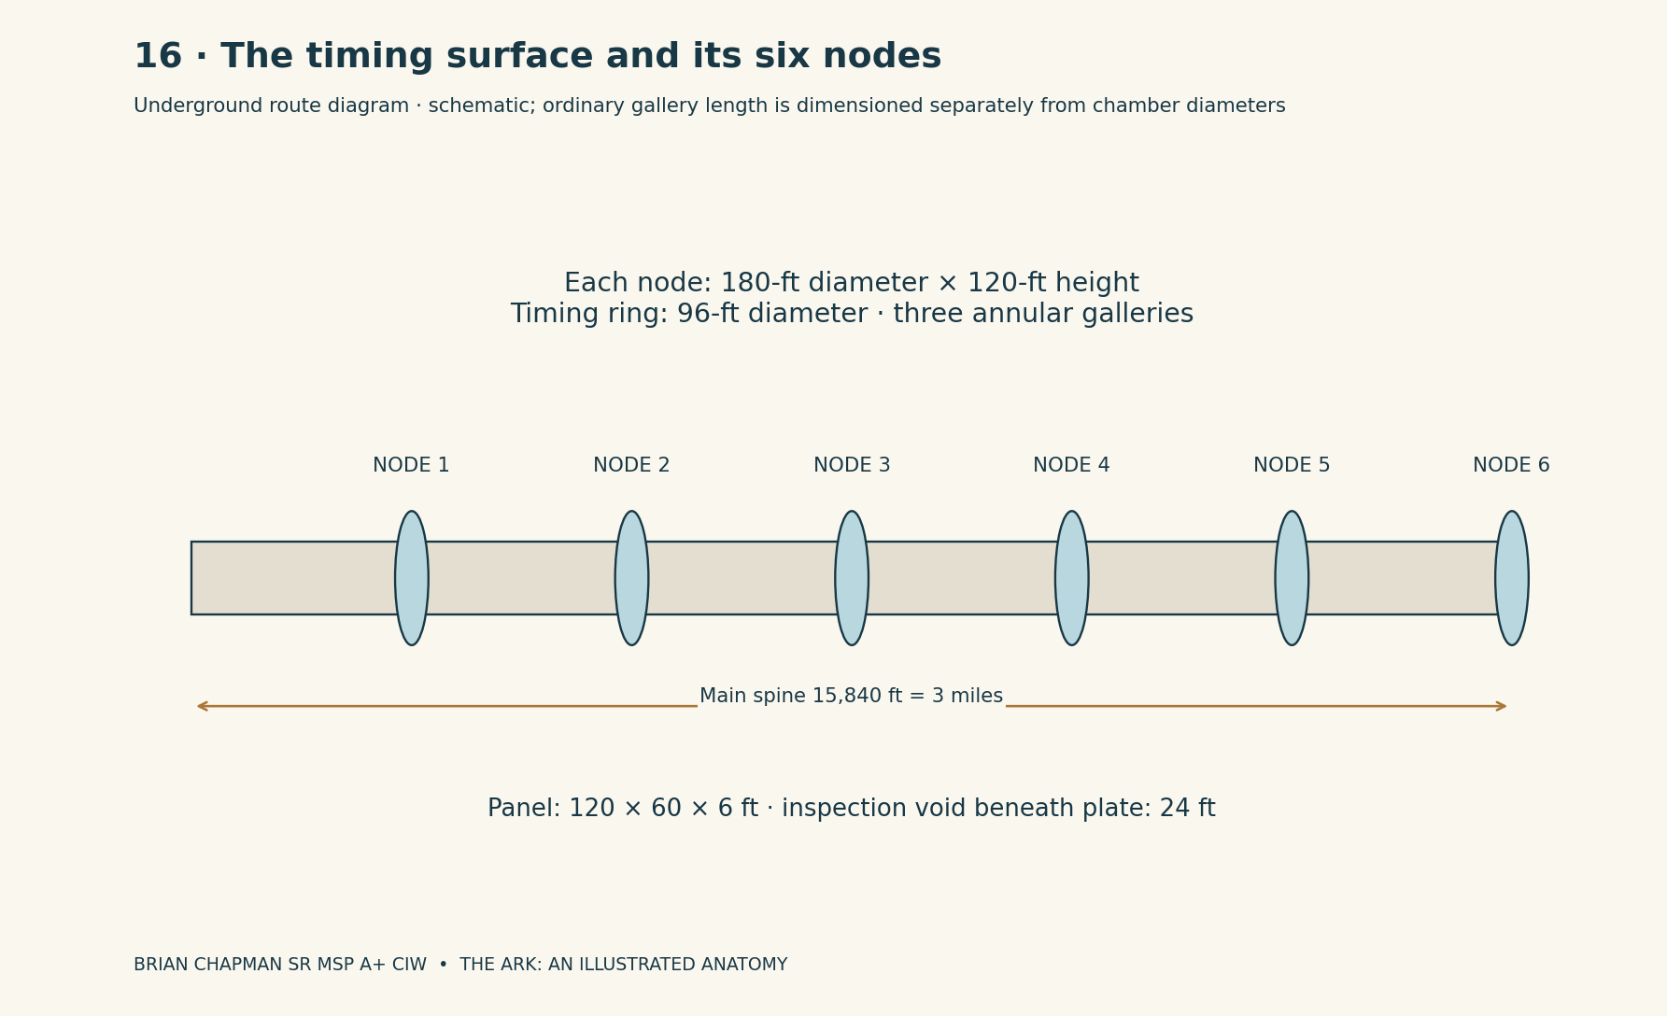
BRIAN CHAPMAN SR MSP A+ CIW

19 | The pyramid complex and its six buried miles
The Pyramid Complex is the ancient anchor installation of this fictional network. It is not an archaeological claim about a real Egyptian monument or an endorsement of recent reports about hidden structures. Its modern rediscovery belongs to the story's survey chronology. The fieldbook's earlier displaced pyramid and the later discovery of understructure are related evidence in this invented world; the complete underground plan drawn here is the atlas's new canonical design.
The main pyramid occupies a square 900 feet on each side and rises 600 feet above its original court. Its exterior is pale mineral stone veined with dark glass. Four triangular faces meet at a cap whose lower edges are interrupted by narrow bronze-colored slots. At sunrise the slots appear black; at night a residual timing field sometimes gives them a faint violet edge. Broad stairs and terrace landings belong to the human-scale base precinct. They do not climb the entire slope as one ceremonial flight.
A 2,400-by-1,200-foot ship apron lies east of the pyramid. Three cradle bays occupy the apron’s north side. Each is 420 feet long, 180 feet wide, and 120 feet clear beneath its gantry. The largest common transit ship in this register is 360 feet long, 96 feet wide, and 72 feet high. It can enter a cradle without changing size. Those bays are neither the Ark's human doorway nor the small receiving hall at the later harbor. Separate scales are given separate outlines.
Beneath the pyramid, the receiving-and-Ark dock chamber is 600 feet long and 180 feet wide, with 96 feet of clear height above its quays. Its water level lies 144 feet below the old court datum; quay floors are 6 feet above the water and the basin floor 36 feet below it. Four piers, each 24 feet square, support an independent inner structure. Between them, a central opening descends toward the timing galleries. The main inspection shaft is 60 feet in diameter. A protected human lift and a separate stair occupy two constructed recesses along its side. Its lowest ordinary landing lies 900 feet below the court.
The lower network has exactly six miles of principal measured route in this edition: a 3-mile main spine and two branches of 2 miles and 1 mile. This is 31,680 feet of route, not six miles in every direction and not six miles of uninterrupted open hall. The ordinary galleries are 36 feet wide and 24 feet high. At intervals of 2,640 feet along the main spine stand the six 180-foot timing-node chambers. Galleries carry local passing bays and isolated inspection rooms; chambers are wider volumes with their own dimensions.
On the modern rediscovery plate, the east apron is rubble. The main pyramid has lost portions of its outer skin. An exposed stair leads down through a collapsed upper receiving room, where daylight reaches only the first landing. Below that, survey lights pick out bronze conductors, black plate panels, and the rims of shafts. The current-condition sheet distinguishes the broken 552-foot summit from the original 600-foot cap height. A discovered opening is not labeled an explored mile. The map distinguishes measured route, remotely imaged route, collapsed route, and the surviving local timing node. The extraordinary country remains something that has to be surveyed a foot at a time.

Measured plate · The pyramid complex and underground routes
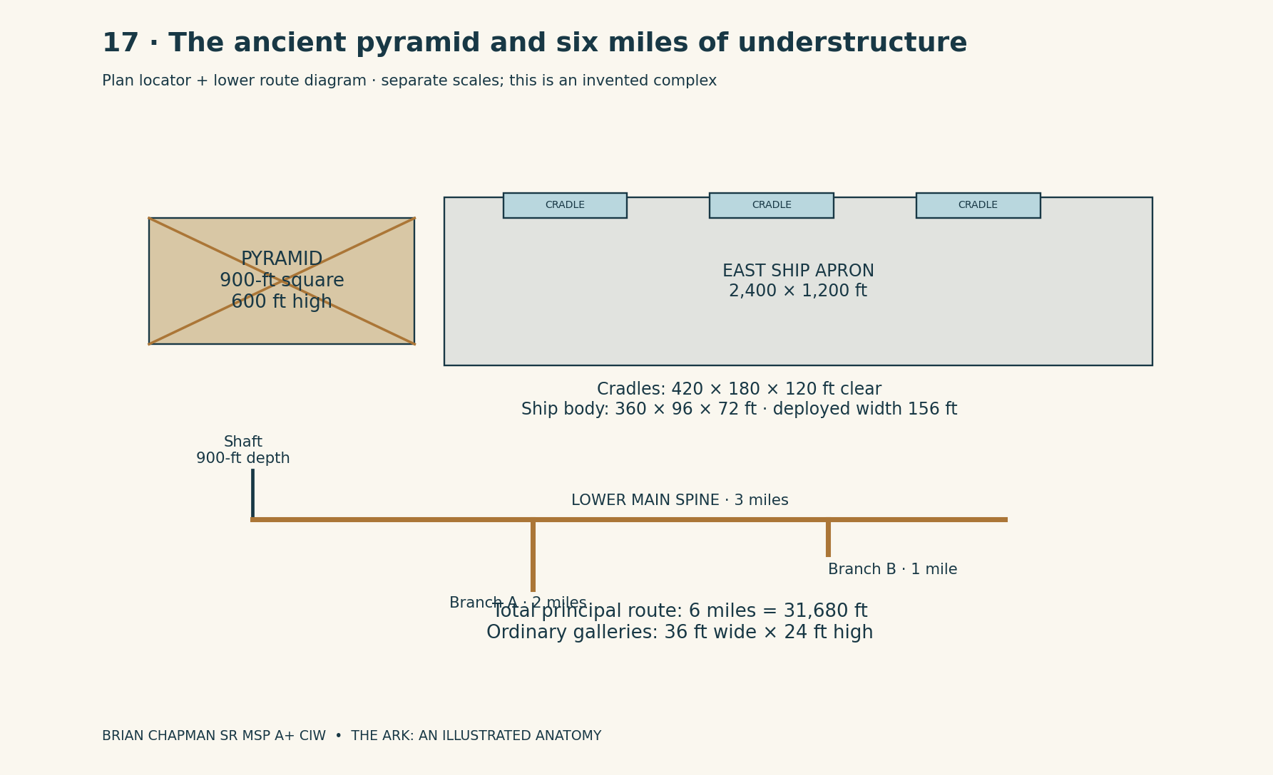
BRIAN CHAPMAN SR MSP A+ CIW

At rediscovery: what remains, what is reached, what is only mapped
The current-condition survey is the controlling view for later chapters. It does not show the original installation restored because a new character has arrived. The present pyramid retains its 900-foot base outline, but only three long portions of the original pale casing remain intact: a west-face band between 180 and 270 feet above the old court, a lower north-face panel, and a narrow southeast corner strip. Elsewhere, rougher inner courses stand exposed. The cap is absent. A dark socket 48 feet square marks its last complete support platform, 552 feet above the old court. The original 600-foot profile is drawn as a dashed ghost outline above the broken summit.
A 24-foot-wide diagonal scar crosses the east face from the upper third toward the base. It is an impact-and-failure scar in the fictional record, not a hidden doorway enlarged for the picture. Within it, black glassy bands interrupt pale broken stone. Windblown sand fills the lowest recesses. After the season's rain, shallow pools form on the collapsed apron and leave pale silt rings when they dry. The current monument consequently changes color with weather, while its damaged geometry remains the same.
Of the three original north-side cradle bays, the western bay has lost its roof and two gantry frames. The center bay retains one tilted ring-shaped support. The eastern bay is buried to a depth of 36 feet beneath slab fragments and later sediment, except where the latest survey has opened a narrow observation cut. Ship A's main keel fragment is 210 feet long. It lies diagonally across the ruined western bay, its former window band turned downward. This is not an intact 360-foot vessel waiting to be flown away. Ship B's stern ring stands half-buried south of the court. Ship C's remnant is mapped only within its fractured transfer chamber; its missing length is not drawn as recovered wreckage.
The upper receiving chamber has an open roof wound 120 by 90 feet. Sunlight reaches its floor at the correct angle for part of the day, illuminating one surviving 24-foot-square pier and the broken edge of a second. Two other piers remain partly embedded in collapse fill. A descent route has been established along a separately surveyed edge. The original central opening is visible but not treated as a usable public stair. Modern survey railings, cables, and lamps are drawn as additions of a different color from the ancient installation.
At the 900-foot level, the first 2,640-foot main-spine segment is physically traversed in the current record. The next segment is partly imaged through an offset bore. Between Nodes 2 and 3, a collapse interrupts the ordinary gallery. Node 3 has a flooded lower annulus, with water 18 feet above its original floor. Node 4 is dry but isolated behind damaged timing conductors. Node 5 returns an intermittent local pulse without an open human route. Node 6 has been located by the fictional remote survey, but its chamber has not been entered. The entire 3-mile spine therefore has a registered design, while only named portions have a confirmed present walking route.
The 2-mile branch retains its first 900 feet as a dry stepped gallery, after which a displaced wall masks the next turn. The 1-mile branch has a surviving roof for 1,320 feet, then a debris plug. A plan's line can continue beyond both obstructions because the ancient design record and the fictional remote imaging supply a route hypothesis; a separate dashed convention shows that this is not a visitor's claim to have walked every foot. The word “discovered” does not mean undamaged, safe, powered, or fully explored.
Later chapters retain these same conditions. The Amalgamation chapter refers to the broken shared timing system, not a running master machine. The mountain-burial chapter shows later cover above the original disaster surfaces. The channel-house chapter places new equipment at a mapped surviving node, not in an intact ancient control room secretly ignored by the survey. The final continuity ledger records a change only when an actual event in the fictional survey alters it: water is lowered, debris is removed, a route is tested, or a local contact is lost. A dramatic light in a chamber cannot restore its roof between paragraphs.

Measured plate · The complex at rediscovery
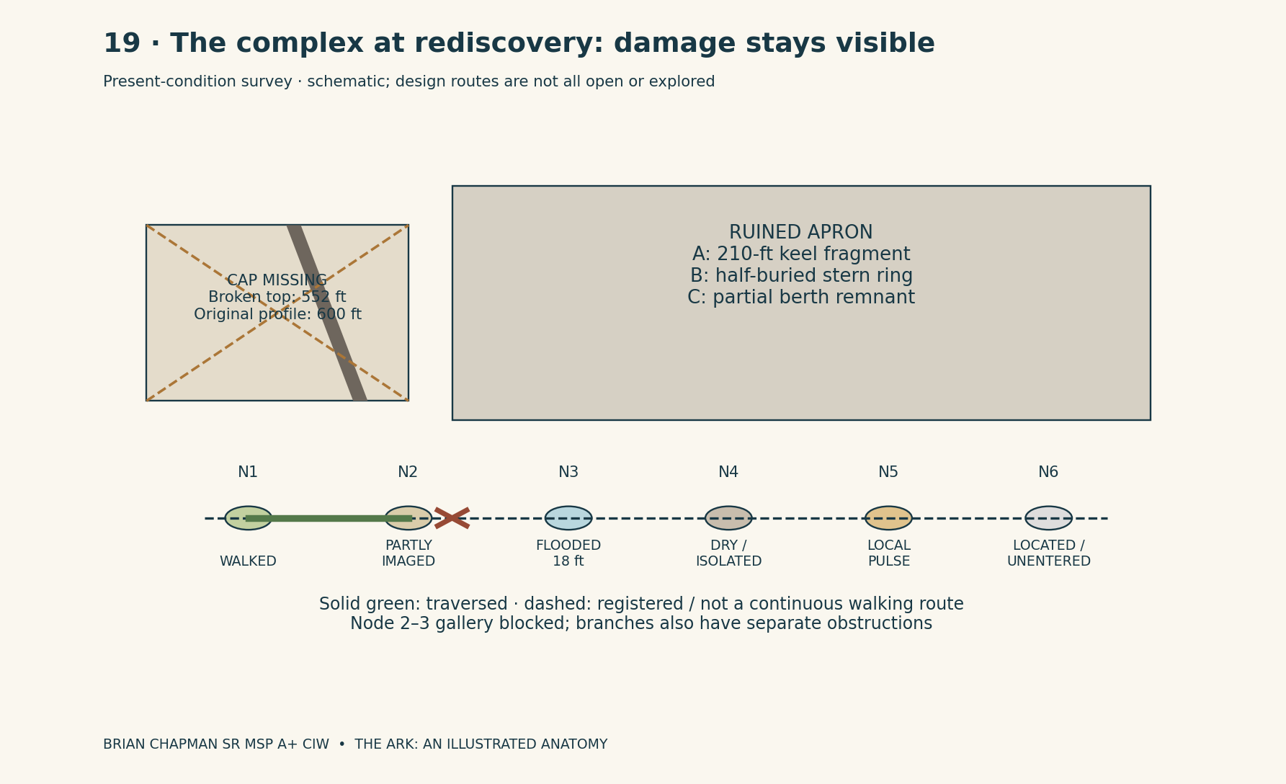
BRIAN CHAPMAN SR MSP A+ CIW

CAD study 54 Arrival court and walkable access
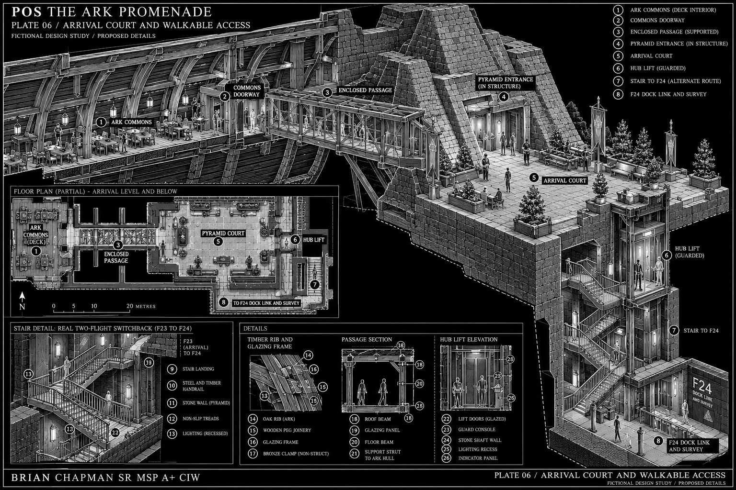
BRIAN CHAPMAN SR MSP A+ CIW
Concept study. Written dimensions, floor names and nonmetallic Ark construction rules in the atlas govern.

20 | The magnetic storm, the ships, and Noah's warning
The complex's final day is fixed by a timing failure during a magnetic storm. In the fantasy account, Noah sees the storm coming before the ship operators agree to close their lanes. This scene belongs to the invented continuation around Genesis, not to a quotation claiming that the Bible describes spacecraft or magnetic instruments. His biblical warning of the Flood remains its own foundation. The atlas adds an ancient technological catastrophe within that larger world of approaching destruction.
The storm is visible first as moving sheets of violet and copper light beyond the higher cloud. It affects the transit ships' magnetic guidance vanes and the complex's timing-reference equipment. These are two related failures: a craft can lose control in ordinary sky, while a ship crossing a dimensional berth can also lose synchronization with its receiving space. The story does not require magnetism by itself to turn flesh to stone. The damaged time system connects the storm to the rupture and the rupture to the giants.
The transit ship’s lower hull is a long dark keel with a pale, faceted upper shell. Four guidance vanes extend 30 feet beyond each side in landing configuration, increasing the 96-foot body beam to a 156-foot deployed width. The outer cradle is 180 feet wide, so its register can receive the deployed craft. A line of small amber windows runs above the keel. At the stern, three ring frames hold the fictional drive field. They are open structures, not flaming rocket nozzles, and their offset ellipses give a grounded ship a recognizable silhouette.
The crash sheet records three different wreck positions. Ship A reaches the east apron at a steep angle and strikes the first cradle. Its 360-foot hull breaks across the apron, where the debris field extends 900 feet. Ship B falls beyond the southern court, carving a 720-foot scar into the surface before the aft ring tears free. Ship C is caught at the large transfer berth: the receiving room and the hull disagree in timing, and only its forward portion remains in the local chamber. Each wreck is plotted; “ships crashed” does not become a decorative cloud covering an otherwise undamaged plan.
The first impact ruptures the fictional field-energy stores beside the north cradle. The release destroys the apron gantries and breaches the upper receiving structure. The reference network tries to hold its remote joins while its own nodes answer at different moments. That is the time-plate rupture. Shock damage collapses parts of the underground galleries; the timing break arrests connected giant tissue far beyond the visible blast. Later Flood deposits and subsequent cover conceal the wrecks, the understructure, and the fallen, enlarged stone people by different processes.
Noah's observation point is a rock platform outside the failing installation's controlled boundary. Its little instrument shelter measures 18 by 12 feet. Its open side faces the storm horizon; its rear wall holds a reference pendulum and a receiver that repeats the timing pulse. In the atlas, his figure stands beside the shelter, not inside the crashing complex. The Ark prototype is represented on a separate distant locator, preserving its 450-foot wooden hull and its passive connection to the parent building. Noah's foresight is expressed by the early warning, the separation of refuge from the failing network, and the decision to close a route before the operators can agree that the danger is real.
The modern understructure survey thus discovers consequences, not a working ancient promise. Some conduits are severed, some nodes retain local response, and some ship fragments are locked across incompatible time records. The later carrier builders inherit the wooden craft rule as well as an architecture: no metal frame, fastener, wiring, magnetic latch, or hidden drive enters the Ark domain; isolate every route, keep household systems independent, and never let an impressive destination erase the need for an accurate return. The exotic disaster becomes the reason the Ark's later doors are carefully measured and named.

Measured plate · Magnetic storm and the three wreck positions
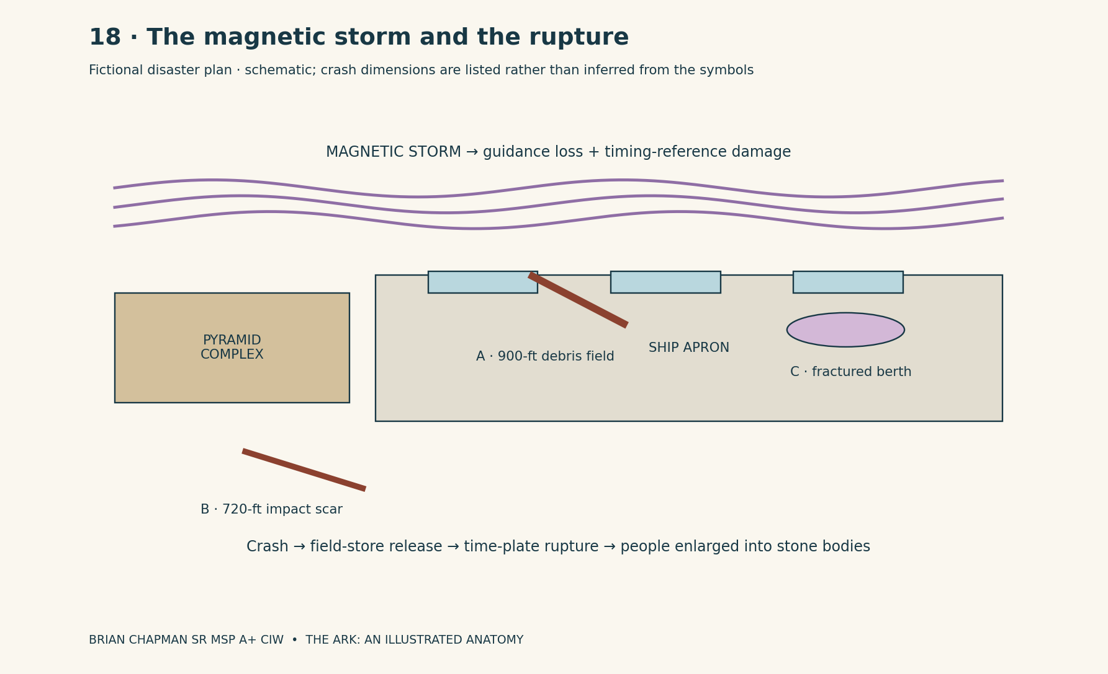
BRIAN CHAPMAN SR MSP A+ CIW

21 | The Amalgamation and the laying down
Within this fiction, the Amalgamation is the mineral arrest caused by the time-plate rupture. The magnetic storm crashes the ancient transit ships and damages the pyramid complex’s shared timing system; bodies linked to that system lose synchronization with their own mineral-support lattice. It is not a biblical term and it is not a known geological event. Its purpose in the atlas is to connect three previously scattered images: enormous bodies, habitable inner cavities, and landscapes whose anatomy can no longer be read from their surface.
The process begins with ordinary-sized people inside the affected network. The rupture unfolds each linked body into a vastly enlarged three-dimensional form while its living structure is arrested into mineral matter. Expansion, throwing or collapse, and petrification are overlapping parts of the same destruction. They are not three ordinary biological processes. Local timing offsets leave portions of some bodies active, which is why a few gigantic survivors can remain living within the later stories. In the plate sequence, a pale inner web spreads through the limbs first. Darker channels survive around selected cavities. The body is neither a complete skeleton nor a human-shaped hollow shell. Much of its volume becomes continuous mineral mass.
Him-a-Lan’s expansion carries him above the terrain before his immense stone weight pulls him down. One knee strikes the basin first. The far hand is driven against a ridge. The torso turns during the collapse, leaving the face partly sideways rather than flat against the ground. His bent arm creates a protected inner space beside the ribs. At the final resting angle, the spine slopes gently eastward rather than lying on a perfectly level floor. The silhouette looks like a mountain range that has fallen onto its side because, in this fantasy, that is the bodily shape the destruction has left. This posture later governs where drainage gathers and where the human road can follow a shoulder without crossing an impossible sheer wall.
The earth receives a mass too large for the human eye to interpret as one event. The atlas shows the stages at a regional scale: displaced water at the basin edge, fractured ground around the bracing palm, and the high arch left beneath the inner arm. The enlarged stone body strikes pre-existing terrain and then becomes the core of a new mountain relief. It is not fitted neatly to the outline of an already finished modern range. Surrounding ordinary ground still exists, with its own ridges and basins.
At the pyramid complex’s present survey date, the broken summit, the three separate wreck sites, the flooded third node, and the blocked galleries remain in the conditions recorded in the pyramid-complex chapter. The transformation of the mountain bodies does not repair that ancient destruction. The remaining inner cavities are protected pockets within this mineralized volume. They are not every blood vessel or every cell preserved as a walkable tunnel. Some are spacious enough to hold settlements; some end in solid material after a few hundred feet. Where a boundary pocket survives, its interior distance can exceed the opening’s ordinary depth. Such a pocket receives a D7 address. A mapped stone passage without that designation obeys the distance and scale shown on its survey.
The stories can therefore contain both a petrified elder and traces of continuing response. A surviving boundary channel can carry a mediated signal from tissue or an adjacent linked space. That does not make every mountain a conscious speaker. The atlas marks active, dormant, and untested regions separately. A closed eyelid contour remains stone on a road map even when a relay far inside the body reports a particular translated phrase.

Measured plate · The four-stage Amalgamation
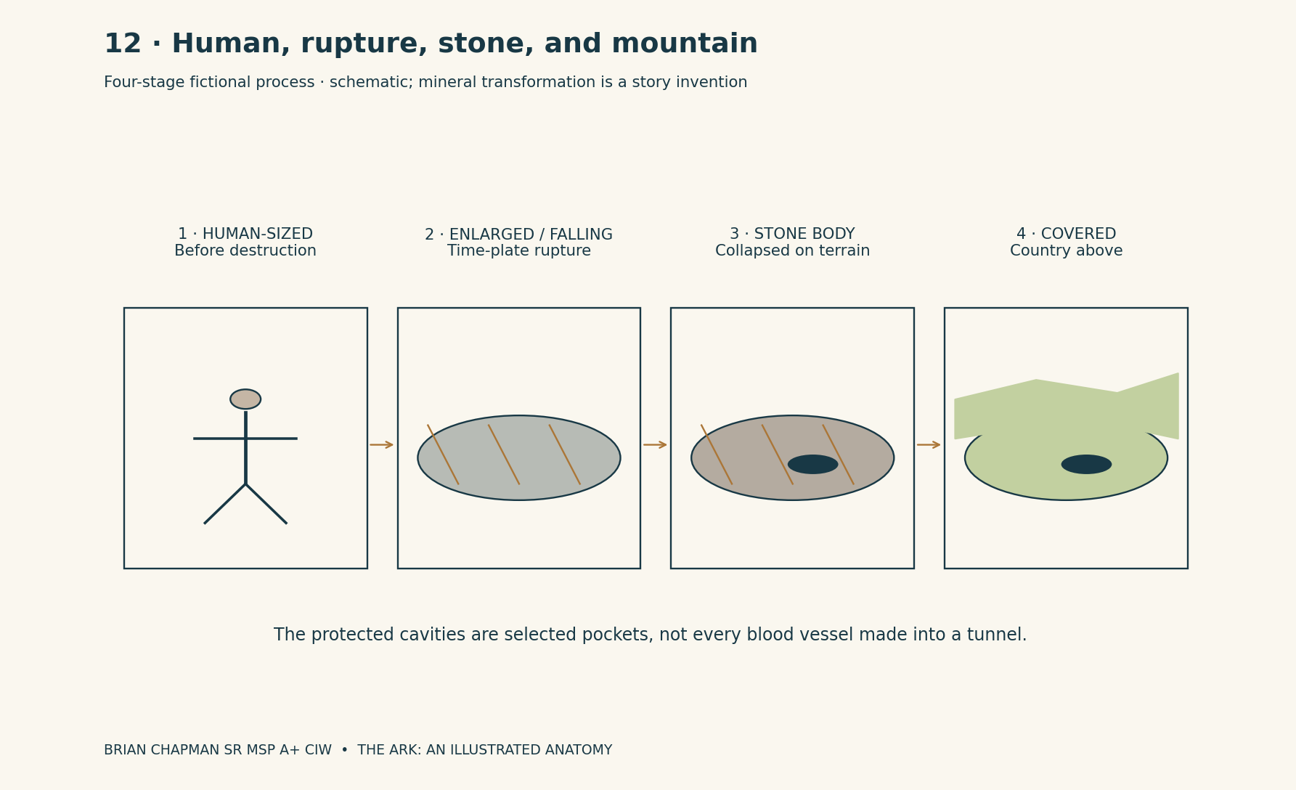
BRIAN CHAPMAN SR MSP A+ CIW

22 | How a body becomes an unrecognizable mountain
Genesis 7:11 — “In the six hundredth year of Noah's life, in the second month, the seventeenth day of the month, the same day were all the fountains of the great deep broken up, and the windows of heaven were opened.”
In the fictional chronology, the Flood and its aftermath obscure the already mineralizing elder with transported material. The quotation supplies the biblical Flood language; the burial sequence drawn here is the invented connecting history. The body is not buried beneath one perfectly even blanket. Sediment gathers deeply in sheltered valleys and is scoured away from exposed high points. Later ice, streams, slope movement, and plant growth further complicate the outline.
At the hand-country, the simplest local section begins with consolidated body stone. Above it lies a broken mineral rind, irregularly 6 to 18 feet thick. Some of this material remains attached; some consists of blocks that have fallen into the creases. Over a broad low palm terrace, the atlas shows 12 feet of mixed sand, silt, and gravel. Above that is a 3-foot developed soil profile, including a 2-foot cultivated upper zone where the farm sits. A thin layer of roots, litter, and grass finishes the visible surface.
Those are measurements for the illustrated farm section, not a universal layer stack. At an adjacent ravine, runoff has removed most of the loose cover. A stone knuckle is exposed in a cliff 180 feet high. In a deep fold near the wrist, the accumulated valley fill exceeds 300 feet. At the elder’s shoulder, distant regional sections show far greater burial and secondary mountain relief. The farm drawing must not be stretched to claim that every mountain has exactly 15 feet of soil over an intact face.
The upper surface hides anatomy through mismatch of scale. A road follows the easiest grade rather than a finger’s outline. A river cuts across old wrinkles. An orchard begins in an advantageous patch of soil and continues over ground where no bodily feature is visible. The fingers are separated by filled channels, not by clean black lines. A visitor standing between two villages cannot see all eight miles of the hand and has no privileged view beneath the crops.
On the landscape plate, the surface view contains ordinary-looking fields, gullies, woodland, and scattered outcrops. The companion cutaway removes the cover in one narrow strip and shows the hidden curve. Neither is an invitation to identify real mountains as bodies. They are two views of the same invented country: what its people can see, and what an architectural atlas can reveal by slicing through its fictional material history.
The old contours remain most readable where exposure meets shelter. A stone fold under an overhang can retain its great parallel ridges while an exposed face above has become a jumble of fragments. A human observer sees the sheltered pattern and begins to suspect a larger shape. The map provides corroborating scale, direction, and neighboring landmarks. Mere resemblance is not enough even within this fictional survey practice.

Measured plate · The farm above the palm
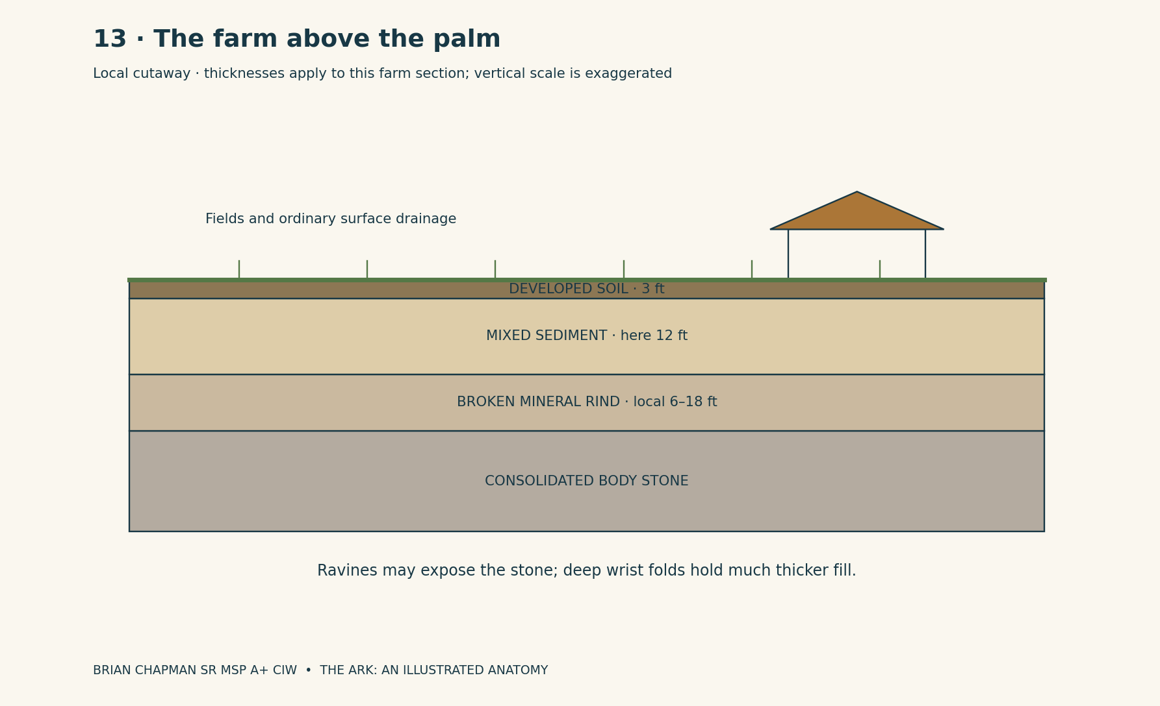
BRIAN CHAPMAN SR MSP A+ CIW

23 | The city under the ribs
The inhabited cavity called the Rib Court lies in the protected space beneath Him-a-Lan’s bent arm. Its main surveyed chamber is 6,000 feet long, 1,800 feet wide at its widest occupied cross-section, and 900 feet high to the lowest complete overhead mineral arch. Those dimensions belong to the ordinary cavity. A deeper linked room, if used, receives a separate annex sheet and is never smuggled into this number.
The principal entrance is a fractured opening on the southern valley side, 120 feet high and 90 feet wide. It narrows after 180 feet into a 48-foot-wide access throat. Human construction occupies one side of the throat and leaves a clear separation from mapped unstable fragments. The first occupied platform stands 12 feet above the inner stream. Its surface is paved in fitted gray blocks, with patched areas where later work has changed the drainage.
The city grows along the lower sides of the chamber rather than hanging invisibly in the air. Four terraces step up the northern wall at 36-foot vertical intervals. Each has a 24-foot public route and a band of shallow buildings set back against the mineral surface. Most houses are 18 to 30 feet deep. Their rear walls are constructed and inspected boundaries; the ancient stone is not assumed to make a dry, warm domestic wall merely because it looks monumental.
At the chamber center is a market floor 360 by 240 feet. Its roof is the distant mineral vault, but market stalls have their own small canopies at human scale. Strings of lamps run between freestanding supports. A person can see a cup on a stall table, a row of windows one terrace above, and the black lower curve of a rib hundreds of feet overhead. These scales occupy the same view. The giant’s body is not a decorative façade behind a city drawn at an unrelated size.
The stream follows the south side and disappears through a screened service ravine. It is not used interchangeably as drinking water and an outfall. A constructed bridge 120 feet long crosses its main cut at the market end. Beyond the bridge, a relay house stands apart from the dwellings. Its outside wall is ordinary stone; its insulated inner room is 18 by 24 feet. A glazed observation bay faces the mineral channel without requiring an operator to stand beside an exposed moving seam.
Sereth’s emergency route uses a different scale altogether. The opening mapped for his exit is 2,400 feet high in the outer valley section. It is not the 120-foot human entrance enlarged in the reader’s imagination. Human work takes place at protected relay positions, not beneath his feet. The atlas keeps those two mouths separate on every plan, so a rescue of people and a return of a giant child can share a landscape without sharing an impossible doorway.

Measured plate · Rib Court
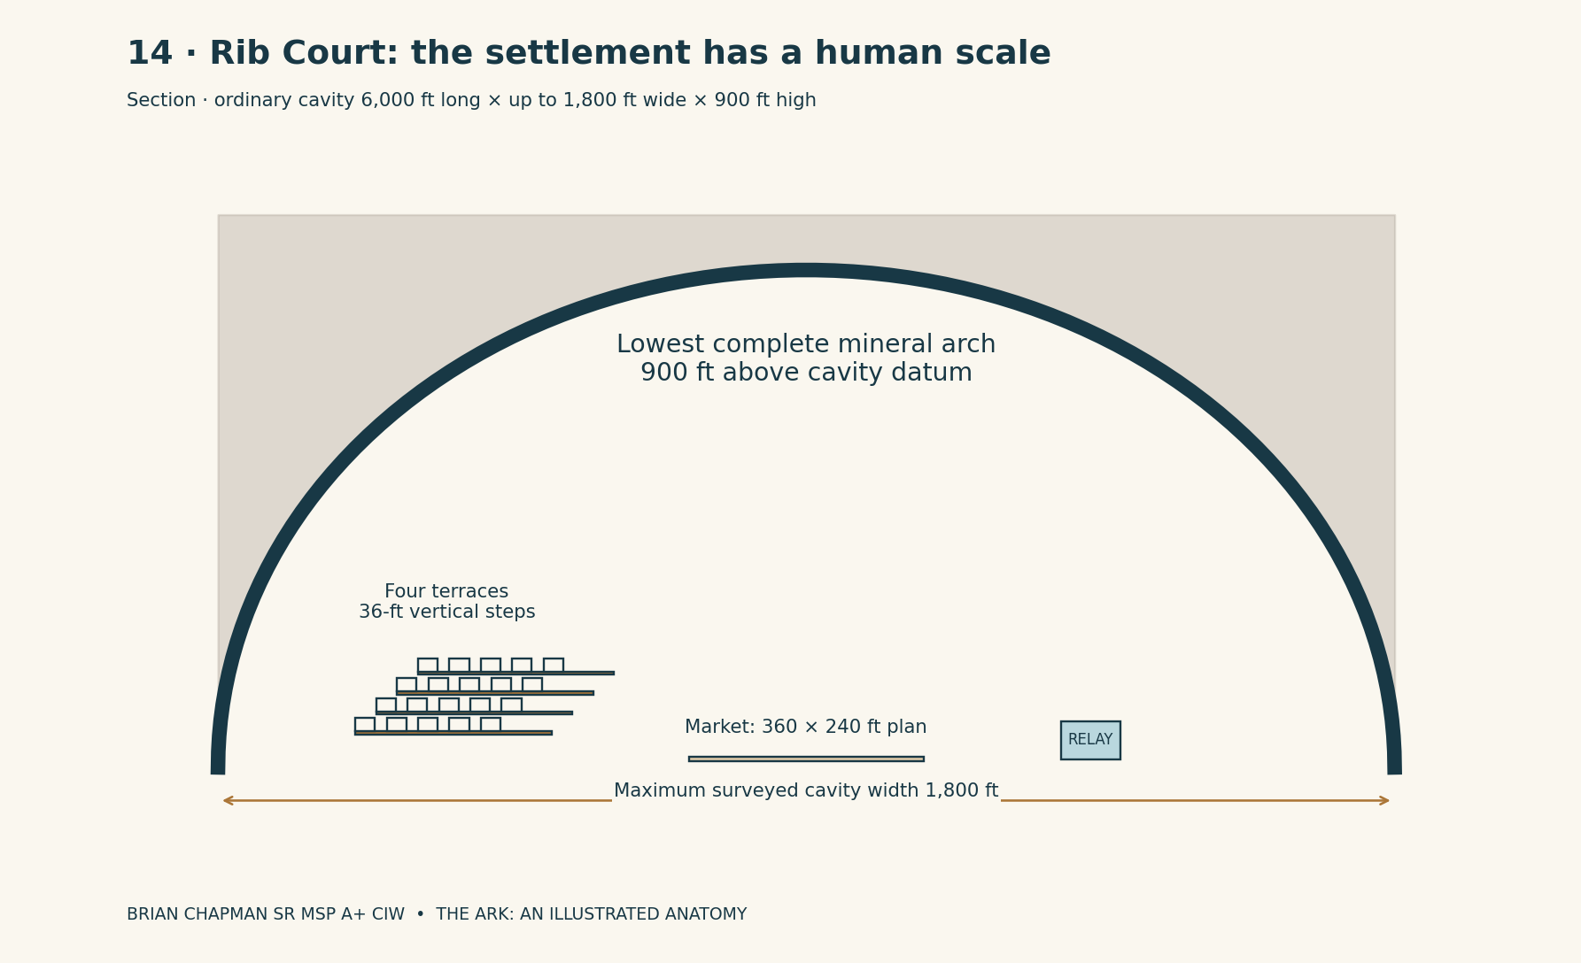
BRIAN CHAPMAN SR MSP A+ CIW

24 | The channel houses and the giant horizon
Contact with living giants occurs through the fictional Contact Directorate’s channels. CIA and FBI references in the stories identify the human institutional layer of that invented arrangement; they do not assert real contact programs. The architectural rule is that translations, timing, and source identity pass through staffed channel houses. A private person may witness a giant or feel environmental pressure without thereby holding a direct translated conversation.
A normal channel house has an outside envelope 60 feet long by 36 feet wide. The entrance lobby occupies a 12-foot-deep strip across the short end. Behind it are two parallel rooms: an 18-by-24-foot operator room and a 12-by-24-foot equipment room, with the remaining width taken by the separating wall and a protected passage. An observation recess projects into the safe side of a surveyed boundary. It is a room with a window, not a balcony built against the moving skin of a colossal hand.
The operator room faces an address wall like the carrier registry, but the readings describe a particular contact path. Two benches stand 6 feet apart. A translator works at one; a second operator checks the route and timing. Paper logs and an independent local clock remain visible. A speaker is fixed to the wall. The voice coming from it is an interpreted channel output, never an invisible mouth speaking freely through every room on the carrier.
Outside, the horizon plate shows Avar beyond the valley. The skyline rises across her shoulder and lowers along her forearm. Her kneeling height is indicated separately from her standing height, since a posture must not be confused with a new body size. Cloud strips cross in front of her upper body, while lower drifting cloud can hide her hands. Sereth stands in the exit valley beneath the scale line. Human observation buildings are drawn as small rectangles with enlarged locator insets.
The channel house does not give its staff command over the giants. It gives them a constrained means of asking and receiving translated replies. The reply has a delay, a source designation, and room for uncertainty in meaning. “Wait” can be related to an actual measured movement on the valley sheet. An ambiguous phrase does not open a new tunnel, erase a landslide, or give a human operator permission to gamble with families still walking through a passage.
When contact is lost, the visible room becomes quieter. A display darkens, but the building still has walls, water, a clock, and a door back to the local refuge. Human voices remain in the room. The failure state is part of the architecture: a boundary system can stop being a conversation without turning the house into a supernatural prison. This is why the plan shows the exit lobby with the same clarity as the luminous contact wall.

Measured plate · The channel house and giant horizon
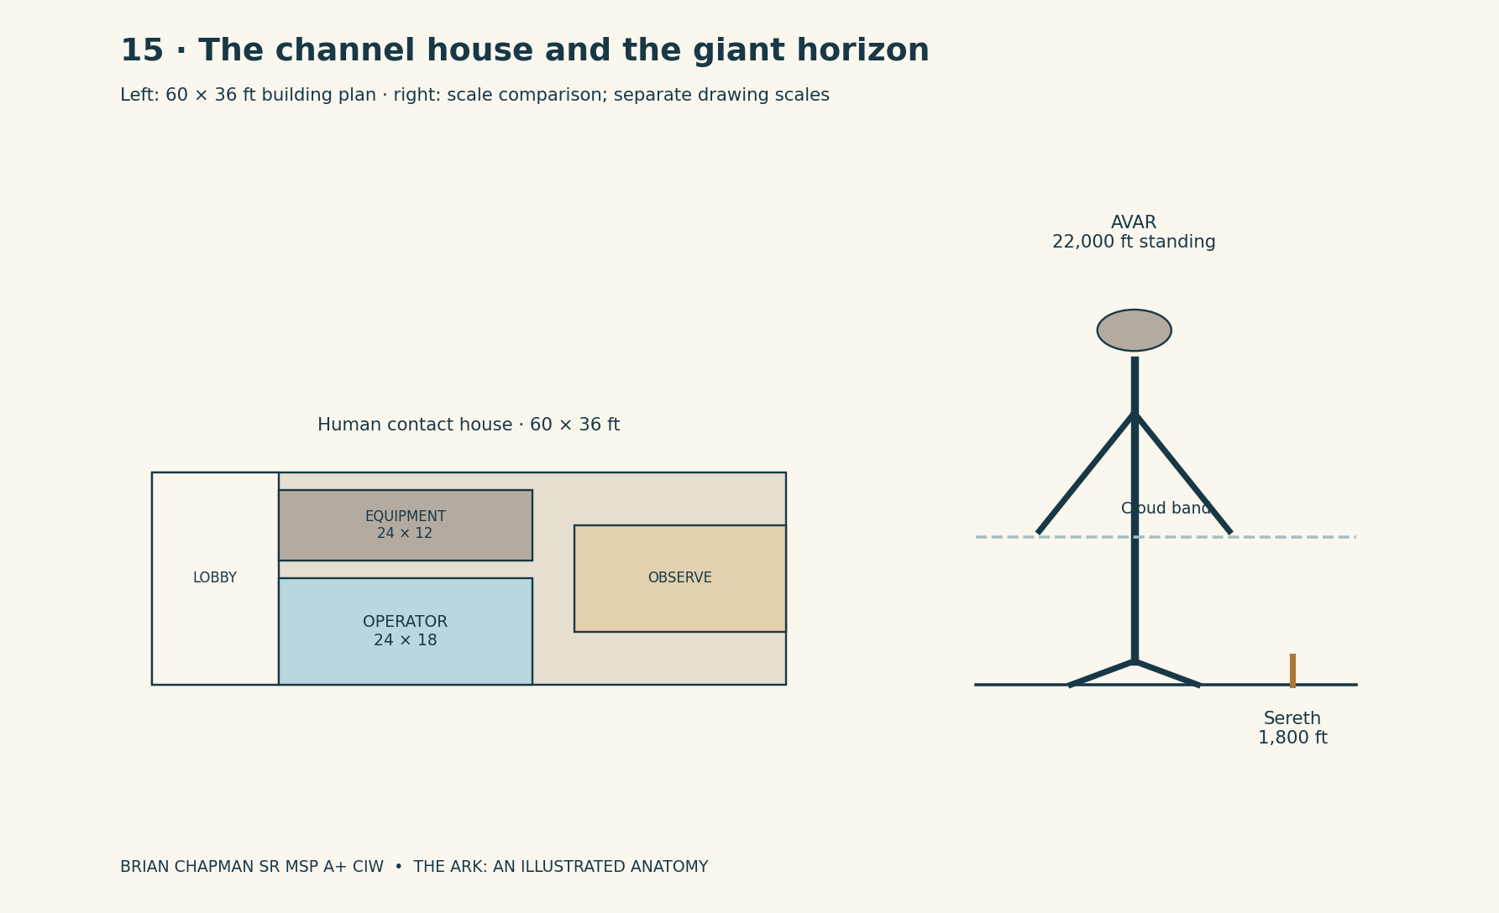
BRIAN CHAPMAN SR MSP A+ CIW

25 | Routes, distances, and the view around each turn
Between the centers of S01 and S24, the Common Spine distance is 690 feet. At an unladen fictional reference pace of 3 feet per second, that takes approximately 3 minutes 50 seconds without stops. The whole 780-foot carrier axis takes 4 minutes 20 seconds at the same pace. These figures make a missed appointment or a hurried return concrete. A person cannot cross the entire ship in two steps merely because adjacent pages show the two rooms.
From S04-C receiving to S12-C commons, the center-to-center distance is 240 feet, approximately 1 minute 20 seconds at the reference pace. From S12-C to S21-L registry, the horizontal component is 270 feet, plus a 24-foot vertical rise and the actual chosen stair or lift approach. The atlas gives no fake single walking time for that mixed journey. Waiting at a lift and helping a child can take longer than the horizontal walk.
A first-time visitor leaving the Ark experiences a sequence of five views. First comes the side-door daylight and the wooden receiving bay. Second comes the material seam and the pale-wood landing. Third comes the sloped folded approach, whose side openings show only registered transfer space. Fourth comes the stern vestibule with a view down twenty-four numbered frames. Fifth comes the local station door. The visitor never needs to imagine that the harbor basin has been hiding beneath the original wooden floor.
The Garden Annex is deliberately slower to cross than the carrier spine. Its straight length is 1,200 feet, but the accessible route between its top and bottom follows a longer alignment than the stepped watercourse. A narrative that moves a wheelchair or a loaded cart must use that route rather than borrowing the direct distance of the stair. The Harbor Annex has a different rhythm: sound carries across open water, while movement is constrained to quays, piers, and boats.
The giant-country map uses miles and then gives feet where a local building begins. The hand district’s 8 miles equal 42,240 feet. It is a country to walk across, not a corridor to hurry down between meals. The Rib Court’s 6,000-foot length is about 1.14 miles. One may see a distant row of lamps without being able to reach it in the next sentence. Distance does not disappear when the view is beautiful.
A door always names its last verified return. The atlas never asks a reader to infer destination from mood, music, a familiar person’s voice, or the appearance of a convincing sky. A wall can frame a grandiose landscape; its plate still names the place. This single habit lets the fiction become enormous without letting its geography become arbitrary.

26 | Chronology and the continuity ledger
Genesis 8:4 — “And the ark rested in the seventh month, on the seventeenth day of the month, upon the mountains of Ararat.”
The chronology has two different kinds of entries. The quoted biblical sequence gives construction, the Flood, and the Ark’s resting upon the mountains of Ararat. The fictional continuation adds the boundary lattice, surviving giant pockets, rediscovered channels, North Terrace, and the later mobile tower. The two sequences are printed together so the world can be followed, while their authorship remains visible. In the current survey, the pyramid’s cap is still missing, Ship A is a wreck fragment, Node 3 is partly flooded, and the route between Nodes 2 and 3 is obstructed; none of those conditions changes without an explicitly recorded intervention.
In the invented ancient period, Noah foresees the magnetic storm. Guidance failures crash the complex’s transit ships, a field-energy release breaches its pyramid installation, and the damaged timing nodes produce the time-plate rupture. The resulting Amalgamation begins before the giant elder’s burial is complete. The ordinary human later called Him-a-Lan is expanded into a colossal stone form and falls across the terrain while portions of his inner boundary state remain active. The Flood and later landscape processes conceal his form. Noah’s physical Ark survives as the narrative’s original wooden prototype, while the protected parent building survives beneath the region later mapped as America and Alaska. In the speculative continuation, the vessel returns through a water route to the Alaskan dock, and the post-Flood protective pyramid is built over the surviving site. The stories do not require an extra engine to have been secretly described by the word “pitch.”
The early modern rediscovery connects the Ark to separately situated communities and records. The North Terrace branch follows the already recorded design-and-rescue chronology: discovery and construction in 2034–2037, inhabited crisis in 2038, wedding in 2039, and archive work in 2041. North Terrace is still grounded through those events. Its six deck names preserve functions inherited from the older tower-and-outpost architecture. The atlas does not date every carrier journey from an inference about when a narrator feels it happened.
Lazara’s giant-country route belongs to a named branch of this fictional network. The relationship histories in the Lazara-and-Elias pilgrimage and the Lazara-and-Tarin investigation are not silently made identical by an architectural diagram. This atlas fixes the shared spaces and names; it does not pretend their incompatible biographical details have already been rewritten. A future collected narrative can explicitly choose a revised relationship chronology or distinguish its parallel branches.
Several physical statements are now fixed for subsequent stories. The wooden hull has three stories and remains 450 by 75 by 45 feet in the chosen conversion. North Terrace has six occupied levels and its own larger grounded envelope. The wooden mobile lengthwise outpost has twenty-four stations, six longitudinal deck positions, and a 780-foot registered body. The garden and harbor are annexes with their own bounded dimensions. Giant-scale openings are never substituted for human doors. Himland is a country name over part of Him-a-Lan’s hand, not a different measurement of his whole body.
If an earlier passage calls the entire network simply “the Ark,” the atlas reads that as a convenient collective name. If a passage requires a large hall, the address determines whether it is a hull room, carrier room, refuge room, or annex. A label cannot solve an actual contradiction in size. The ledger retains the earlier wording, states the conflict, and gives the new design rule. Continuity becomes a record that can be checked, rather than another mysterious device operating out of sight.

Architectural continuity decisions
Earlier ambiguity | Fixed rule for this atlas
“Ark” describes several different structures. | Name parent tower, wooden remote outpost, dock, pyramid, later refuge, and annex separately.
Grounded refuge confused with Noah’s ship. | North Terrace is later; the pre-Flood parent hub survives beneath Alaska and the wooden Ark is its mobile prototype.
No link between a tower and mobile levels. | Tower Floor n maps to Station Sn; six functional decks run through the carrier.
Large rooms seem to fit inside small hull spaces. | D7 annexes hold separate measured volumes beyond a registered seam.
Himland / Him-a-Lan naming. | Himland is the hand district; Him-a-Lan is the buried elder.
Giants seem able to enter human doors. | Use the separate 2,400-ft giant opening; standard human doors remain 12 × 10 ft.
No boundary between verse and invention. | KJV quotations supply the biblical anchors; added physics and anatomy are fiction.
Lazara’s partner histories conflict. | Retain named narrative branches until a deliberate biographical revision is made.

27 | The last view: a ship that contains a way
From the receiving quay inside the Alaskan pyramid, the wooden prototype is seen as a ship-shaped building within a larger installation. The whole undertaking returns to a small number of visible facts. The hull is 450 feet long. Dark timber courses follow that length. The side door stands in the same bay. The upper opening remains under the roof. No orchard spills through the planking. Nothing in the external silhouette proves the existence of the harbor, the carrier, or a giant’s inner city.
Inside the side door is a room small enough to understand at once. Its table has a worn edge. Its mat has two colors. A light falls from the outside opening across the boards and stops where the deeper shadow begins. On the forward wall, the honey-resin reveal is 6 inches wide. Beyond it, when the route is active, pale wood begins. The view can now be drawn without asking the reader to accept a paragraph of names in place of a place.
Farther on, the turned tower becomes a long inhabited order. The station frames repeat every 30 feet. Homes are above the common passage, gardens above the learning rooms, services below meals. At a particular address, a little door opens onto a planted country whose far basin lies 1,200 feet away. At another, a receiving hall looks over water and three piers. The scale changes at a registered seam, not by accident between two sentences.
Beyond the annexes, a buried hand supports a road. A farm field is level because generations of soil and work have made it level, not because a knuckle was conveniently shaped like a garden bed. Beneath the soil, mineral stone holds the memory of a body. The atlas removes a strip of landscape and shows that curve; then it replaces the ground, leaving the people above with the view they actually possess.
The fictional universe is grand enough to hold ships, countries, and enormous living beings, but each picture has an edge. A beam meets a post. A room has a neighboring room. A passage has a length. A mother waits outside an opening large enough for her child. The Ark does not become infinite by refusing measurement. It becomes a place a reader can return to because the next threshold, however extraordinary, has been given a shape.

CAD study 48 Ark complete ship interior cutaway
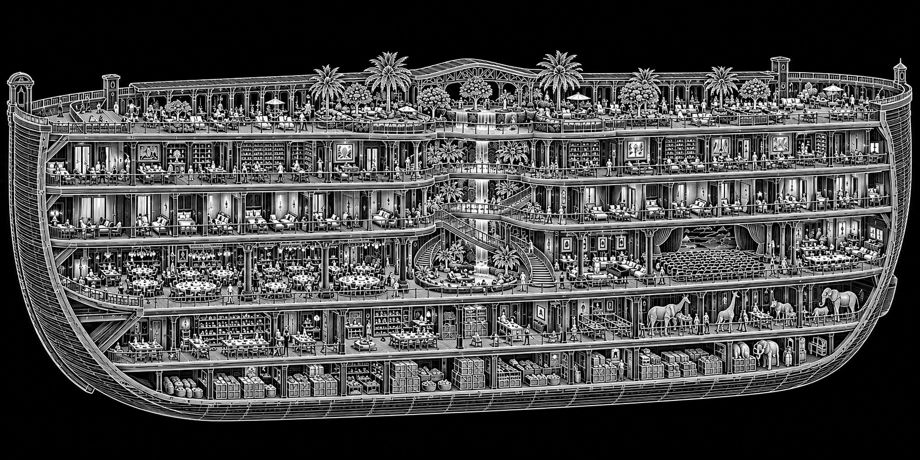
BRIAN CHAPMAN SR MSP A+ CIW
Concept study. Written dimensions, floor names and nonmetallic Ark construction rules in the atlas govern.

Sources and drawing register
Biblical quotations: King James Version, Genesis 6:4, 6:14–16, 7:11, and 8:4. Wording checked against the King James text at Bible Gateway, Bible Hub, and YouVersion. The quoted translation is public domain in the United States. No modern translation commentary is reproduced.
Genesis 6:14–16: https://search.biblegateway.com/passage/?search=Genesis+6%3A14-16&version=KJV
Genesis 6:4: https://www.biblegateway.com/passage/?search=Genesis+6%3A4&version=KJV
Genesis 7:11: https://www.bible.com/bible/1/GEN.7.11.KJV
Genesis 8:4: https://www.bible.com/bible/1/GEN.8.4.KJV
Story sources: the twelve-book illustrated collection by BRIAN CHAPMAN SR MSP A+ CIW, especially the architectural fieldbook and continuity notes in The Ark of Hidden Rooms, the carrier journey in The House Behind the Stars, the harbor setting in The Harbor of Moving Worlds, and the giant landscapes in The Mountains That Remember Us and The Ark and the Sleeping Giants.
All measured plates in this atlas are original explanatory drawings for the fictional setting. Dimension arrows identify stated design extents; diagrams labeled schematic are not to scale. The plates are an architectural worldbuilding record, not structural, marine, life-support, or navigational construction drawings.

The wooden Ark in open water
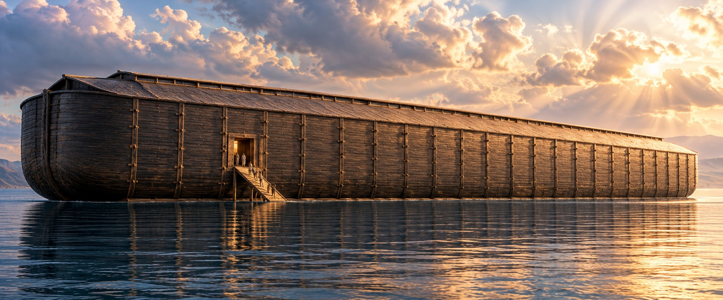
Exterior study after measured plate 01. The established outer envelope remains 450 by 75 by 45 feet.
Cinematic illustration. Refer to the measured plates for exact dimensions.

Life along the middle aisle
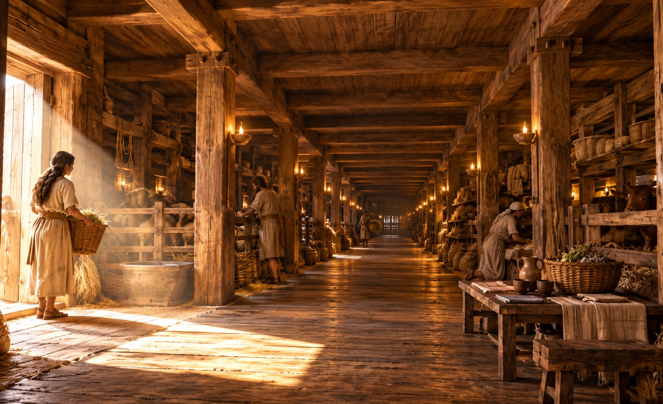
Interior study after measured plate 02 and Chapter 5. Timber rooms flank the clear central aisle of the ordinary middle story.
Cinematic illustration. Refer to the measured plates for exact dimensions.

The Ark within its Alaskan dock
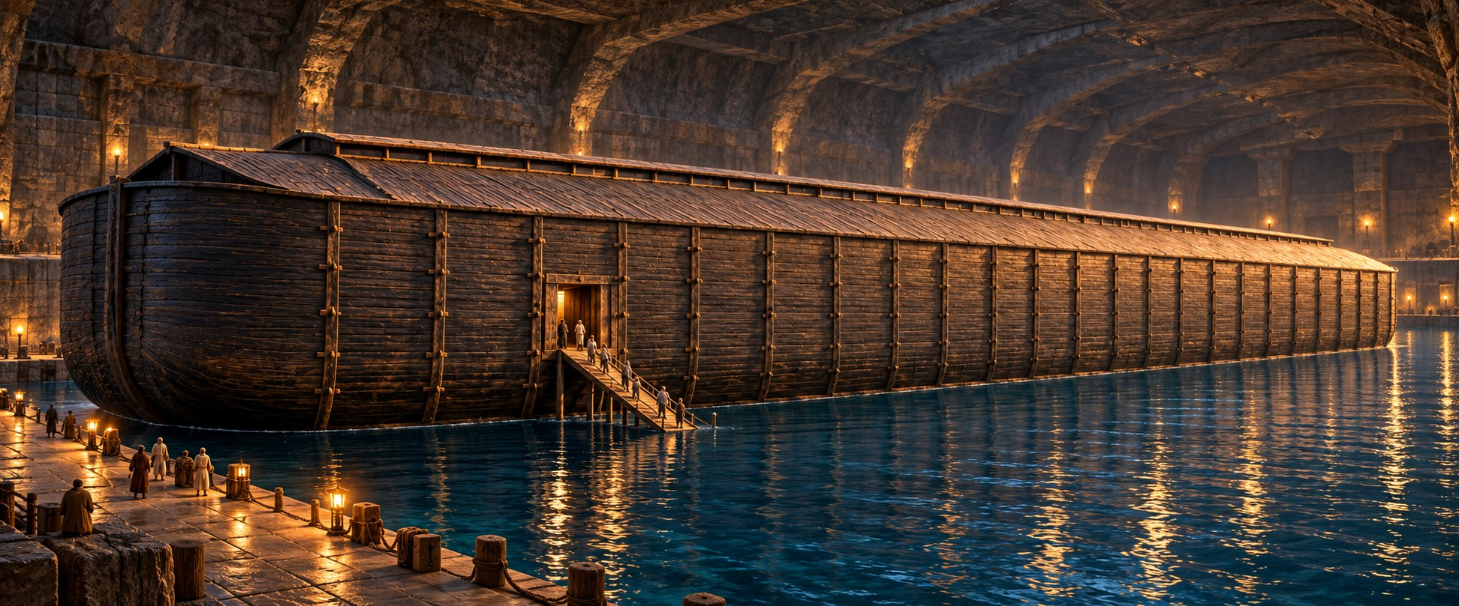
Dock study after measured plate 23. The same wooden vessel rests within the protected receiving chamber.
Cinematic illustration. Refer to the measured plates for exact dimensions.

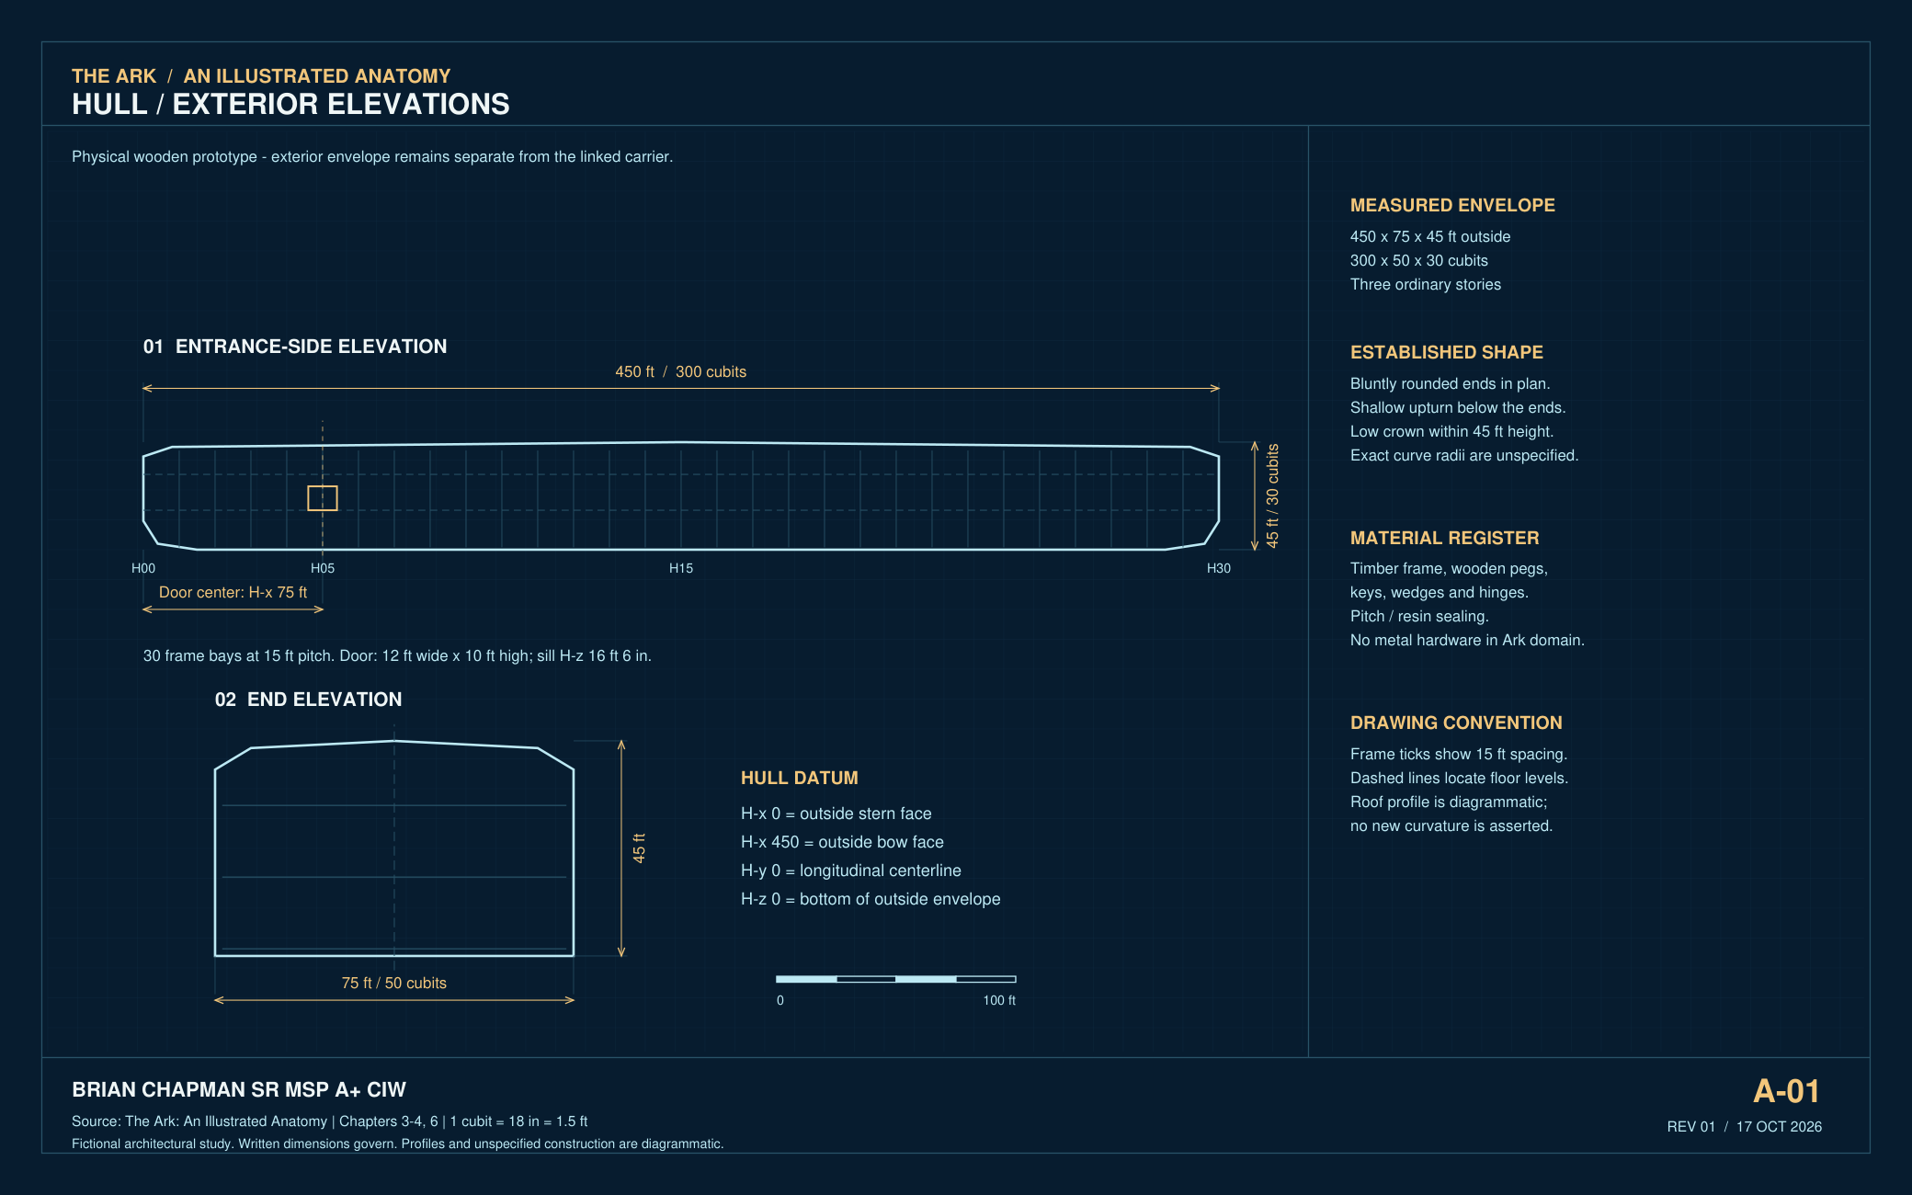
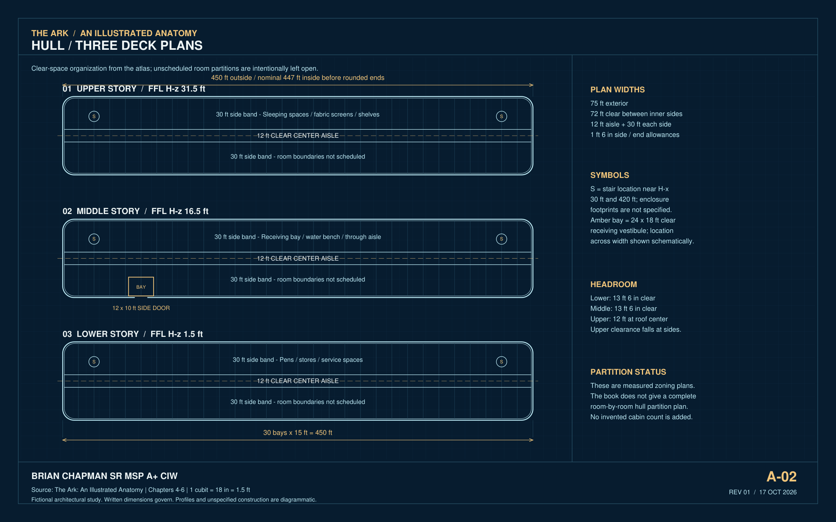
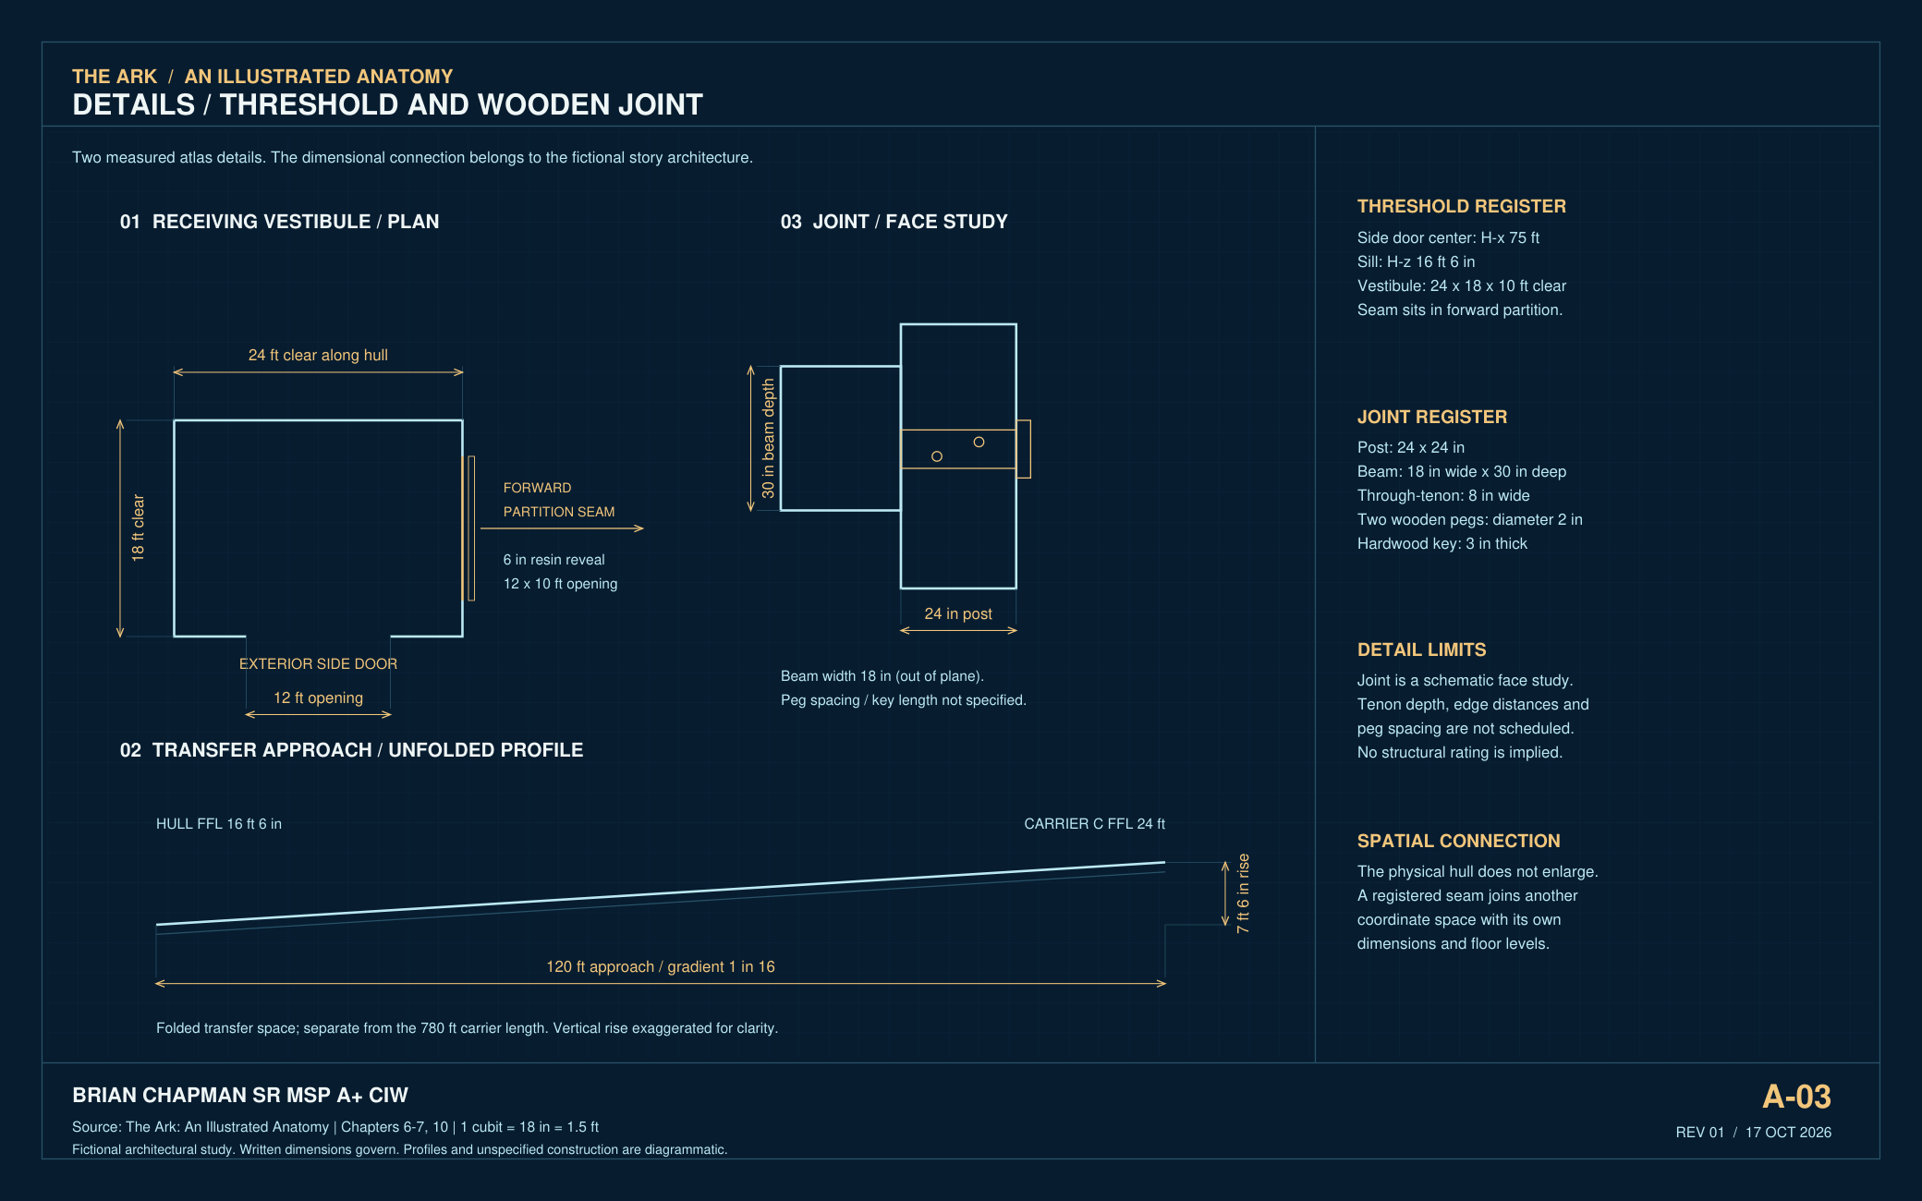
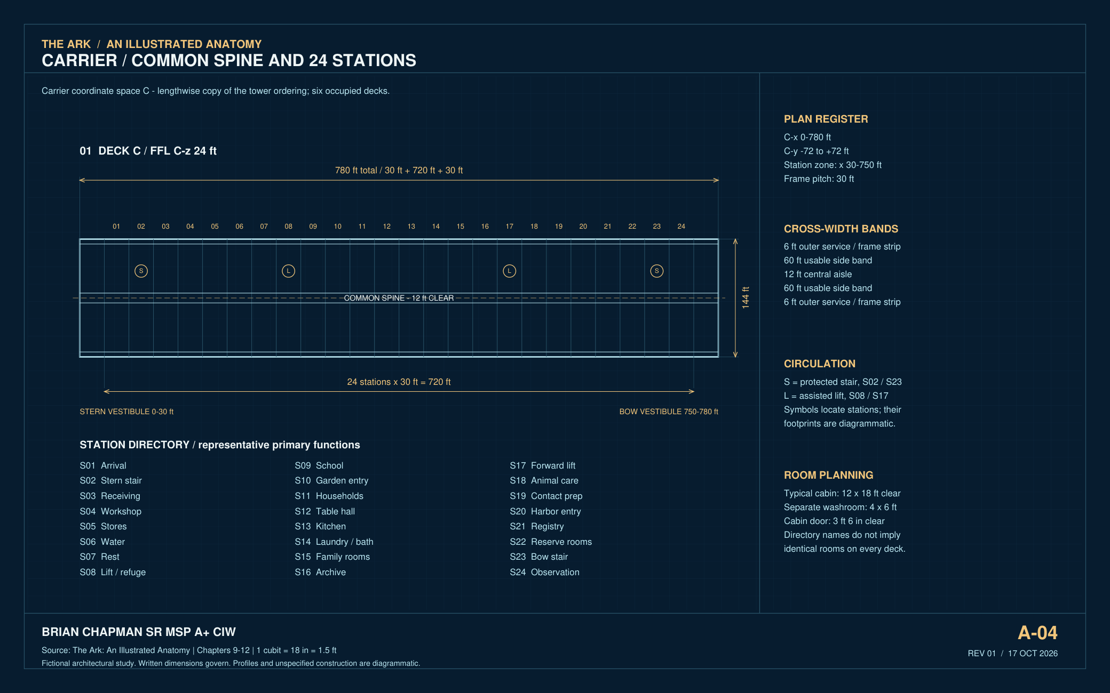
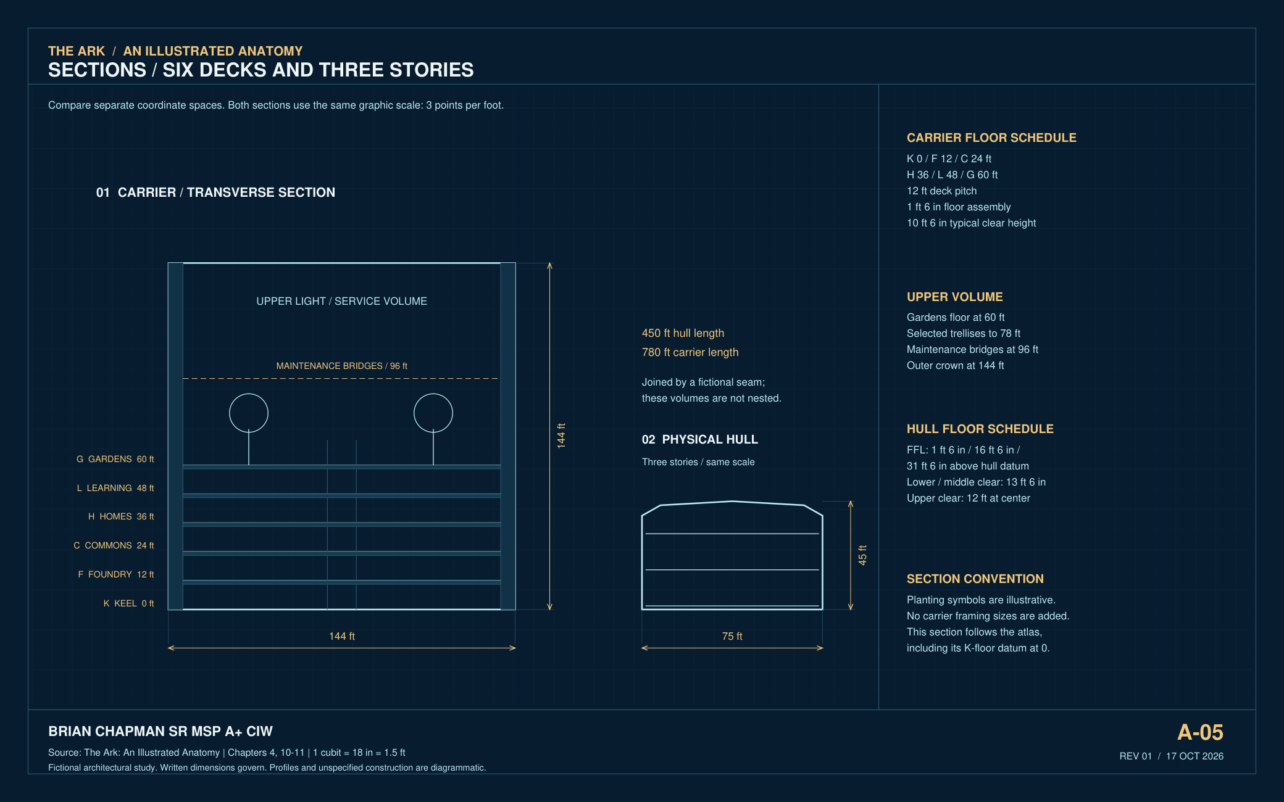
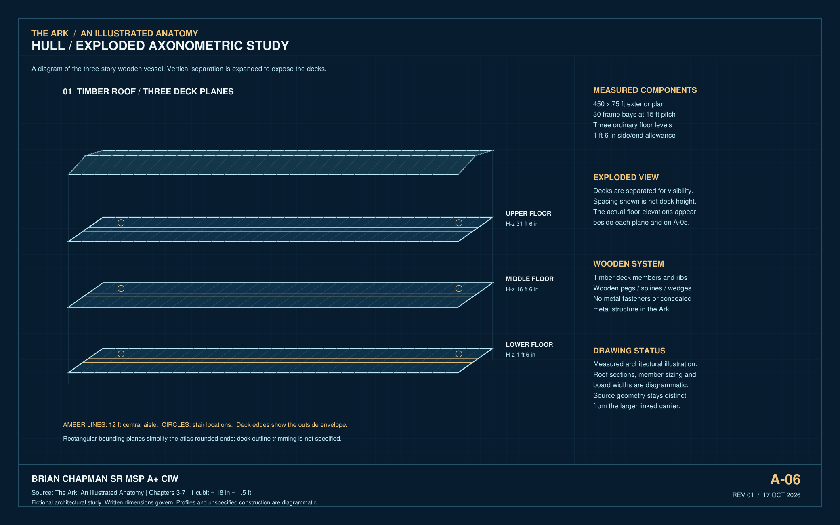
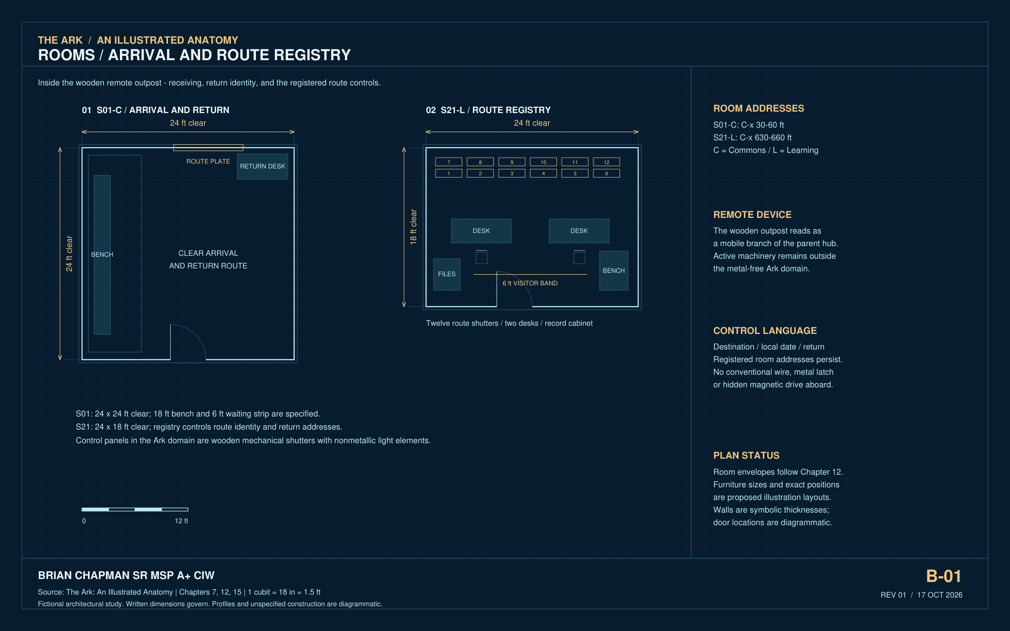
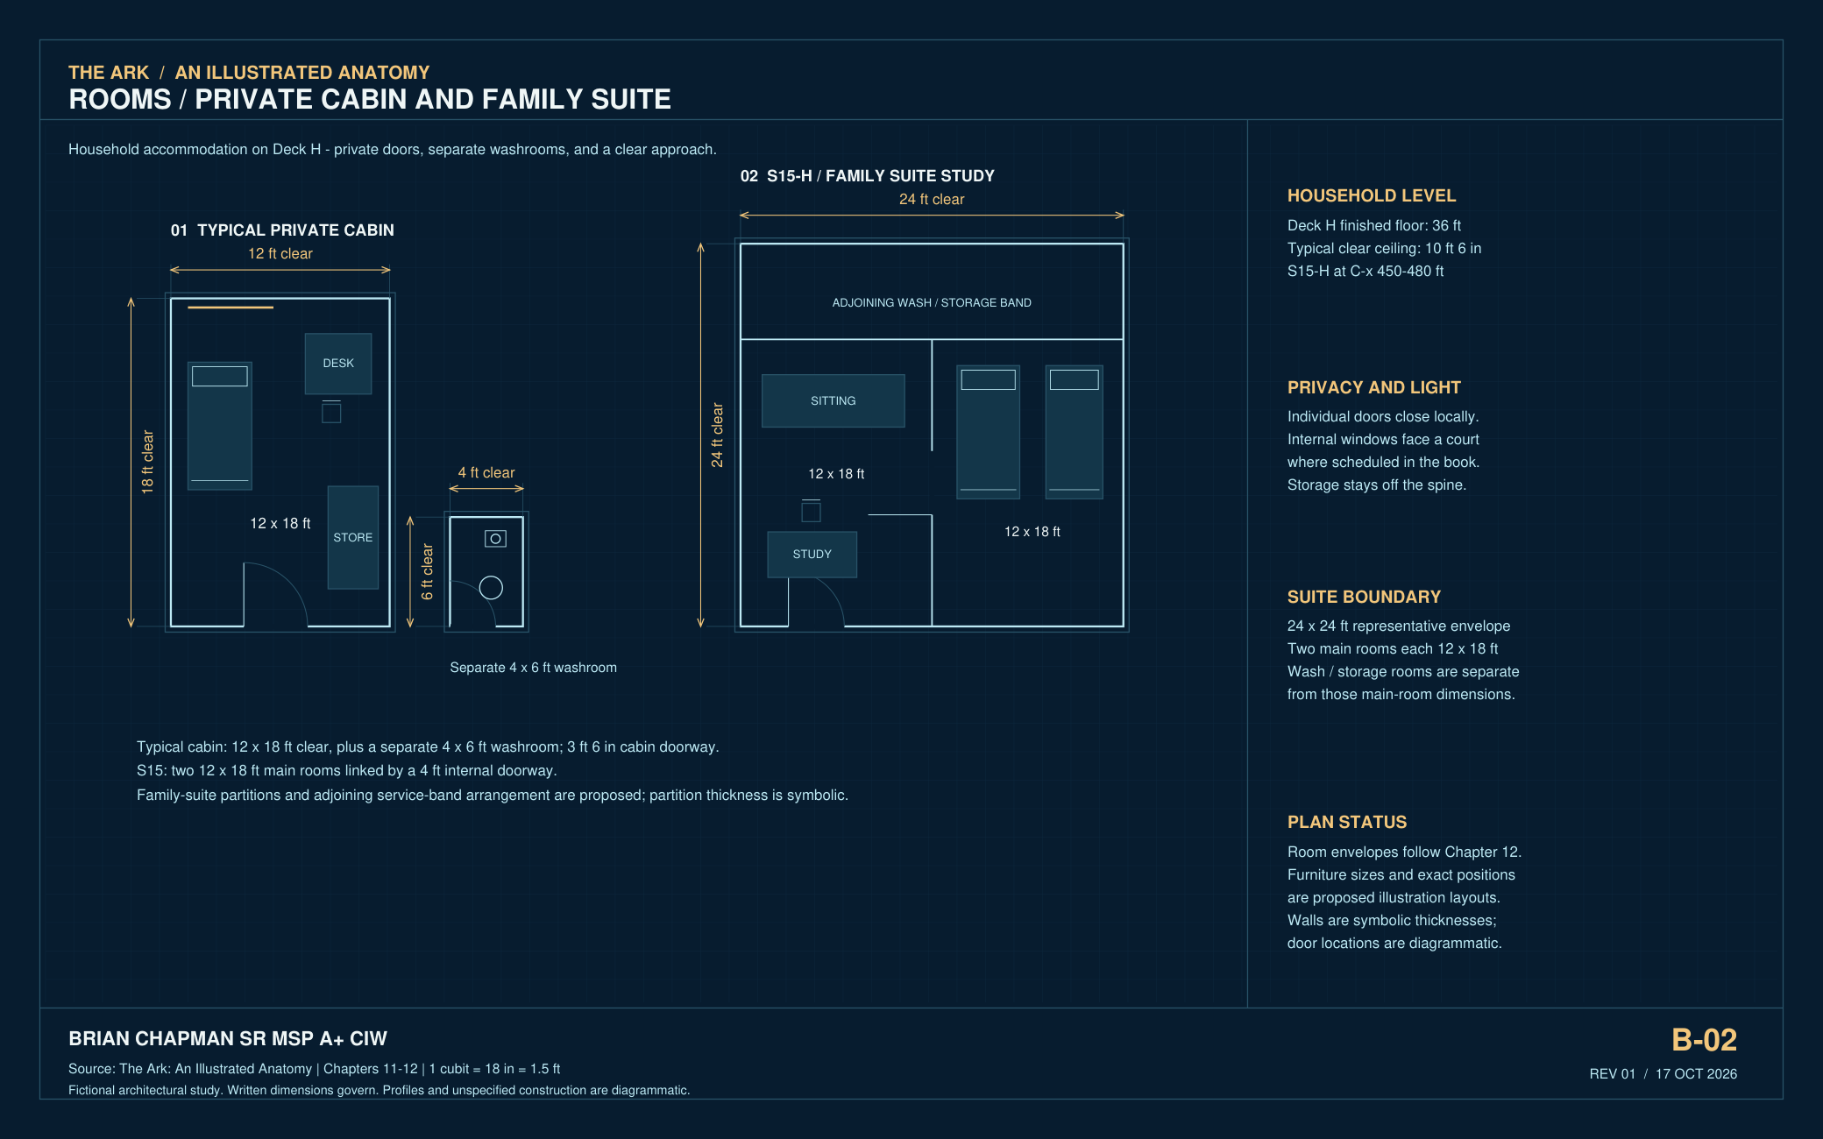
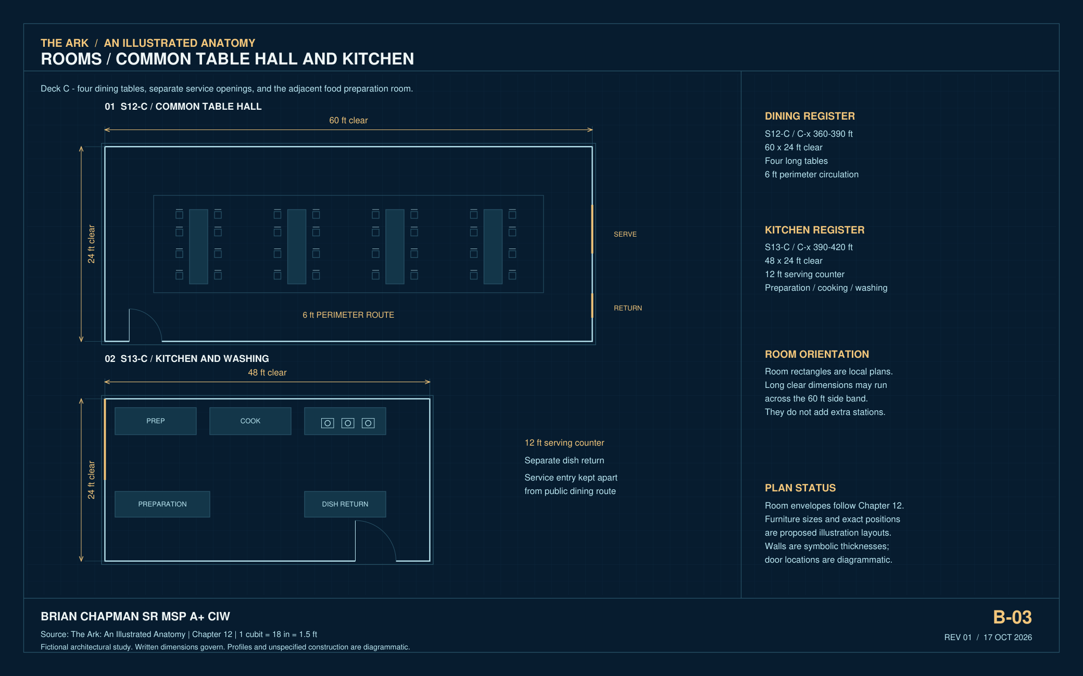
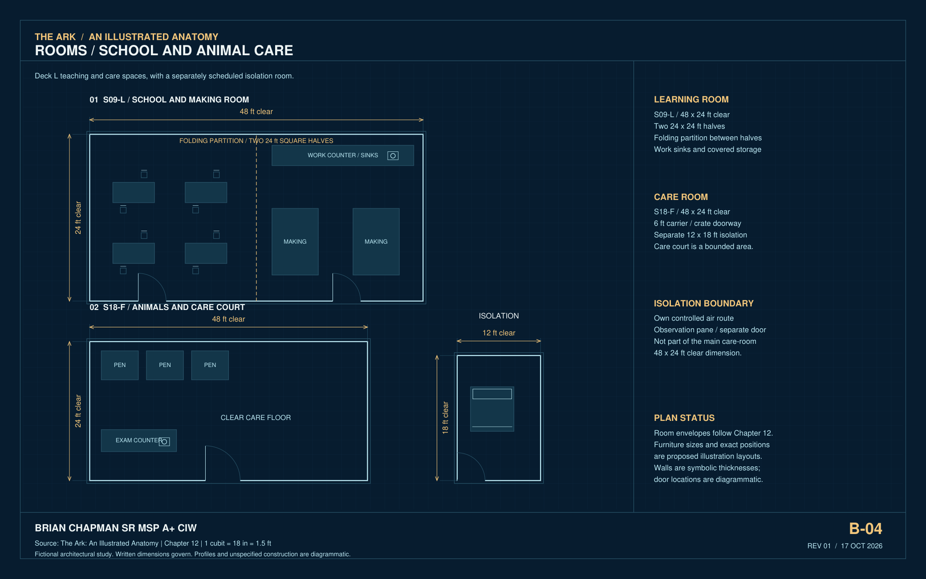
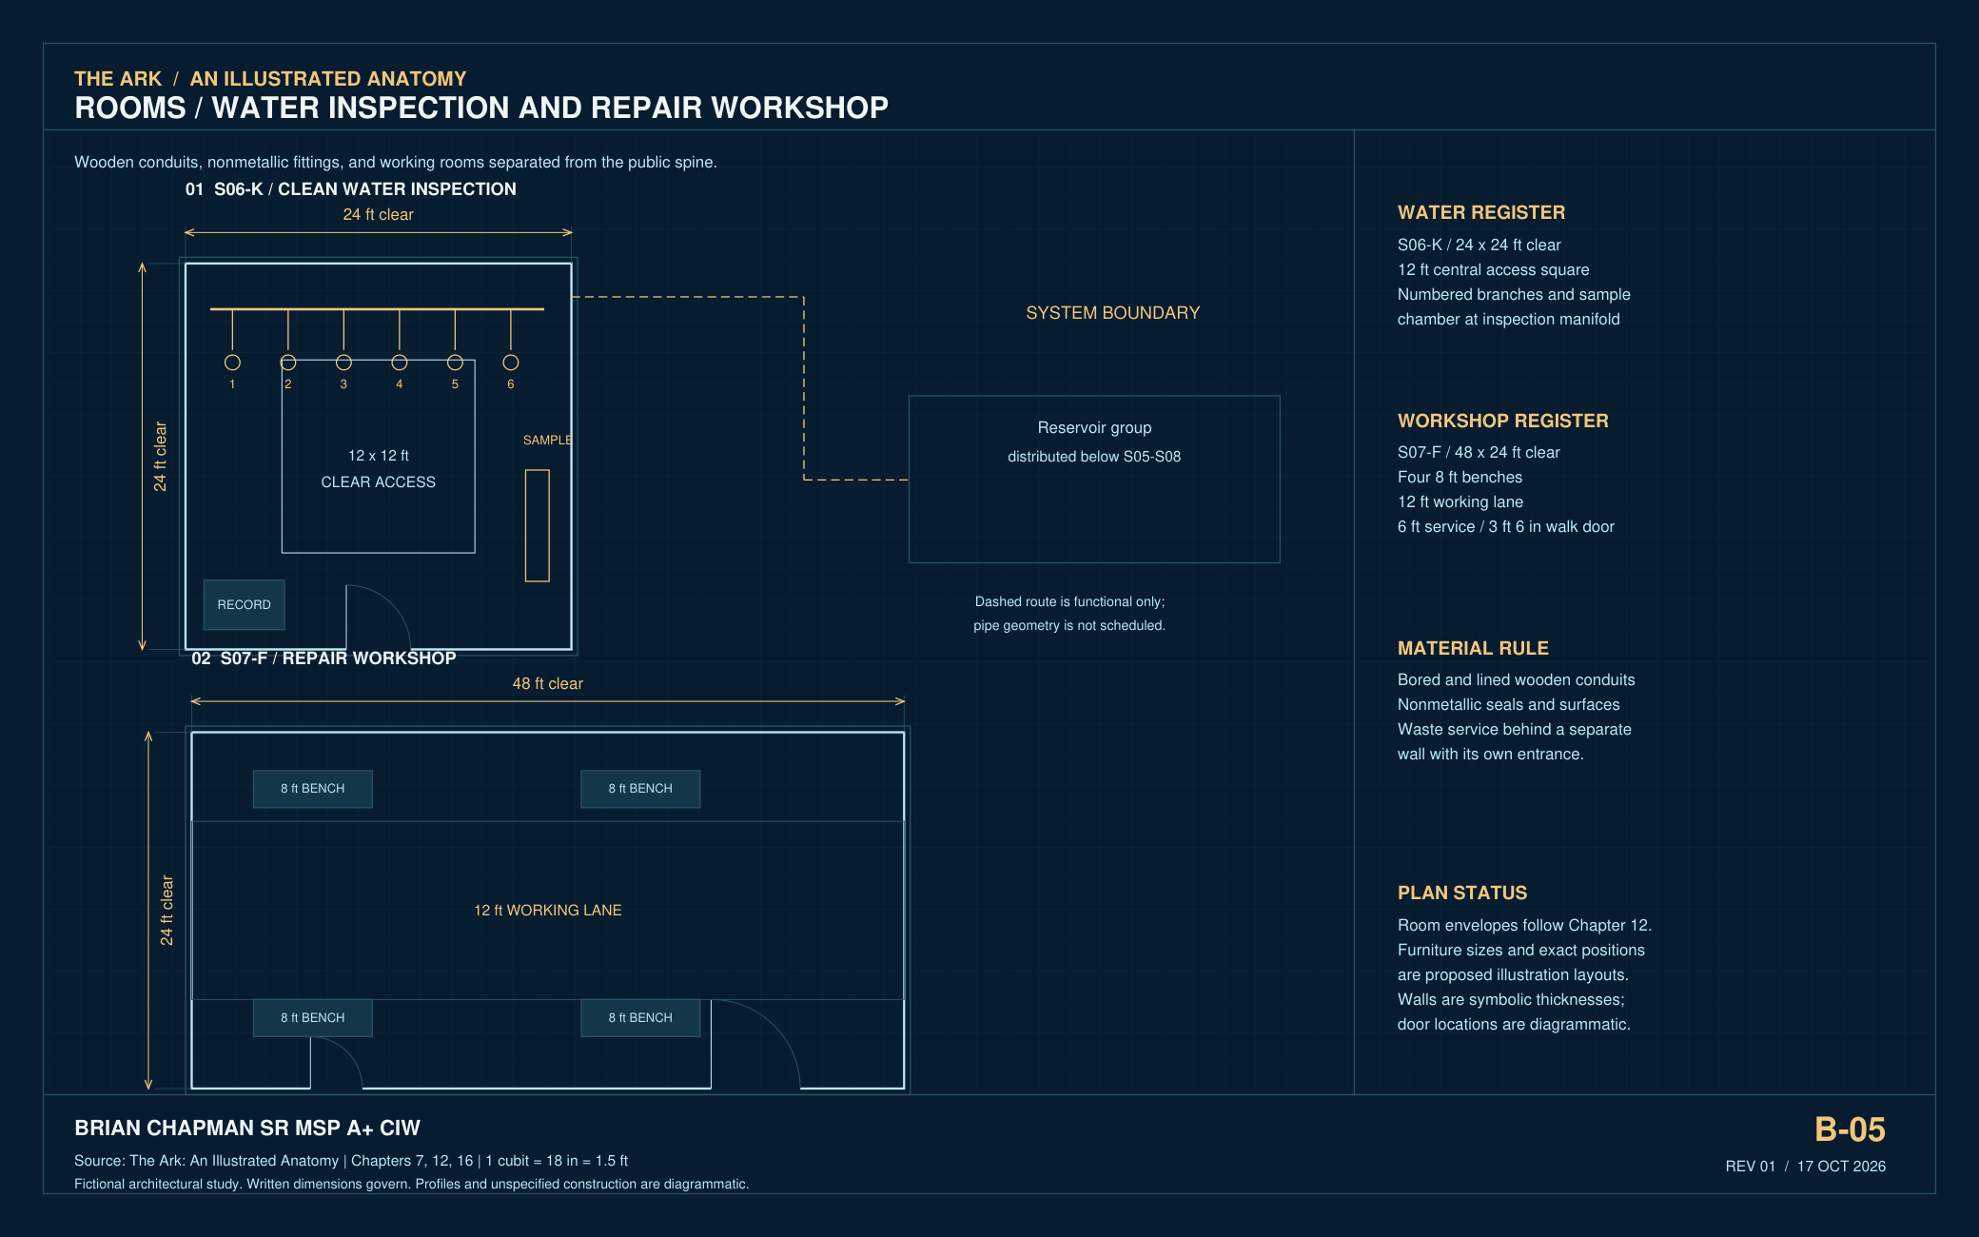
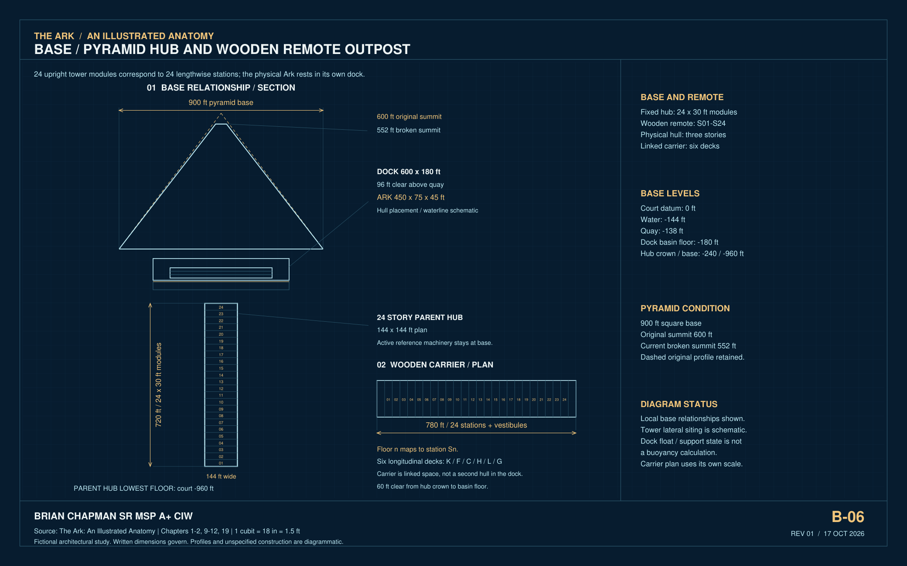
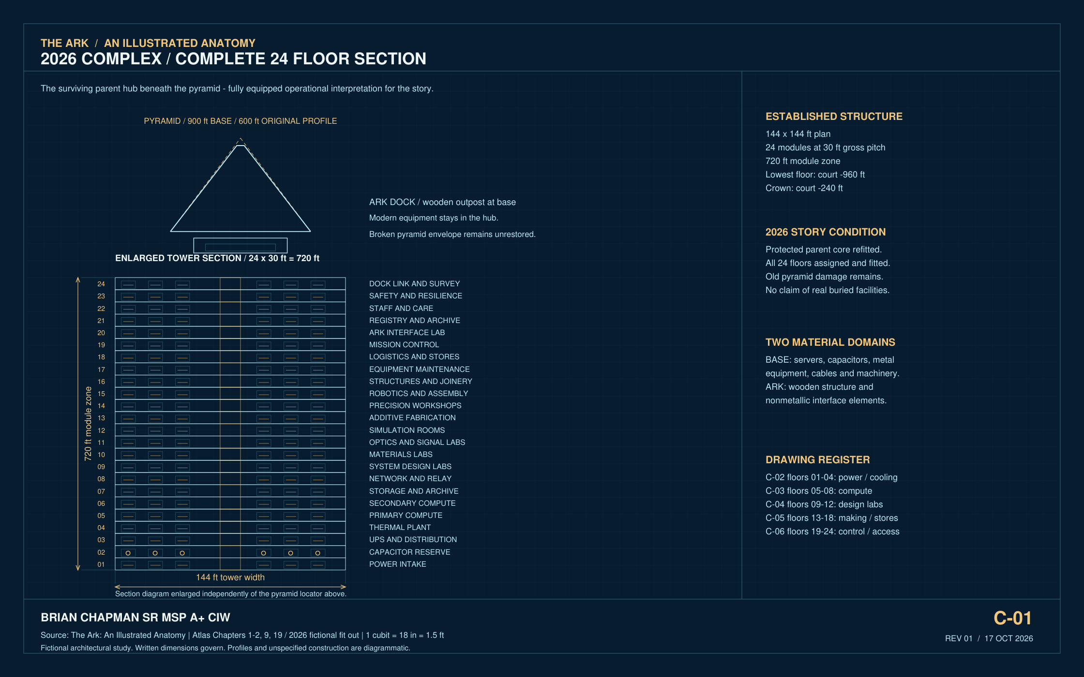
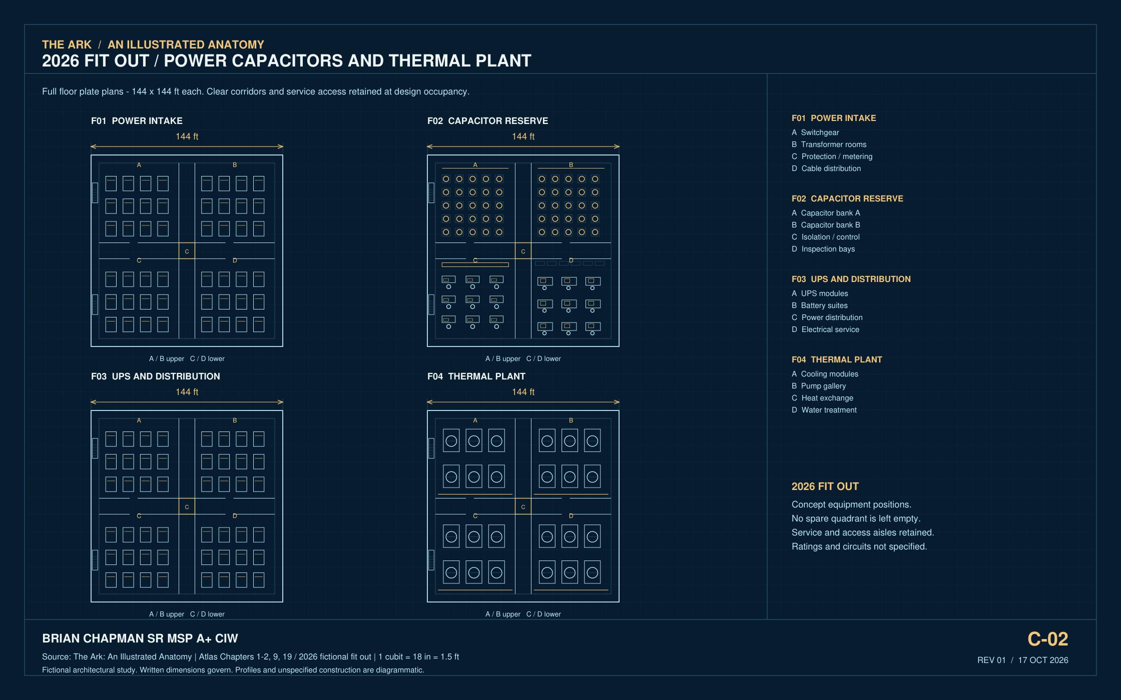
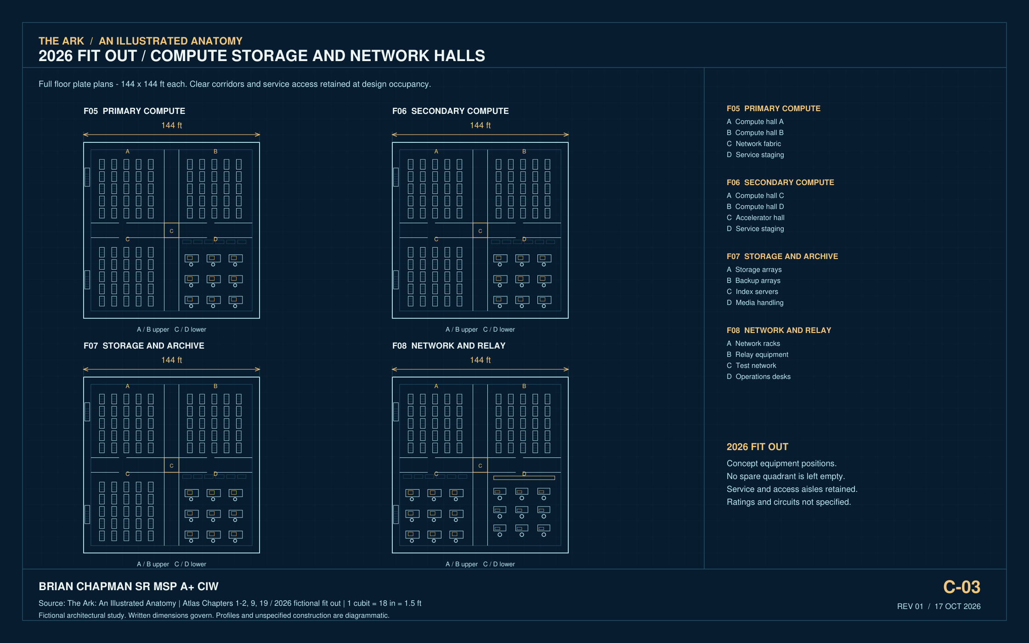
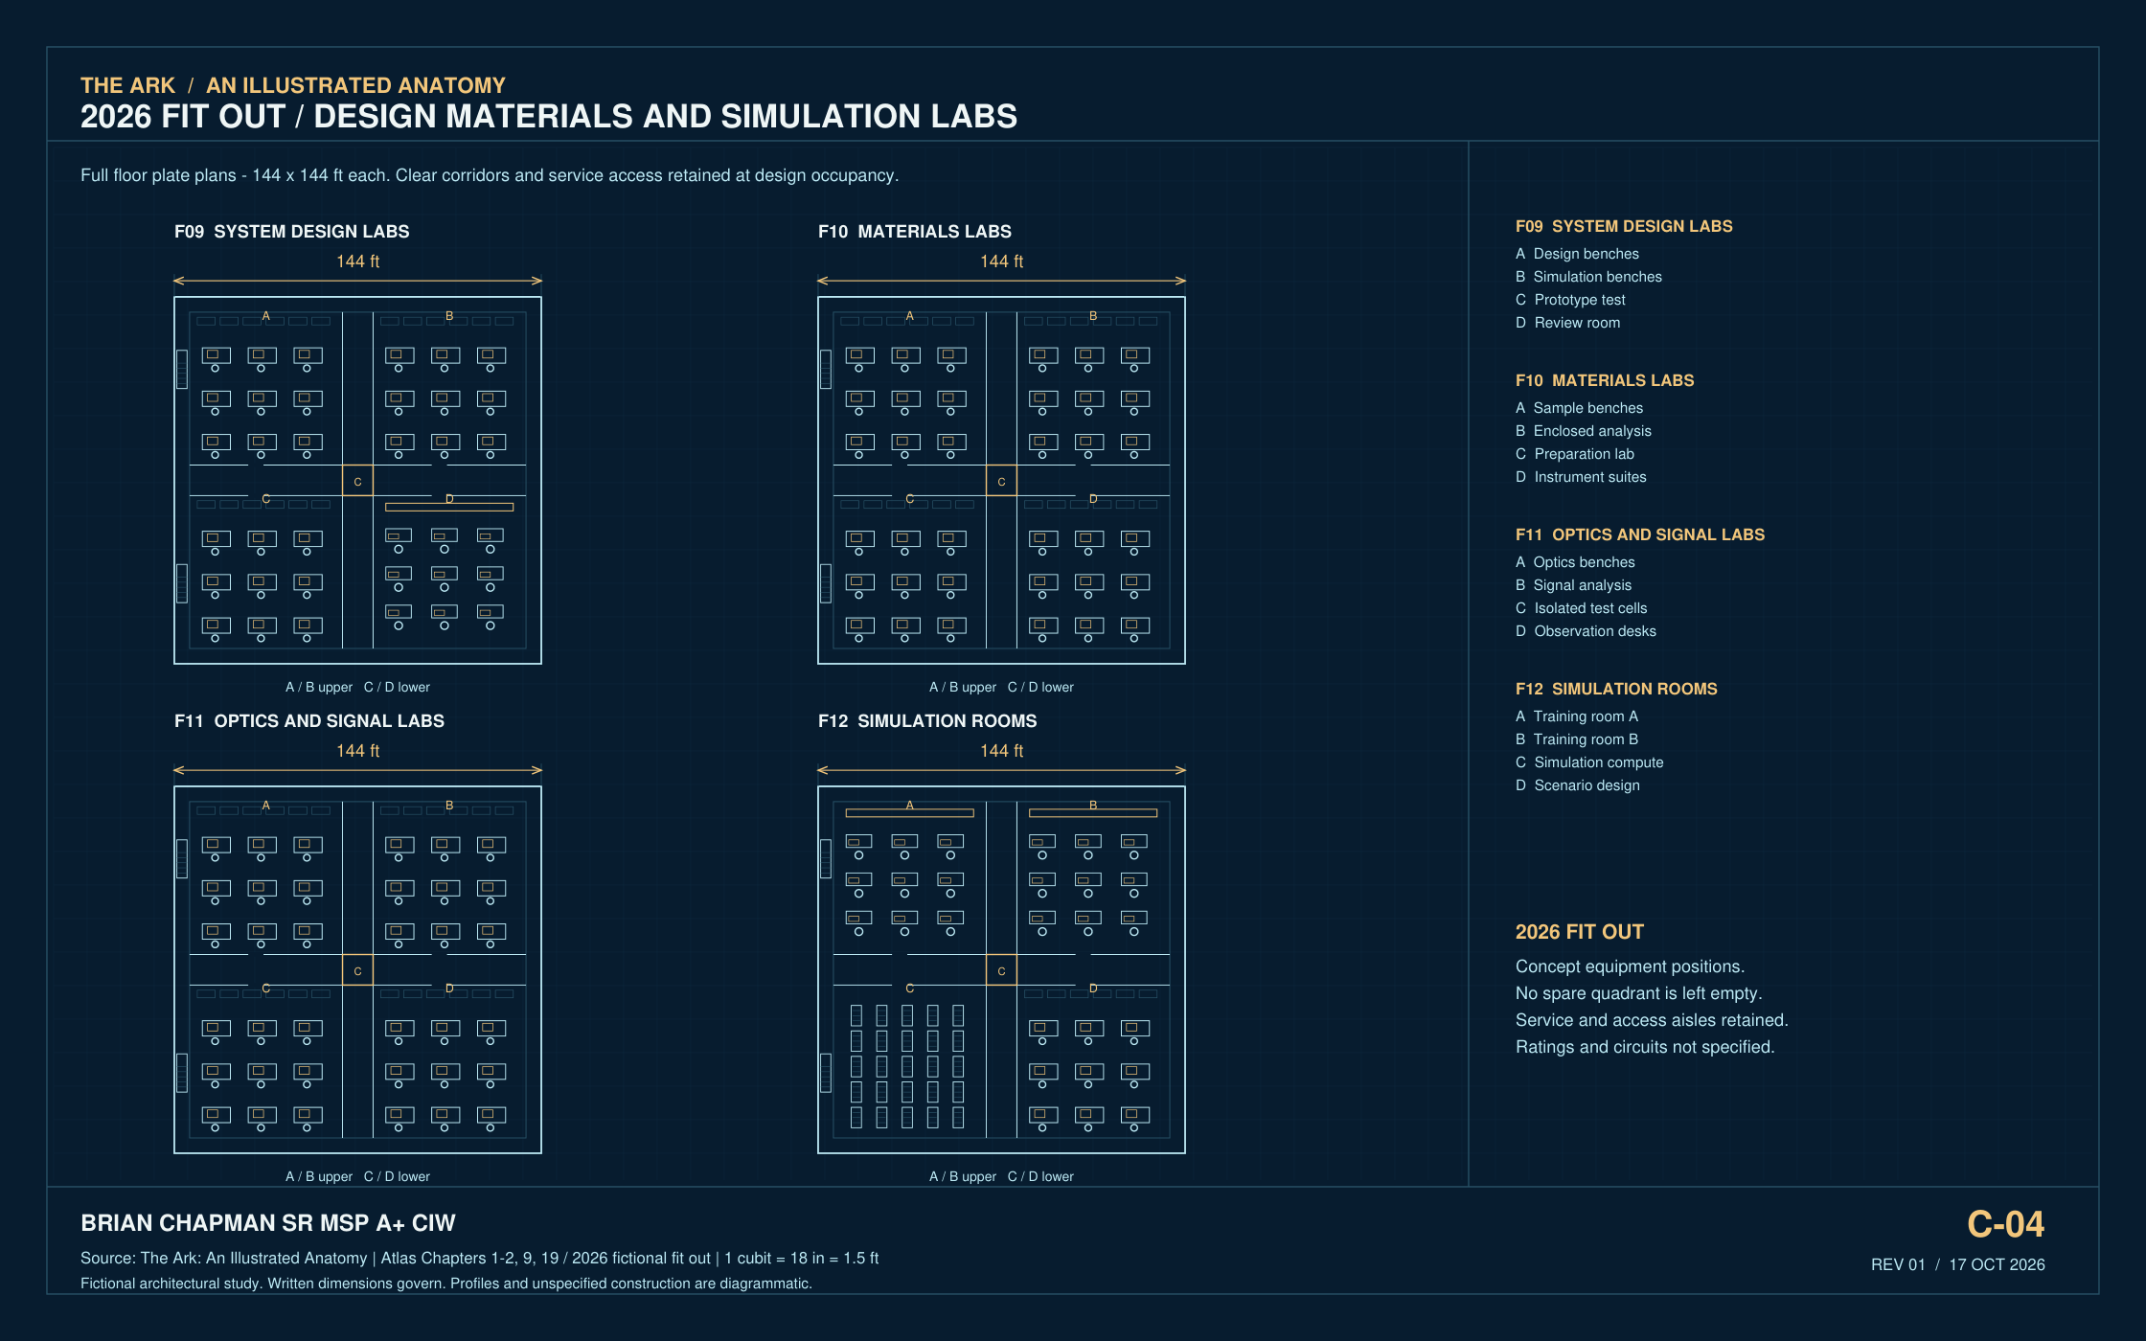
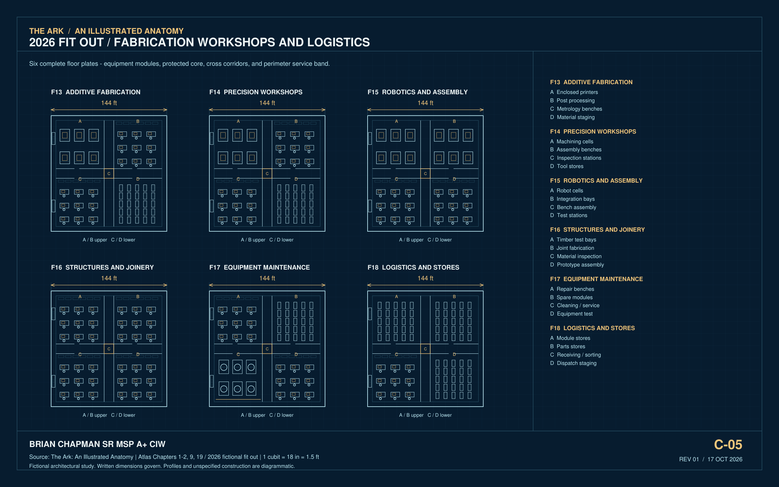
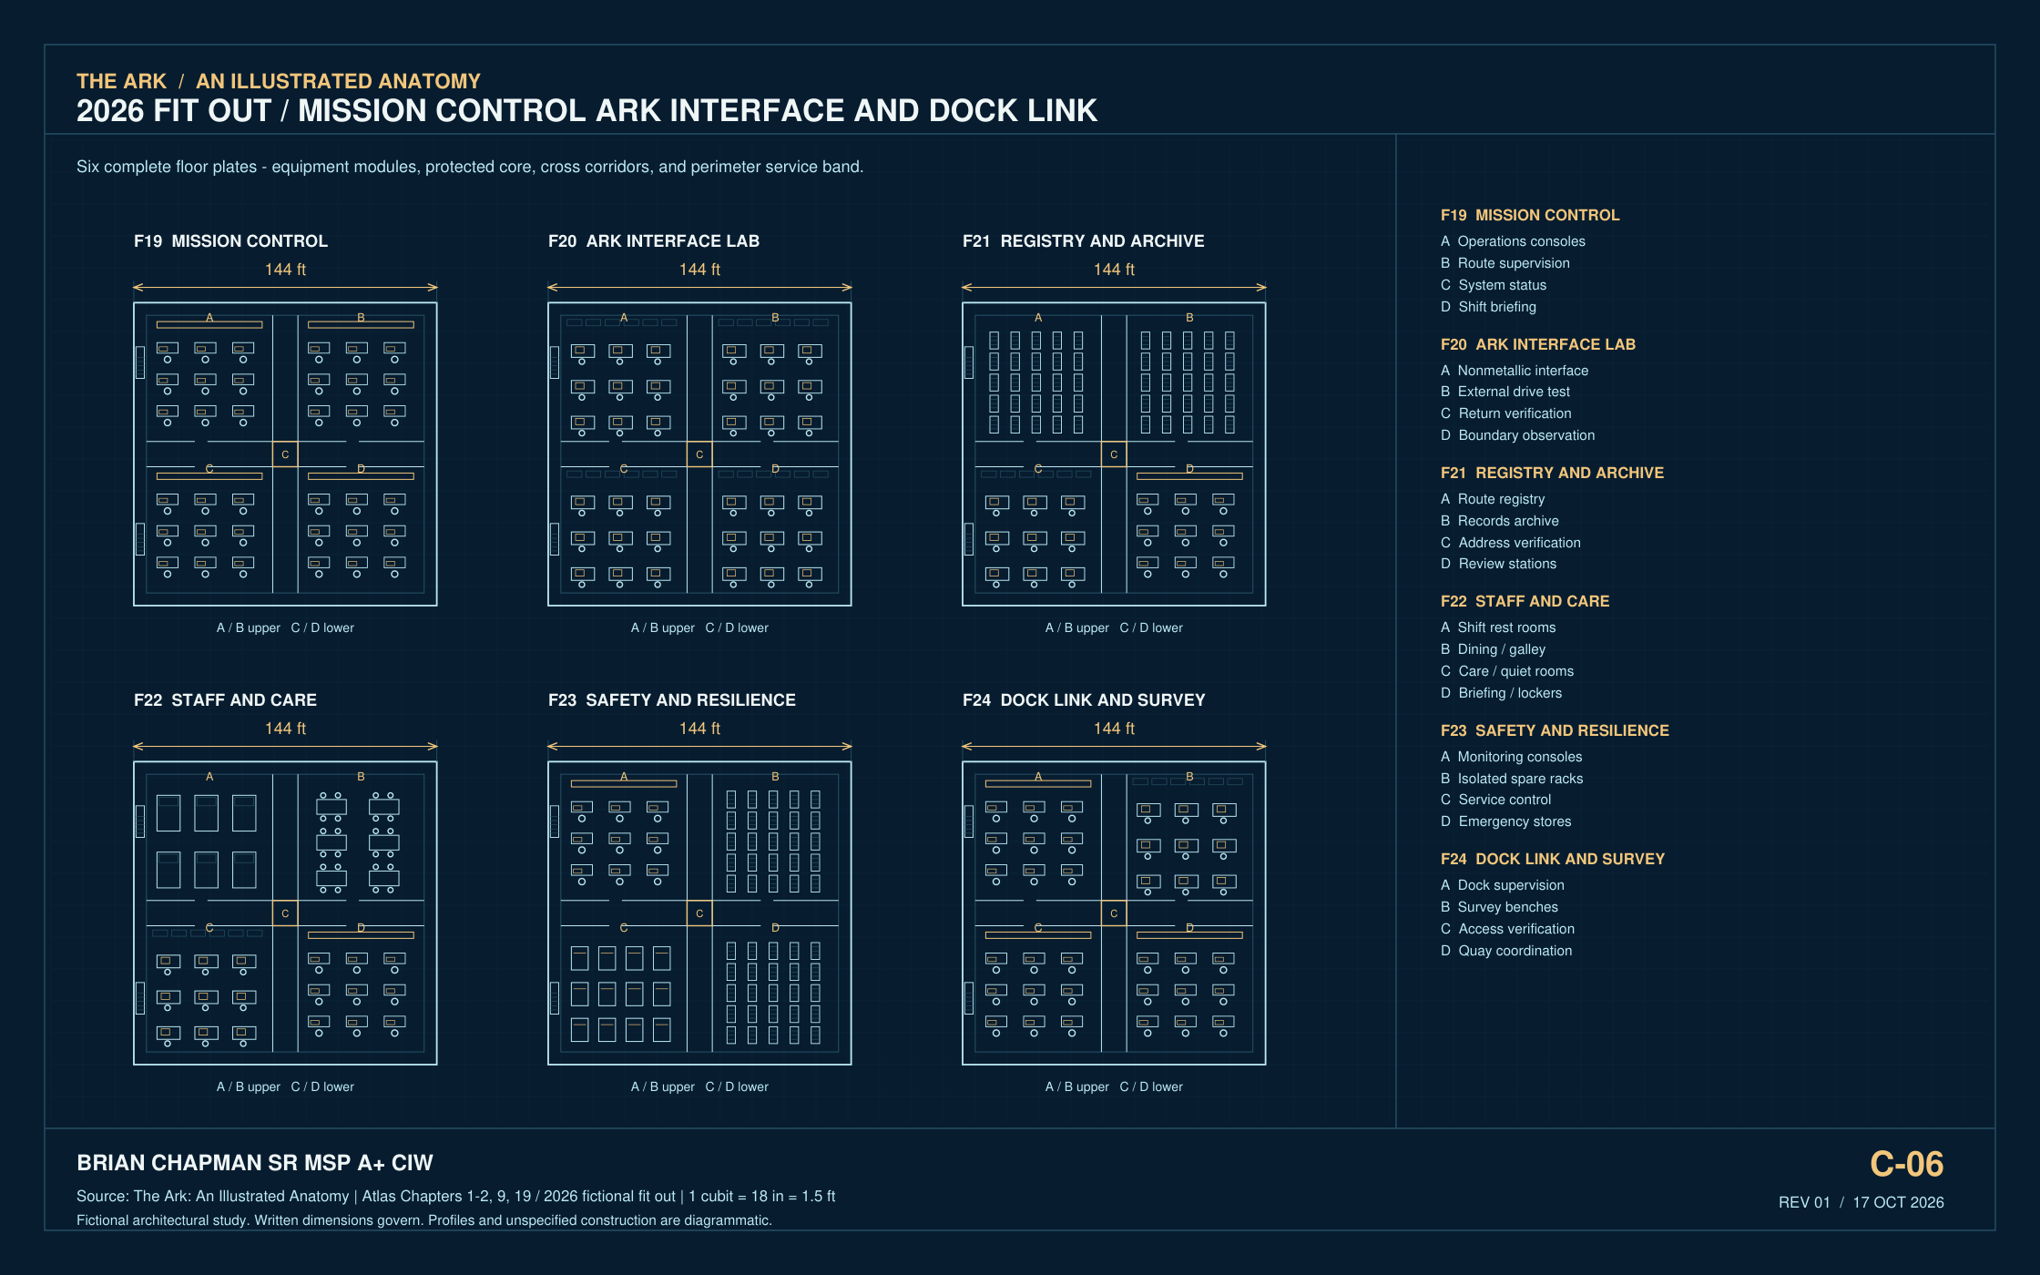
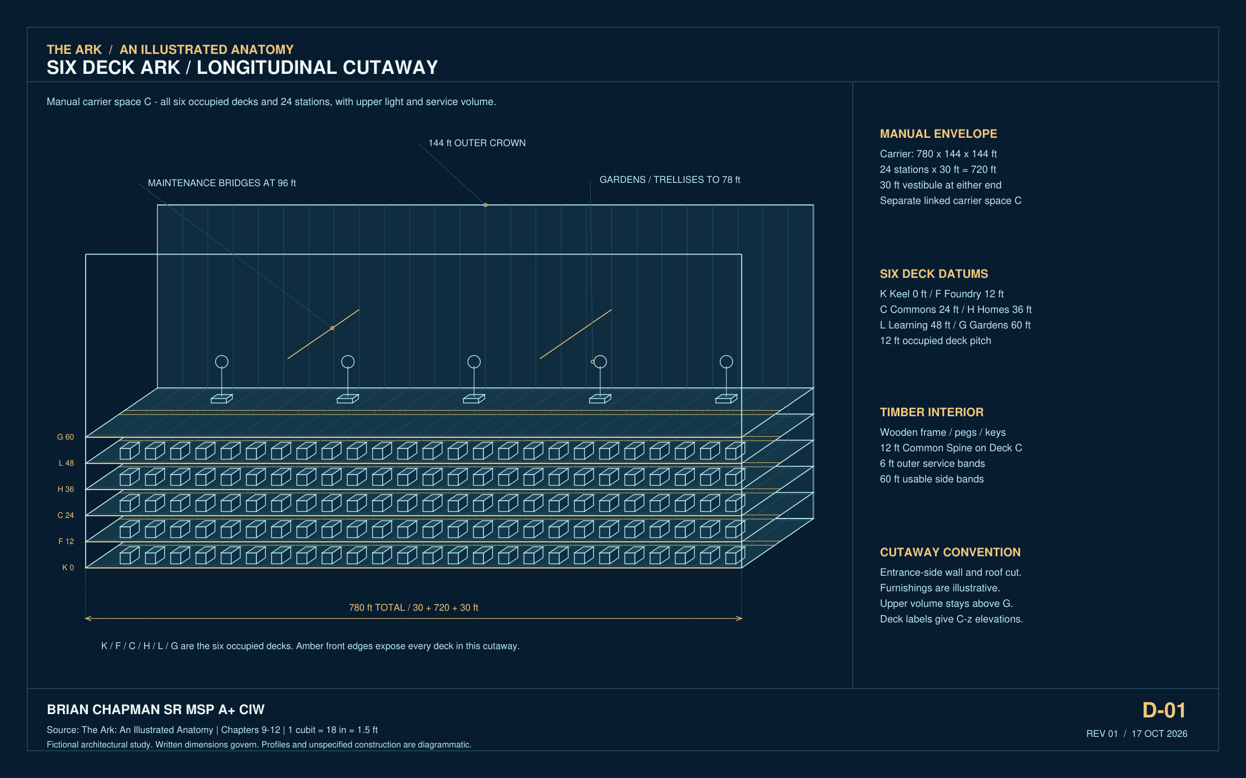
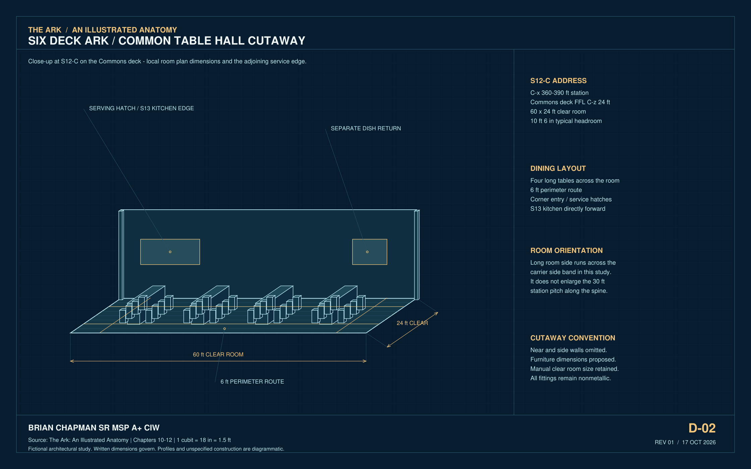
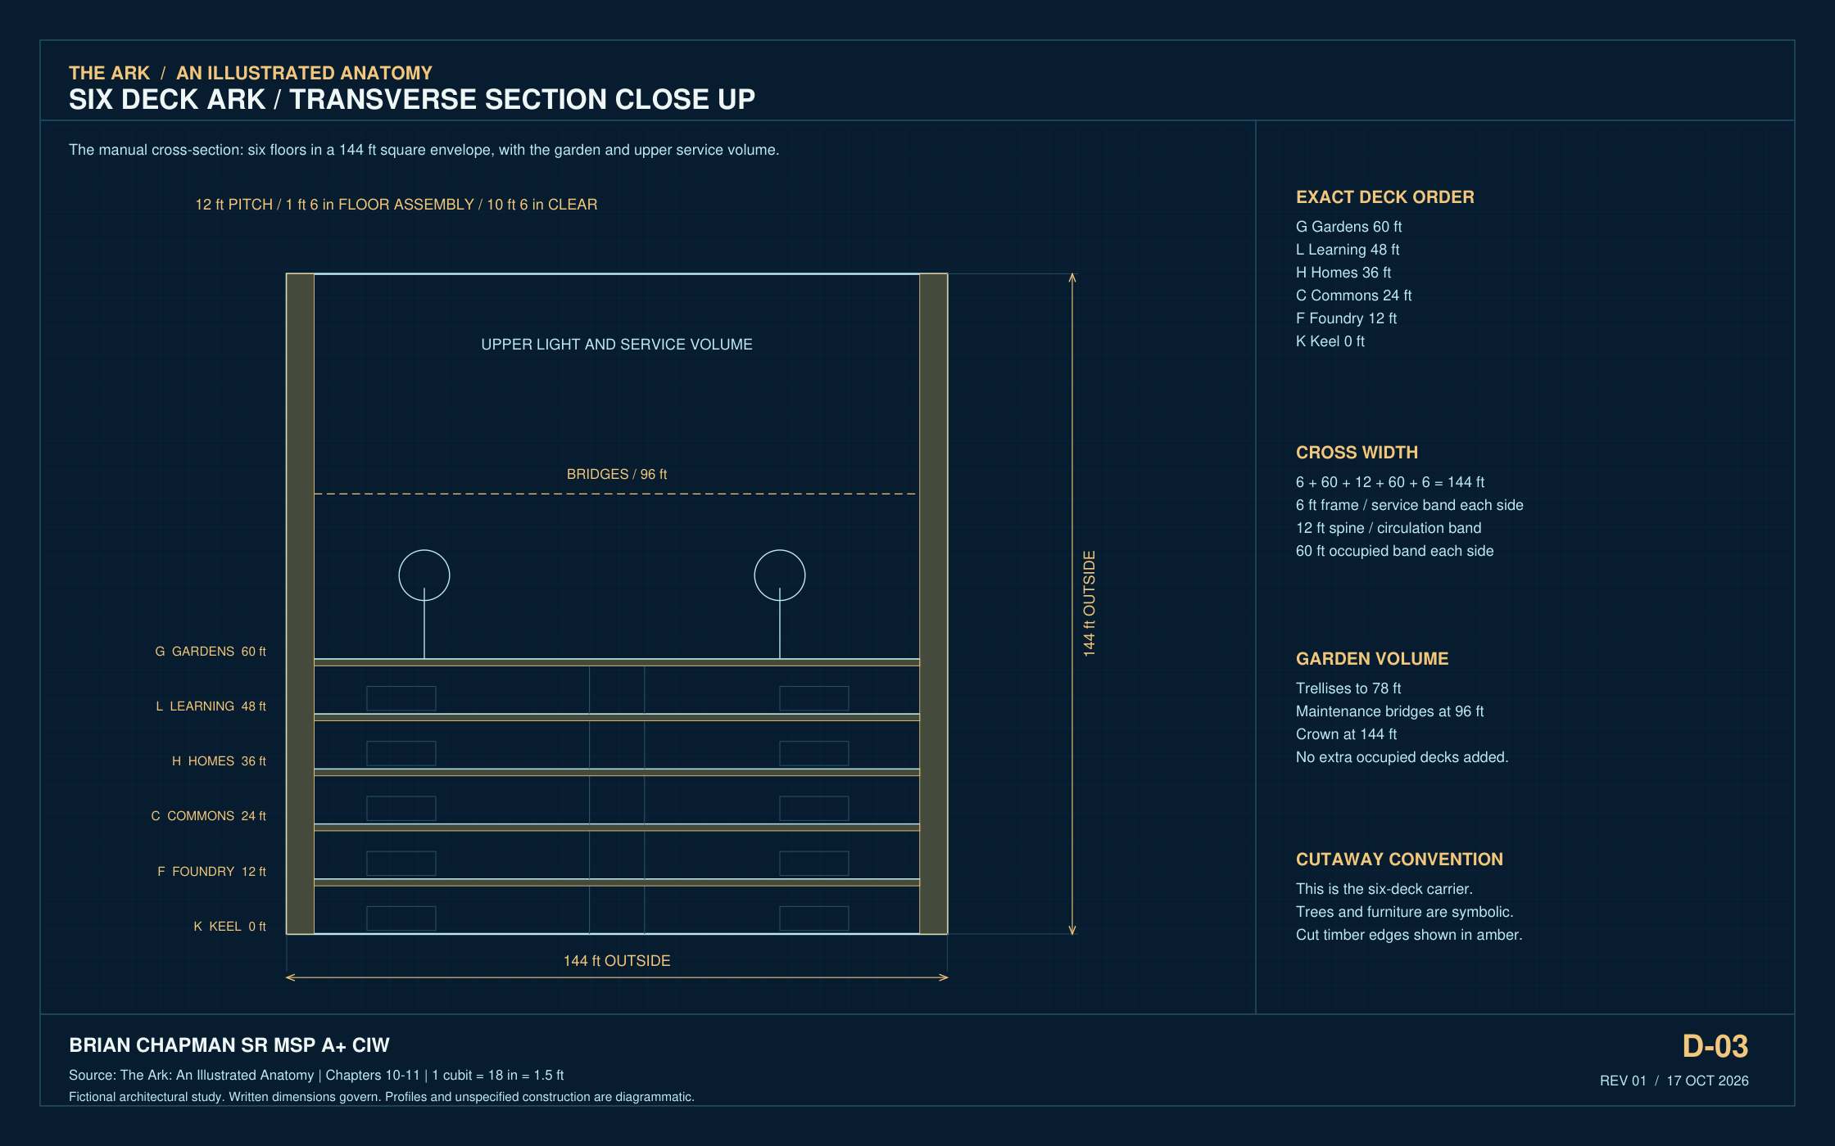
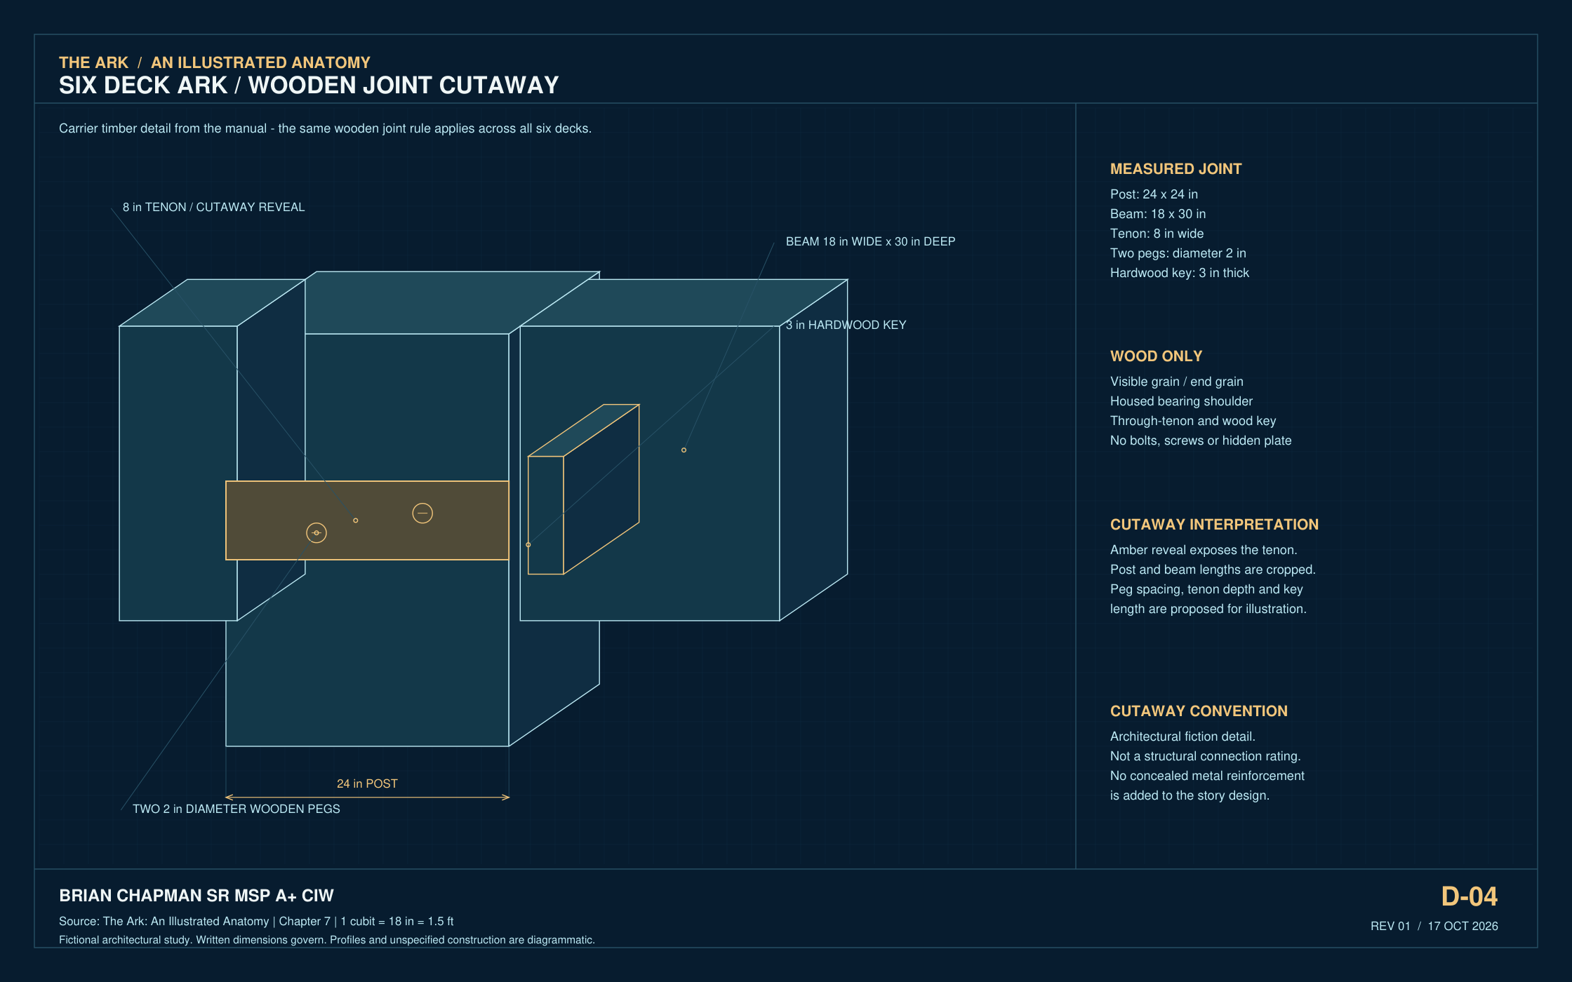
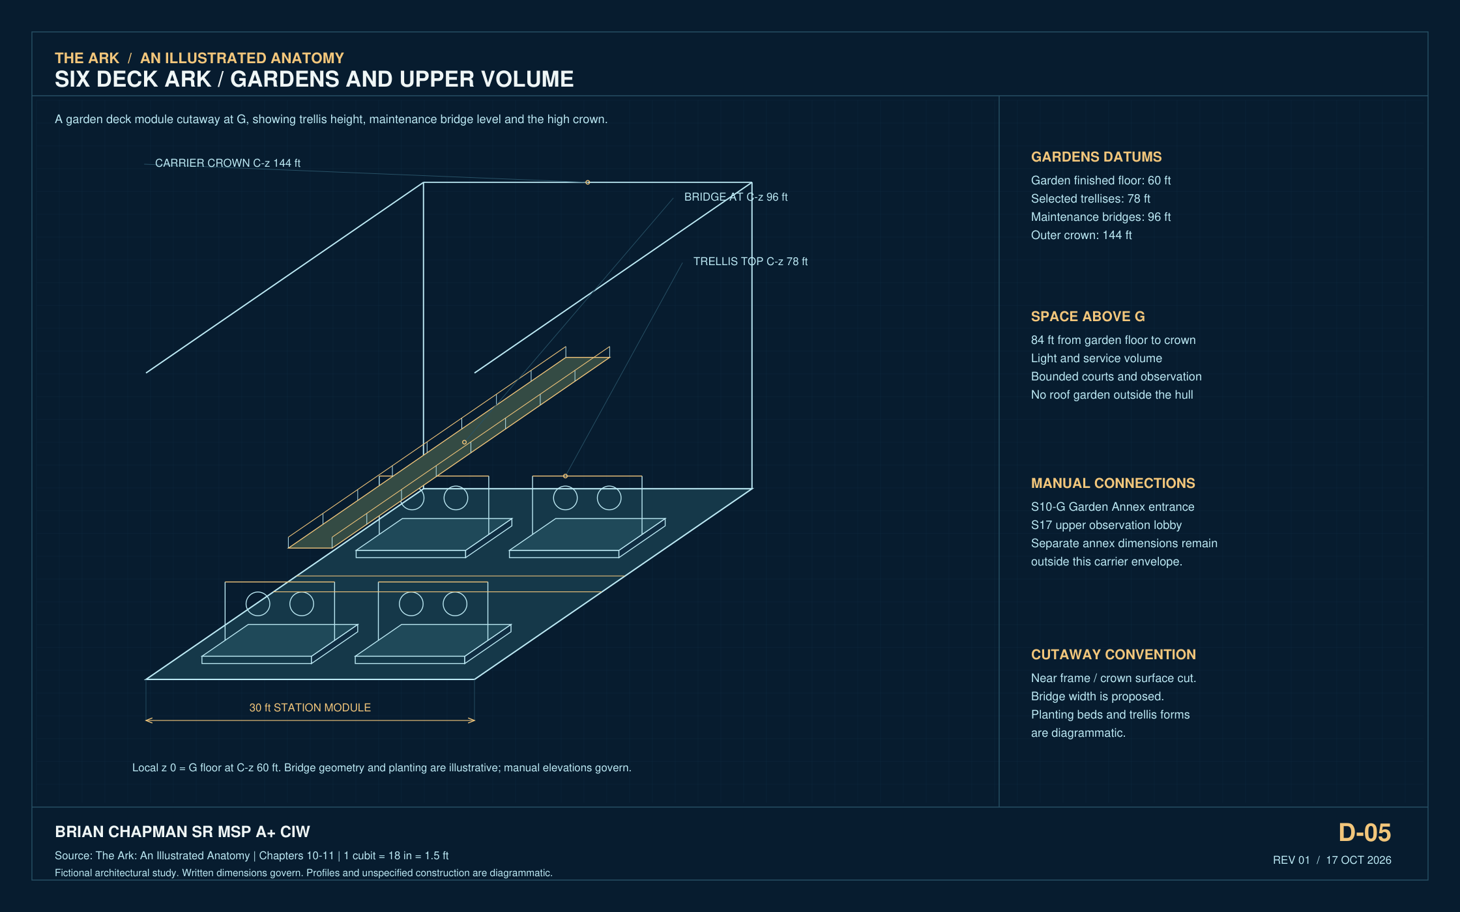
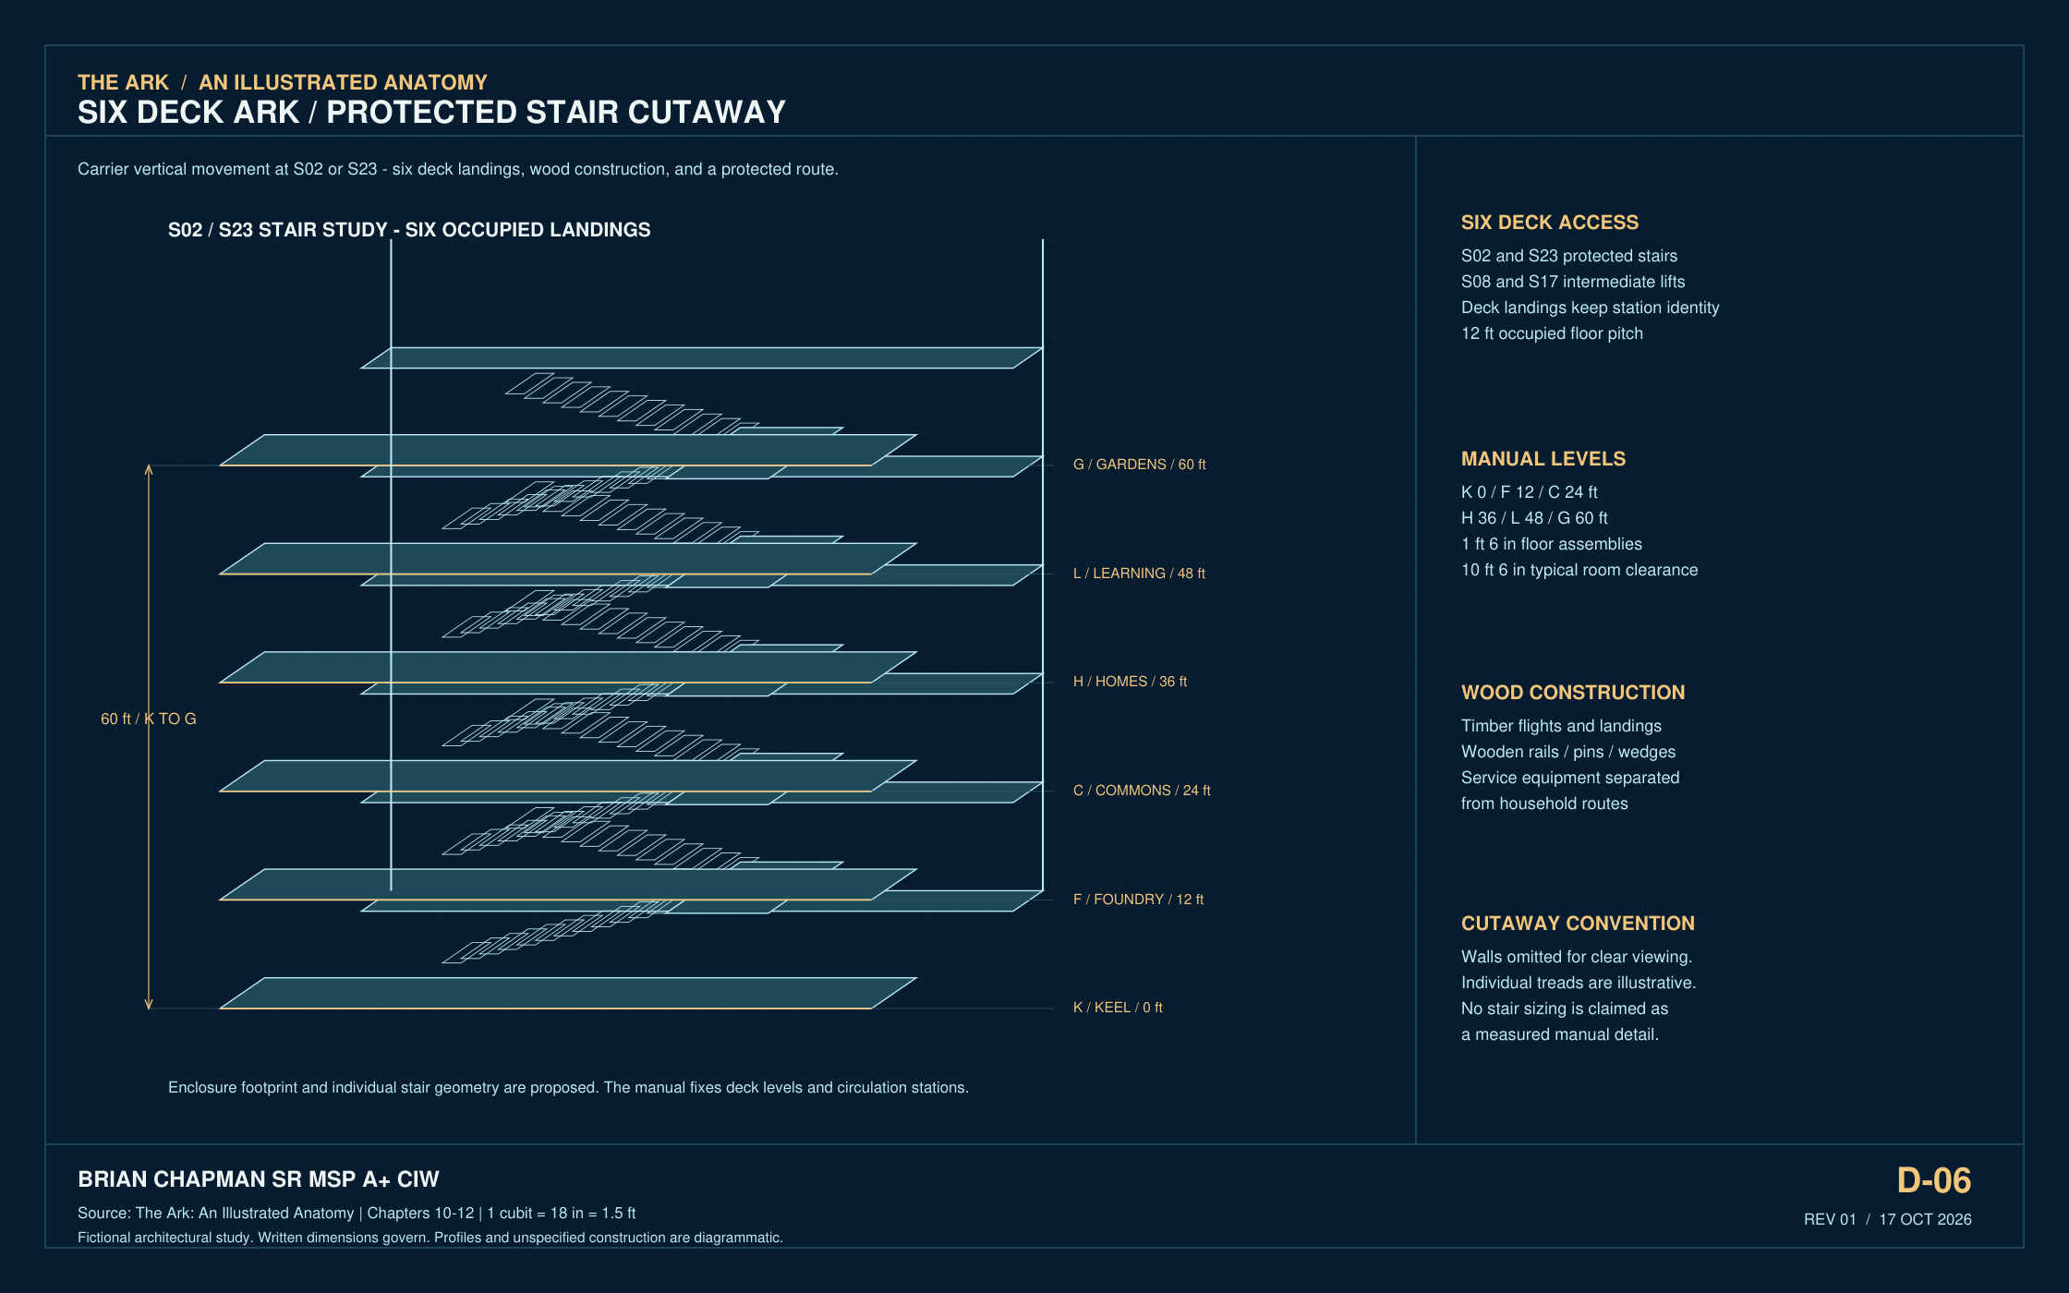
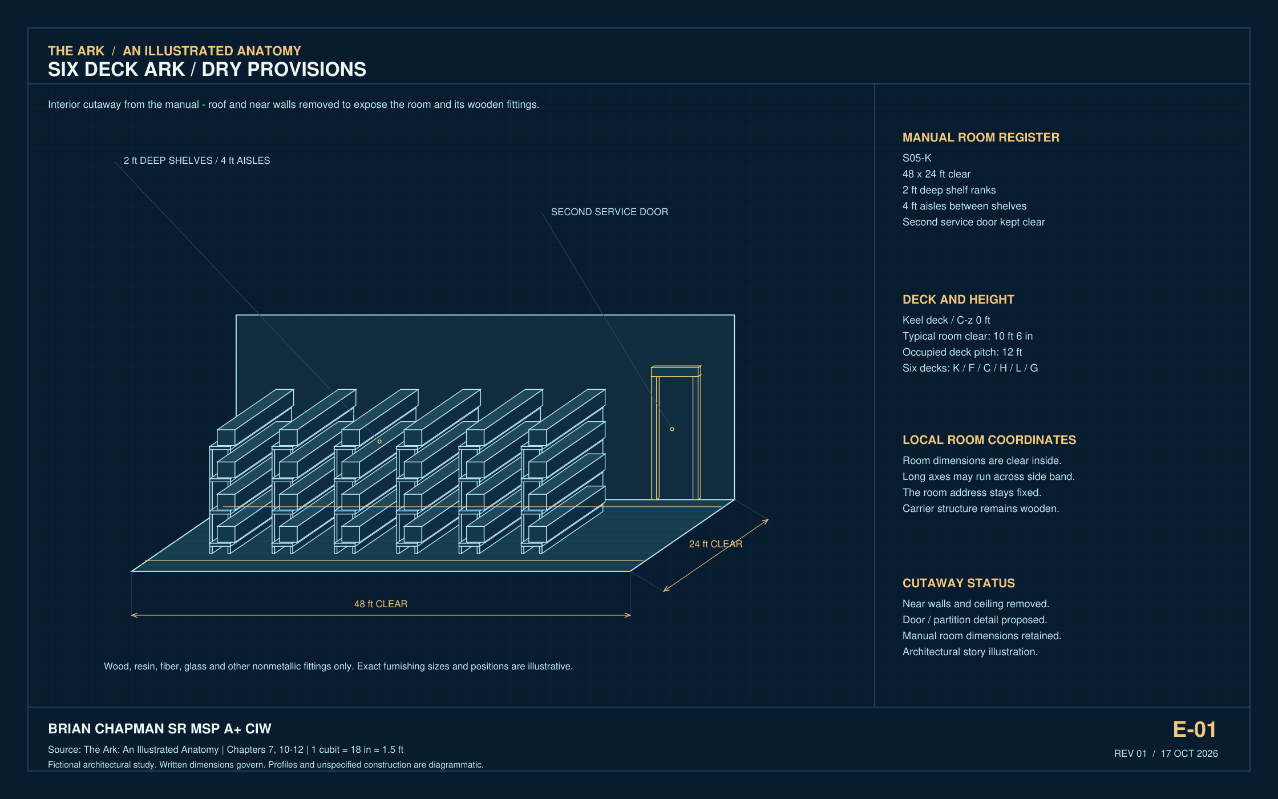
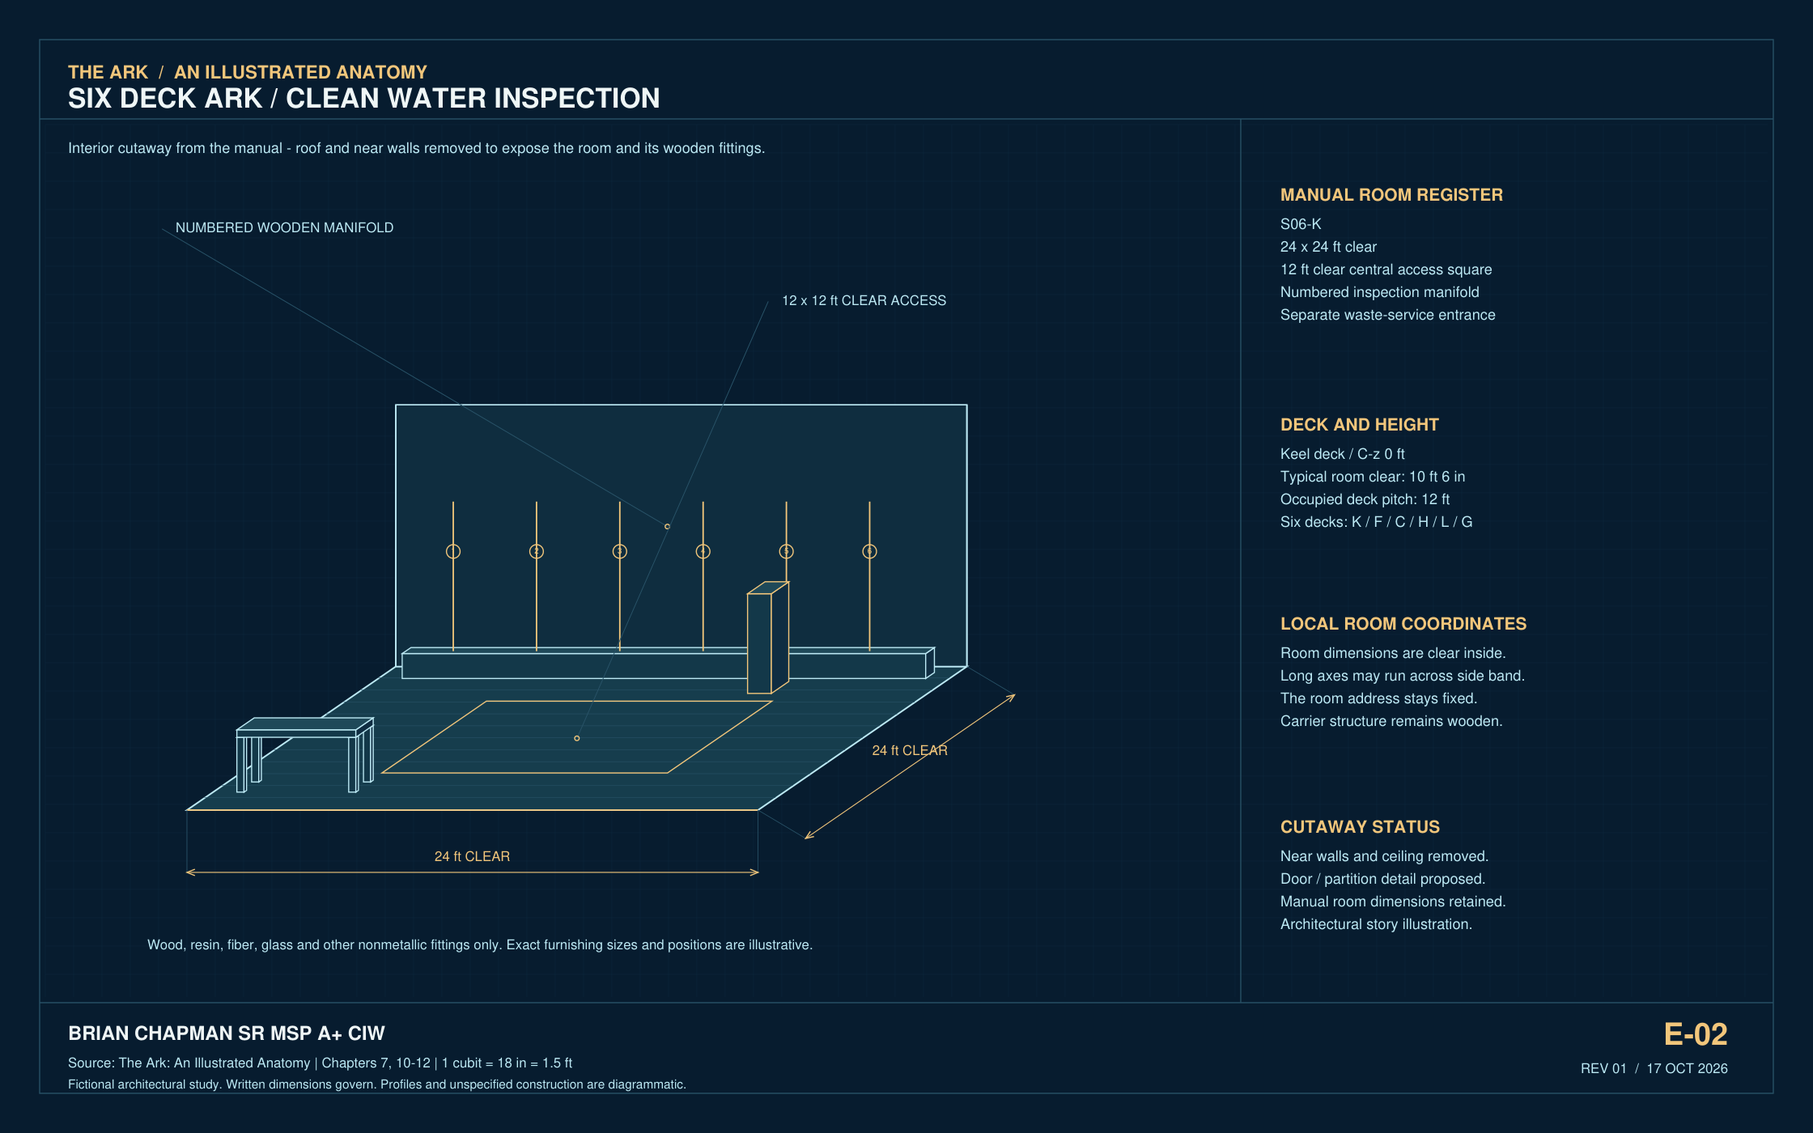
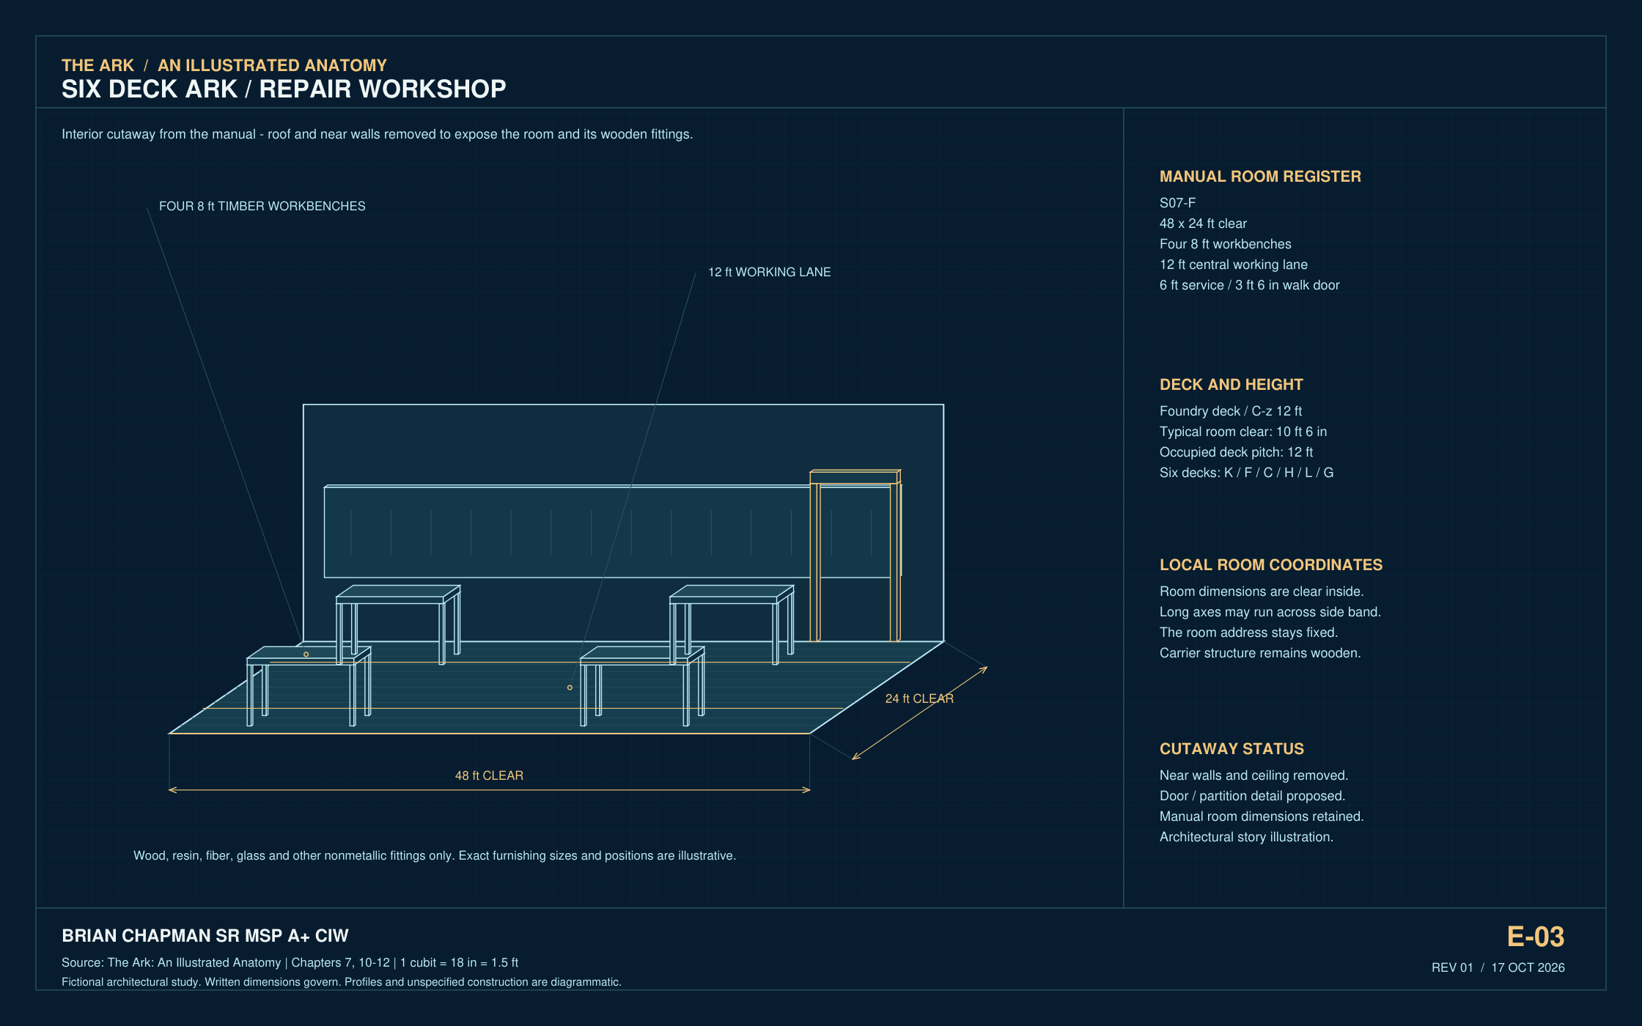
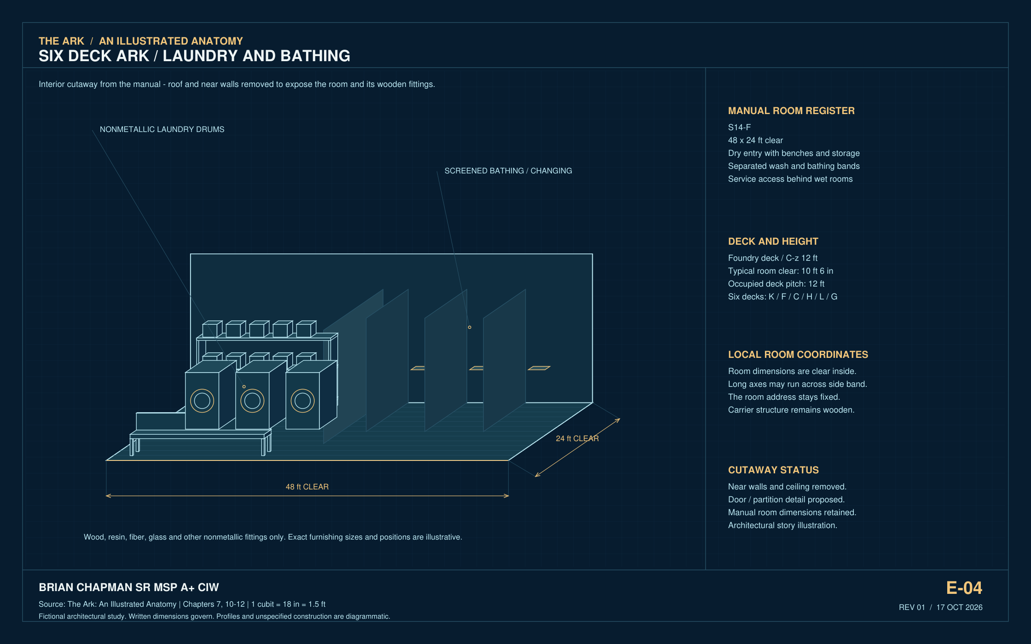
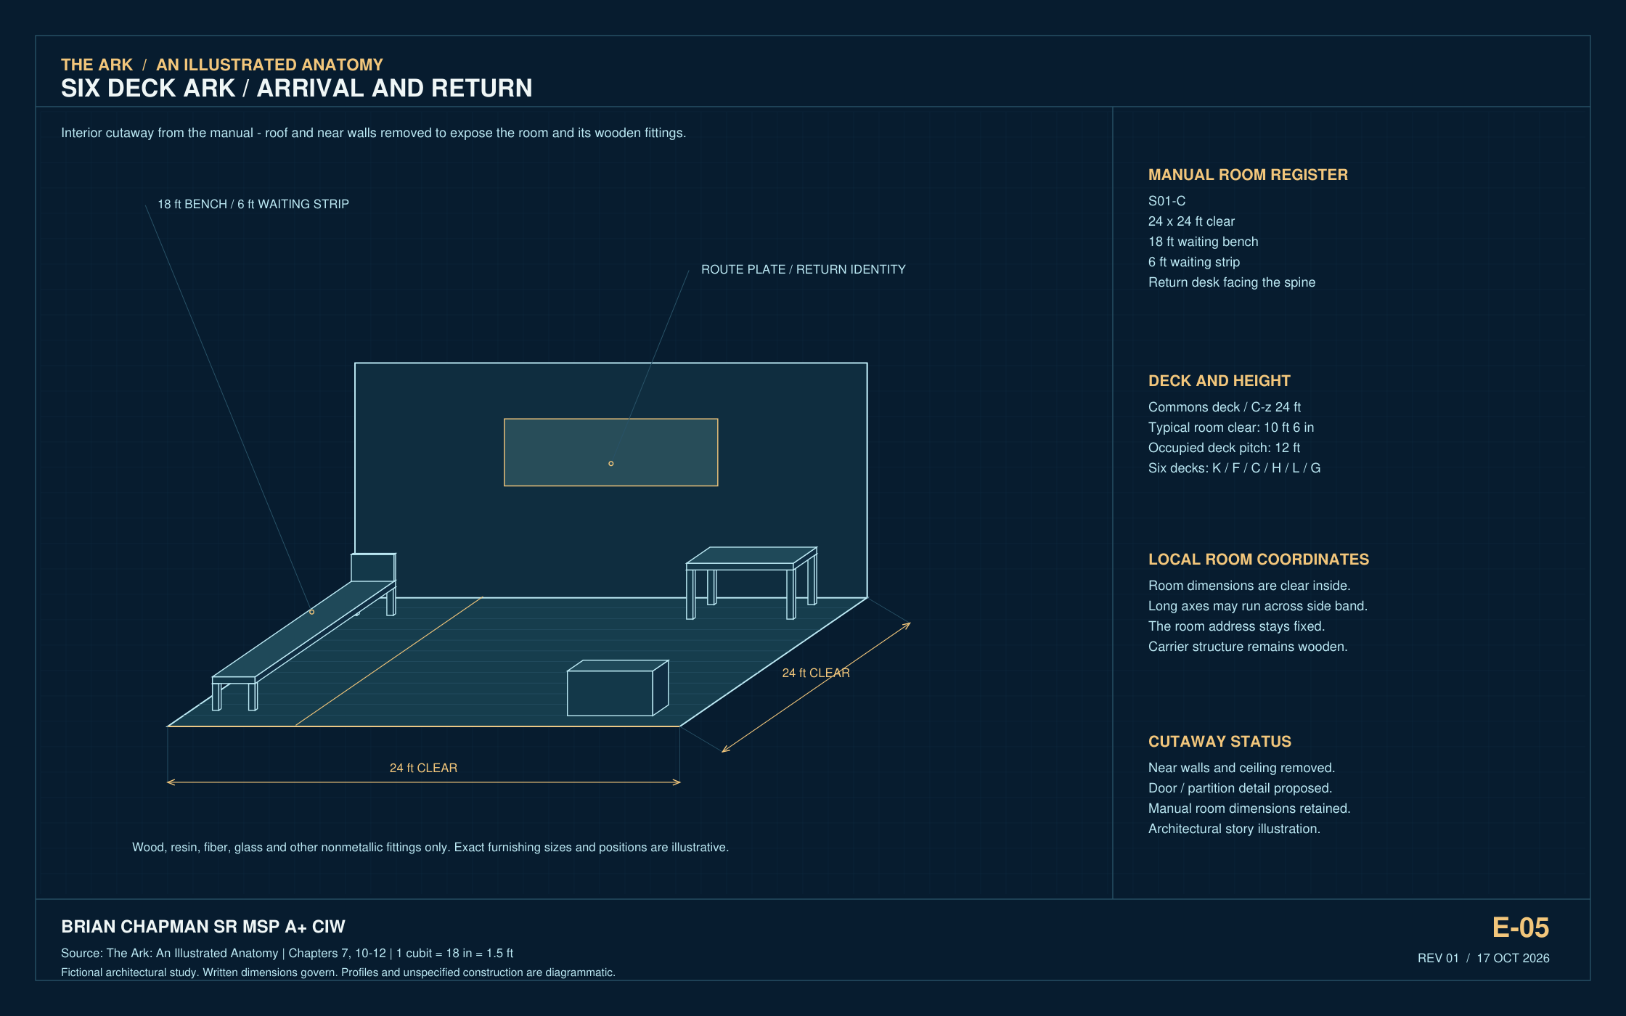
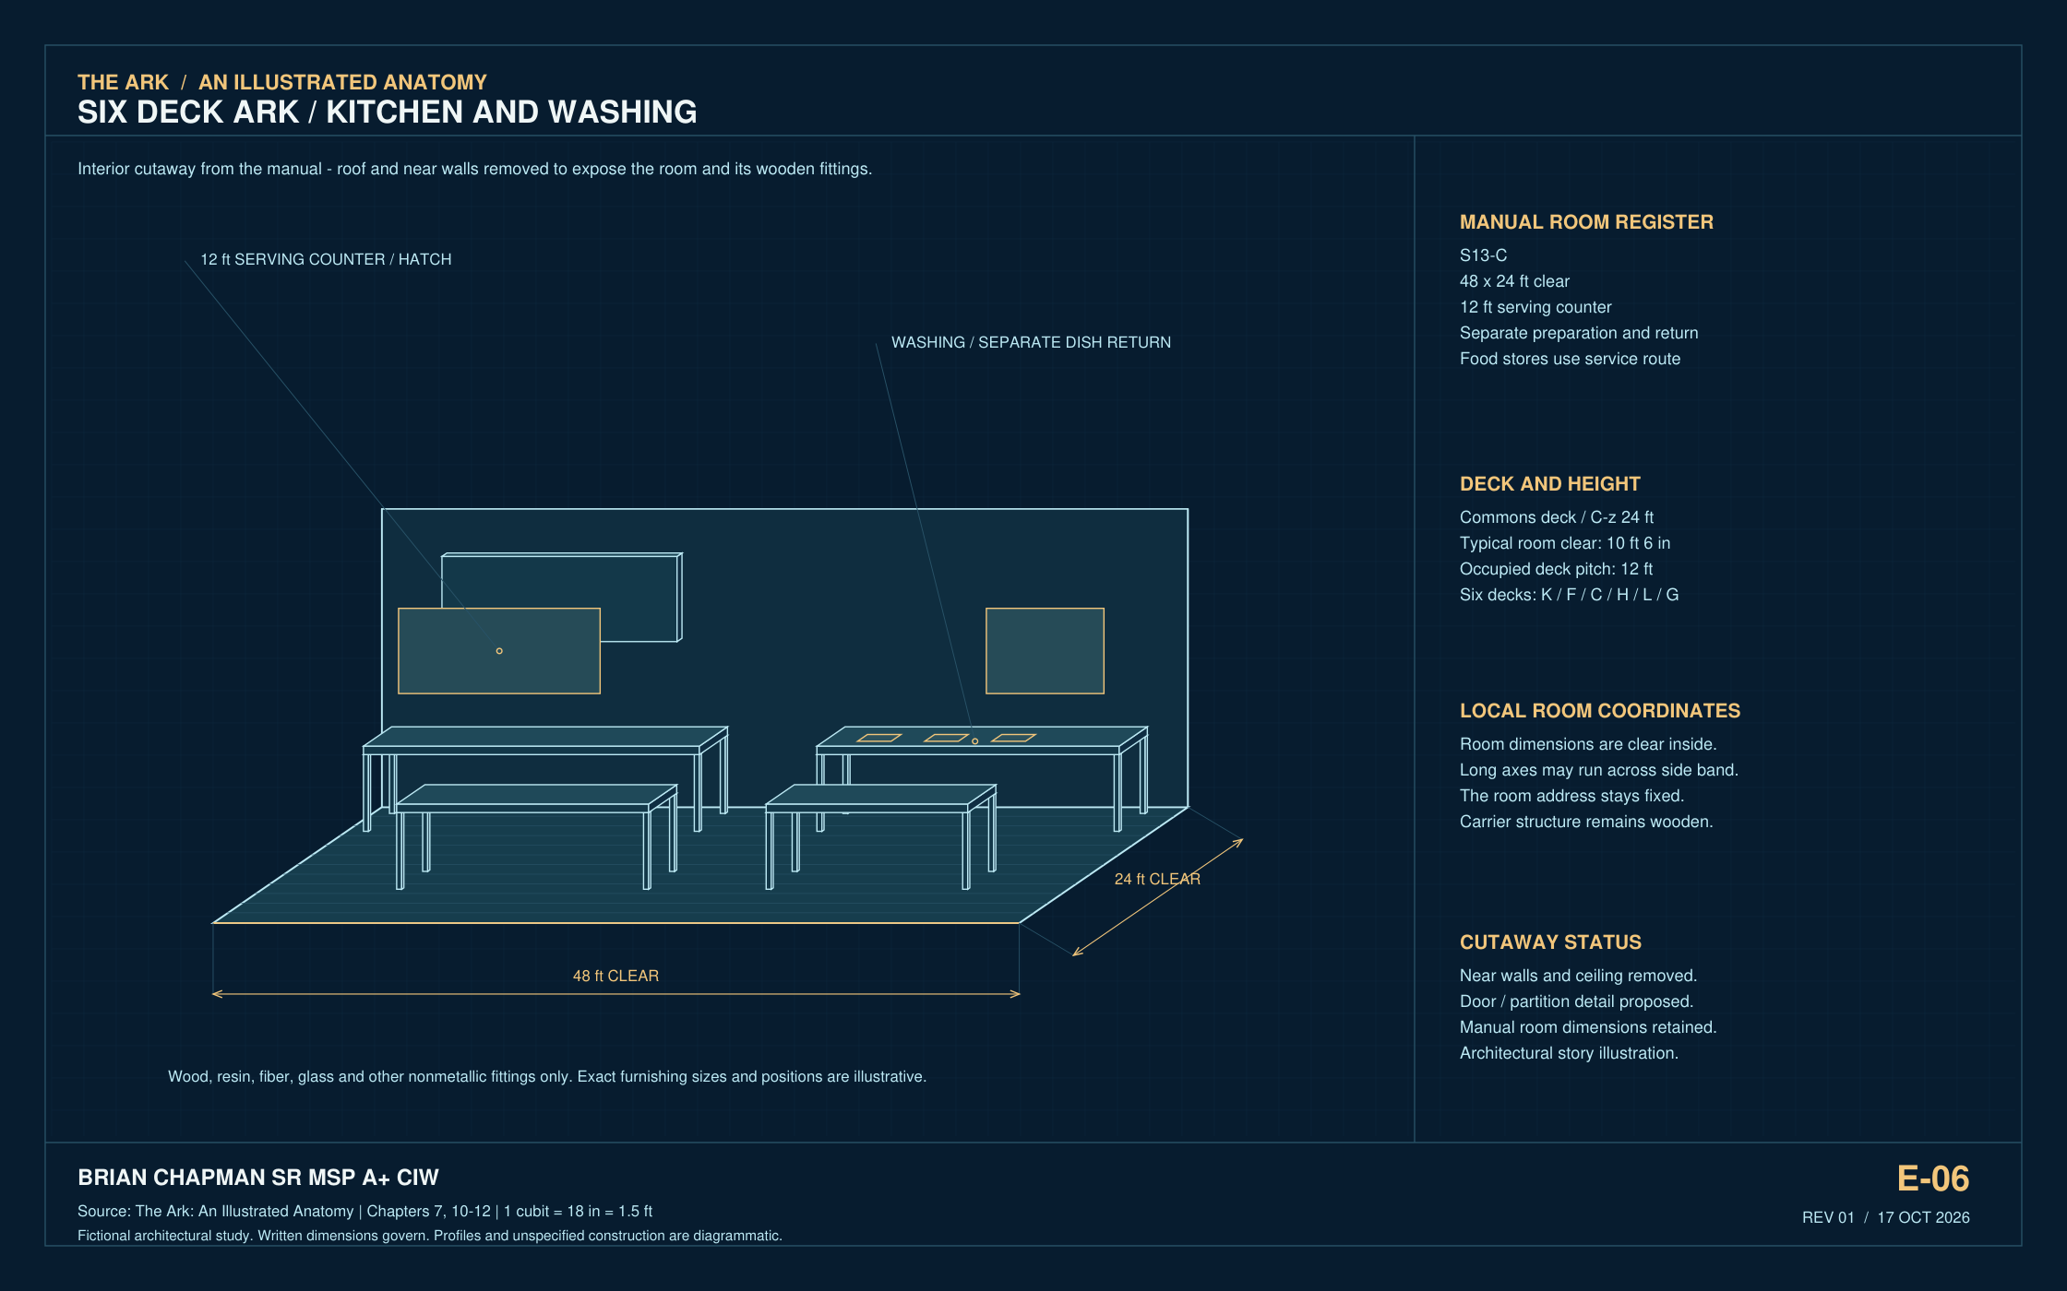
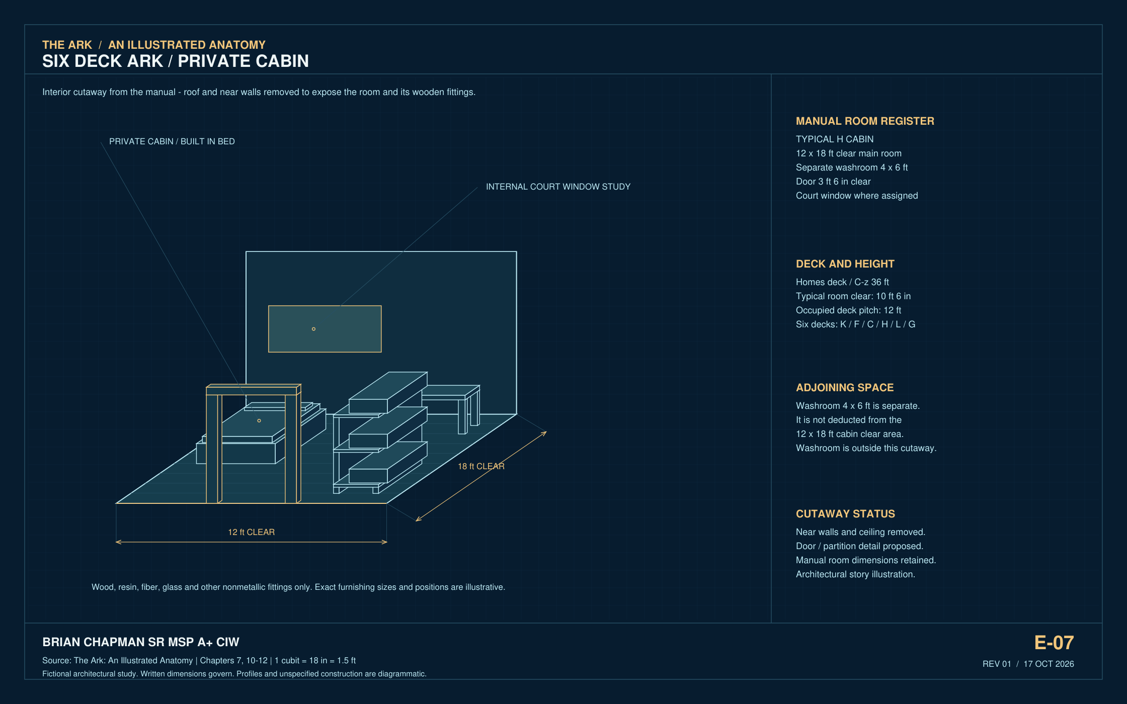
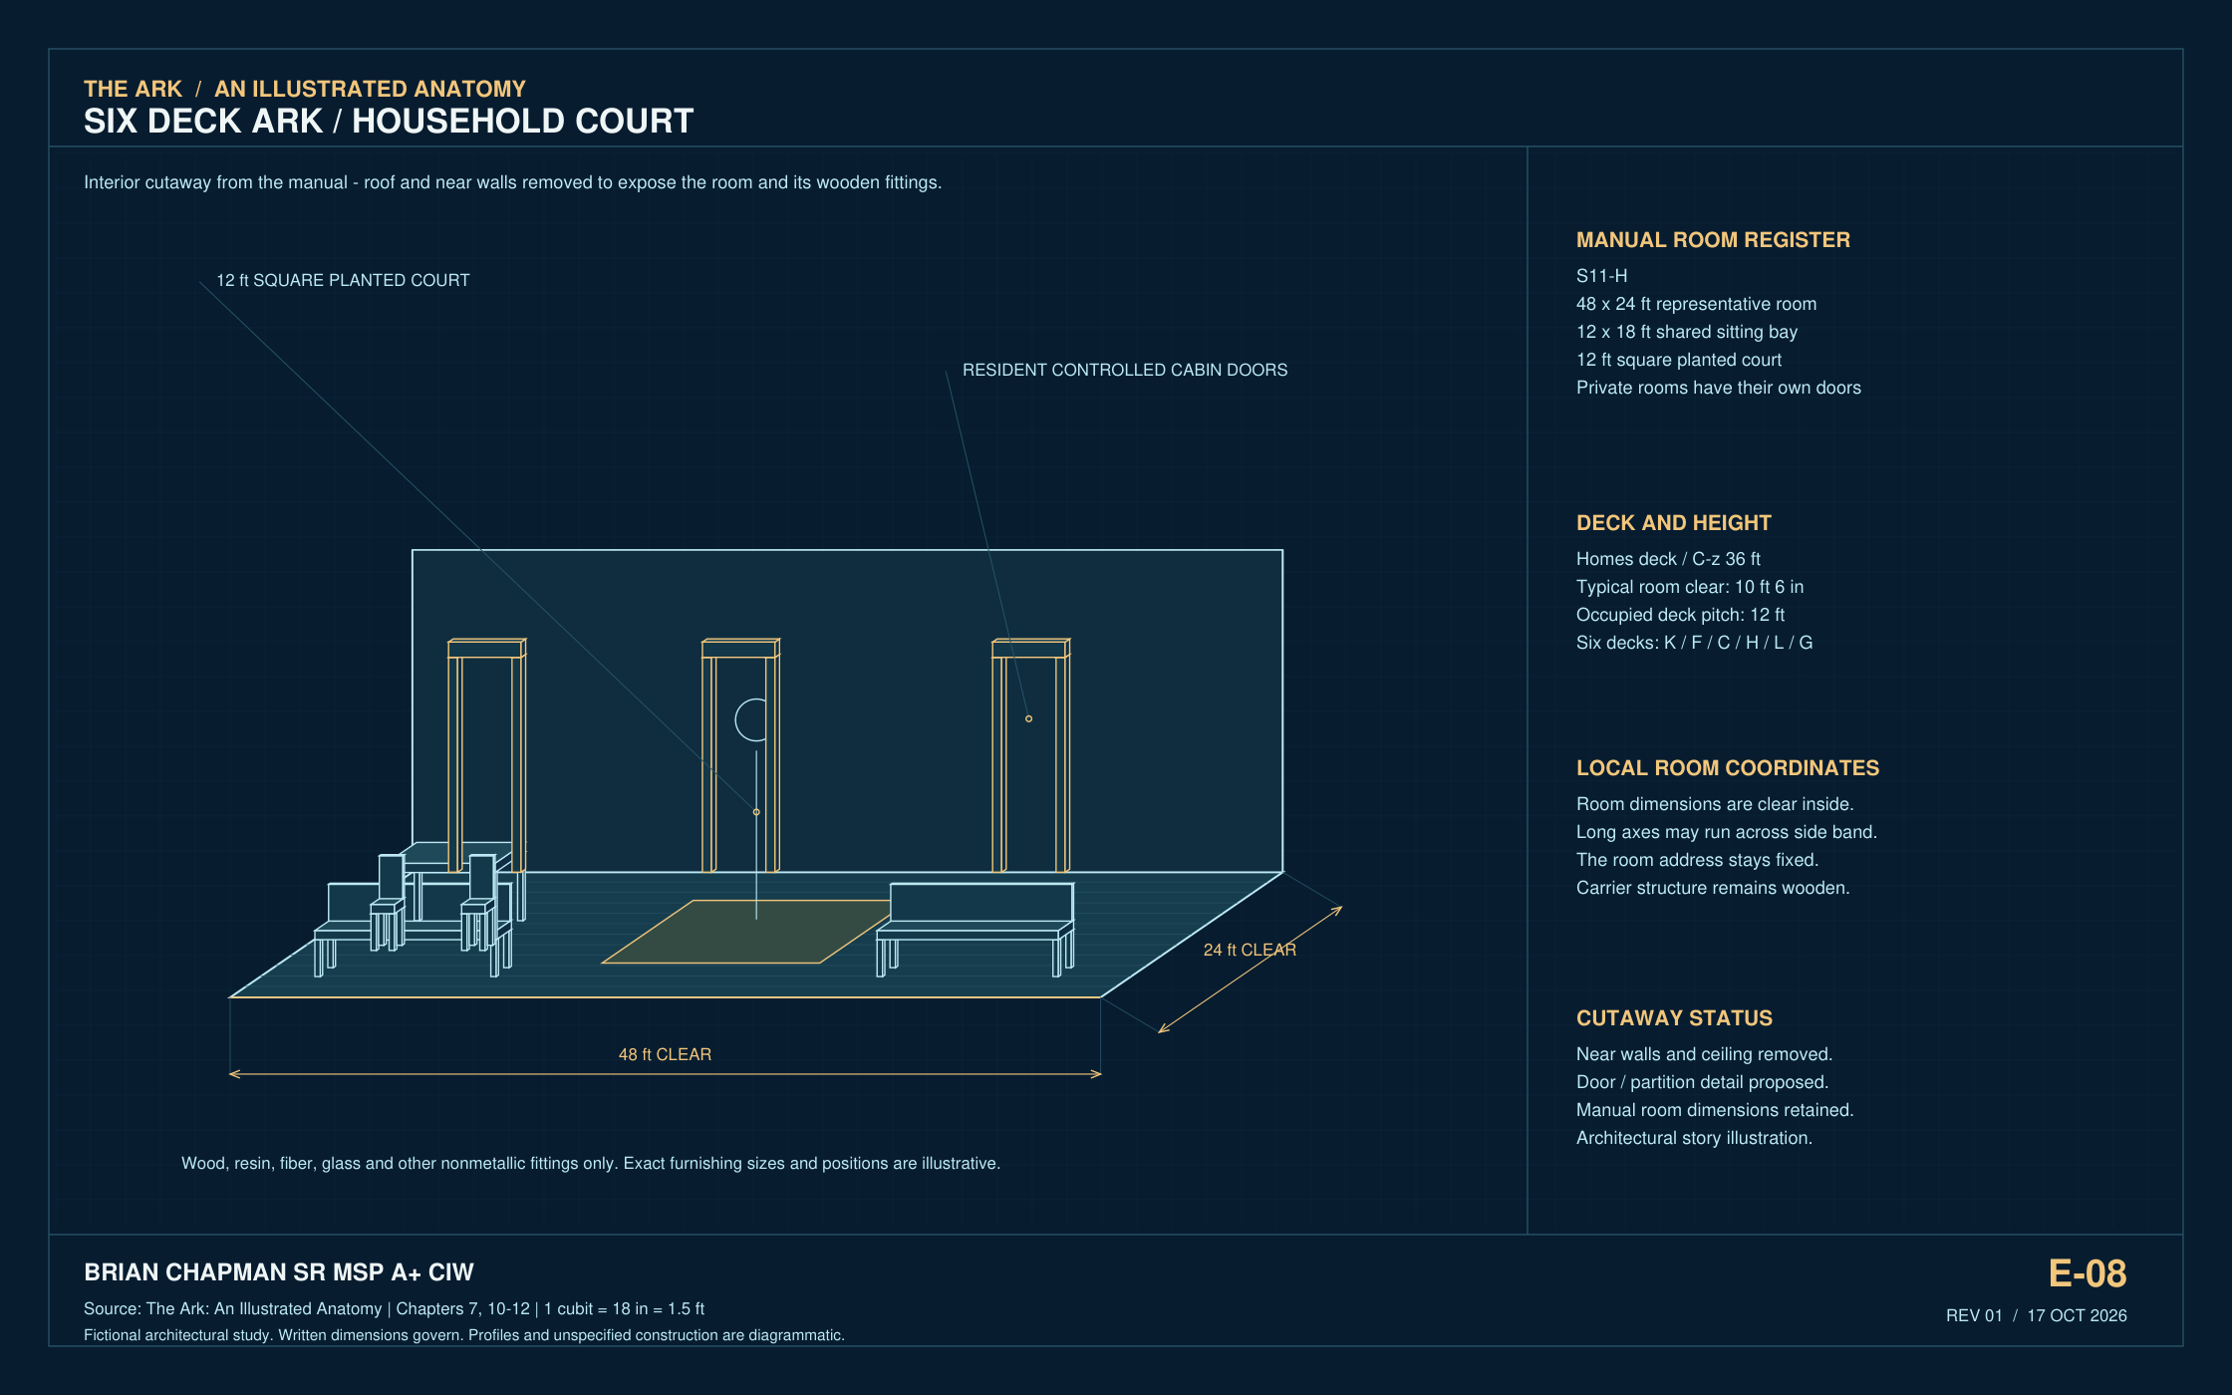
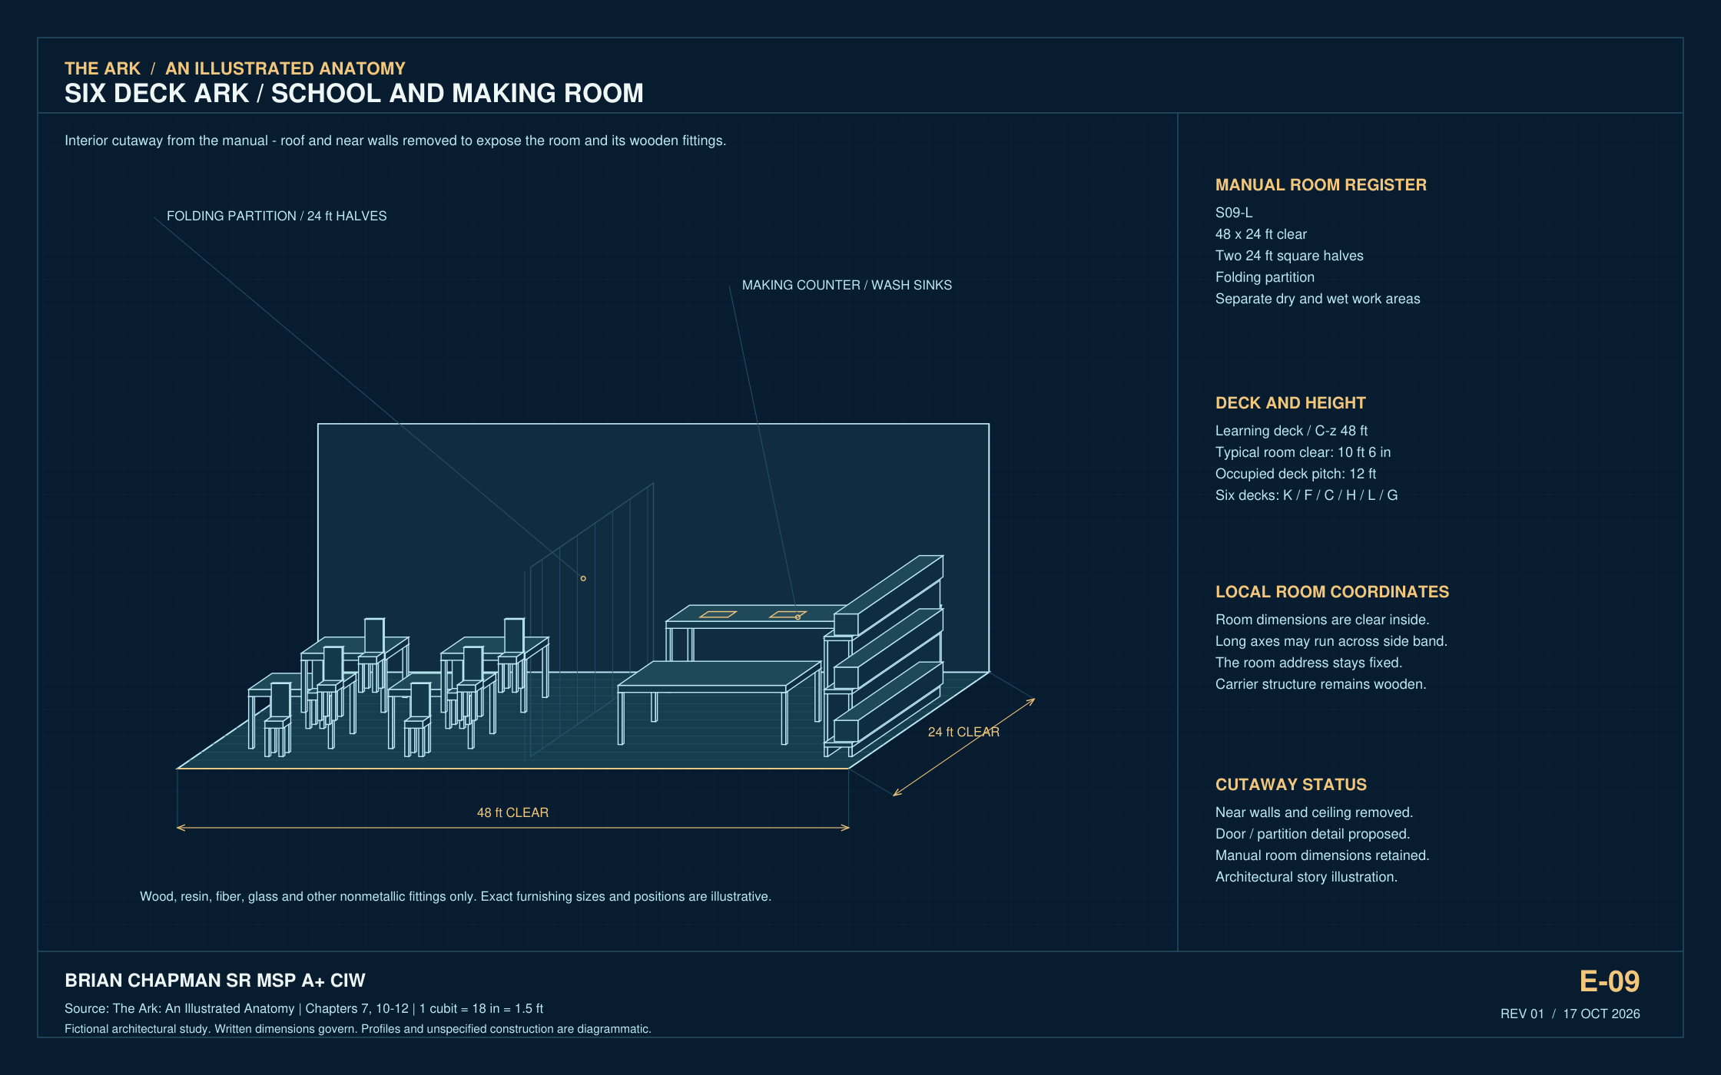
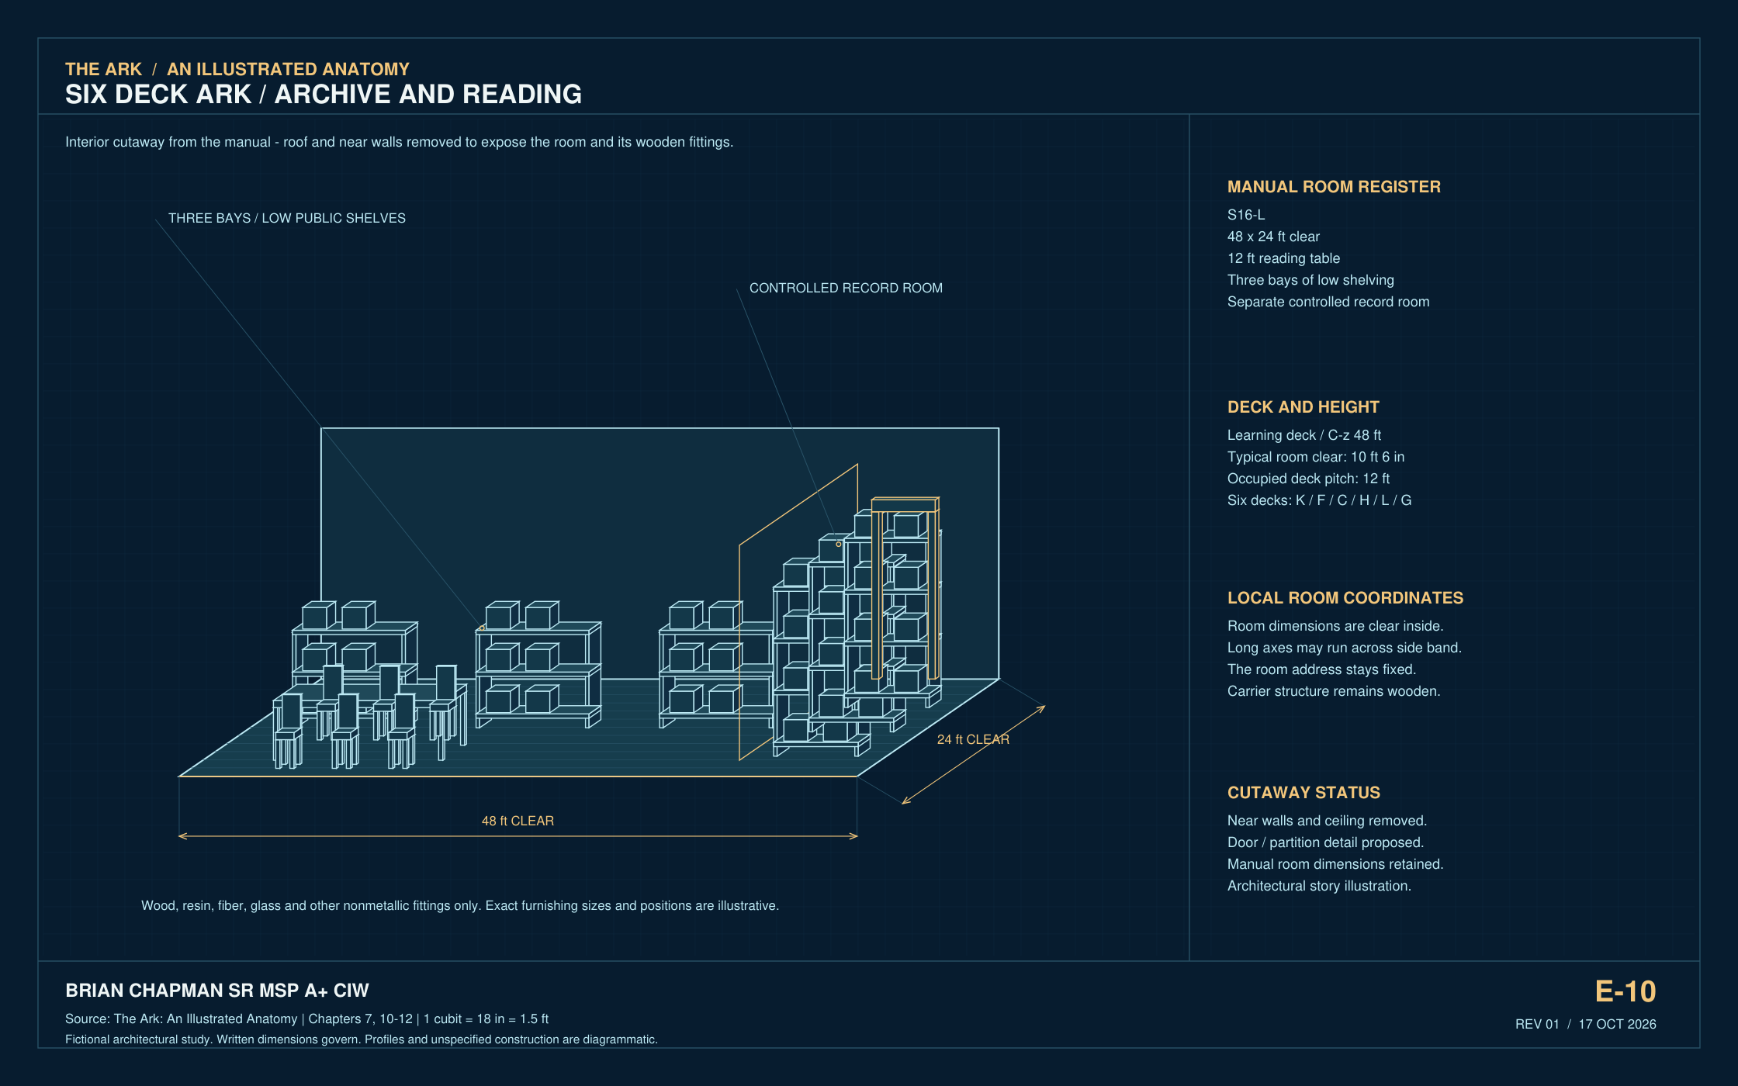
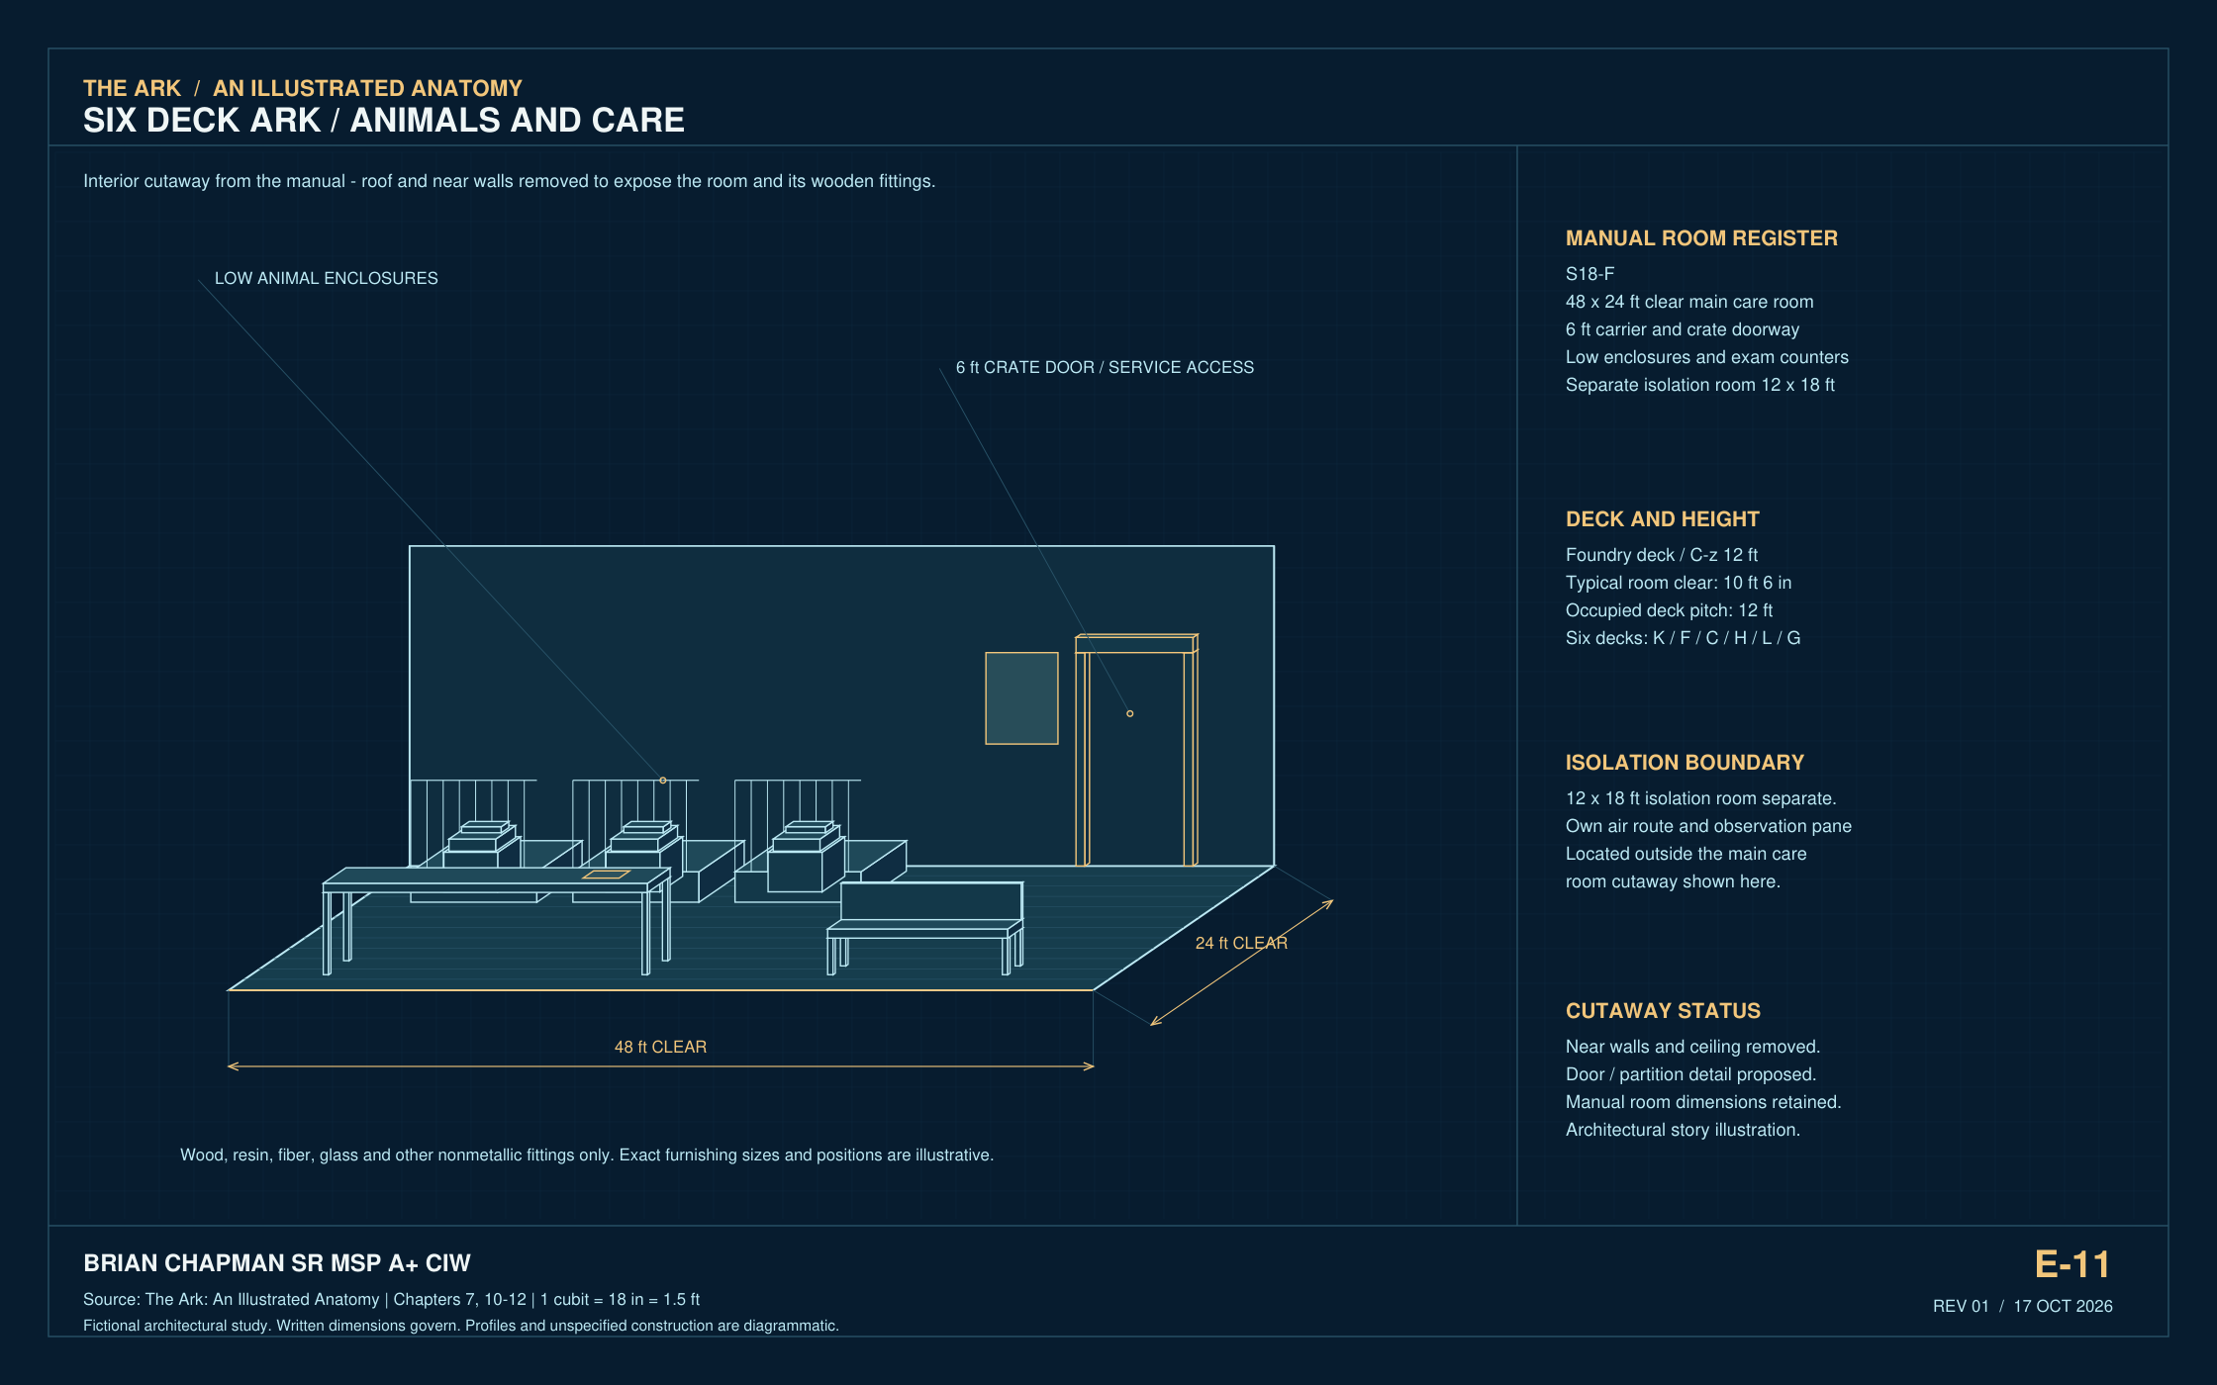
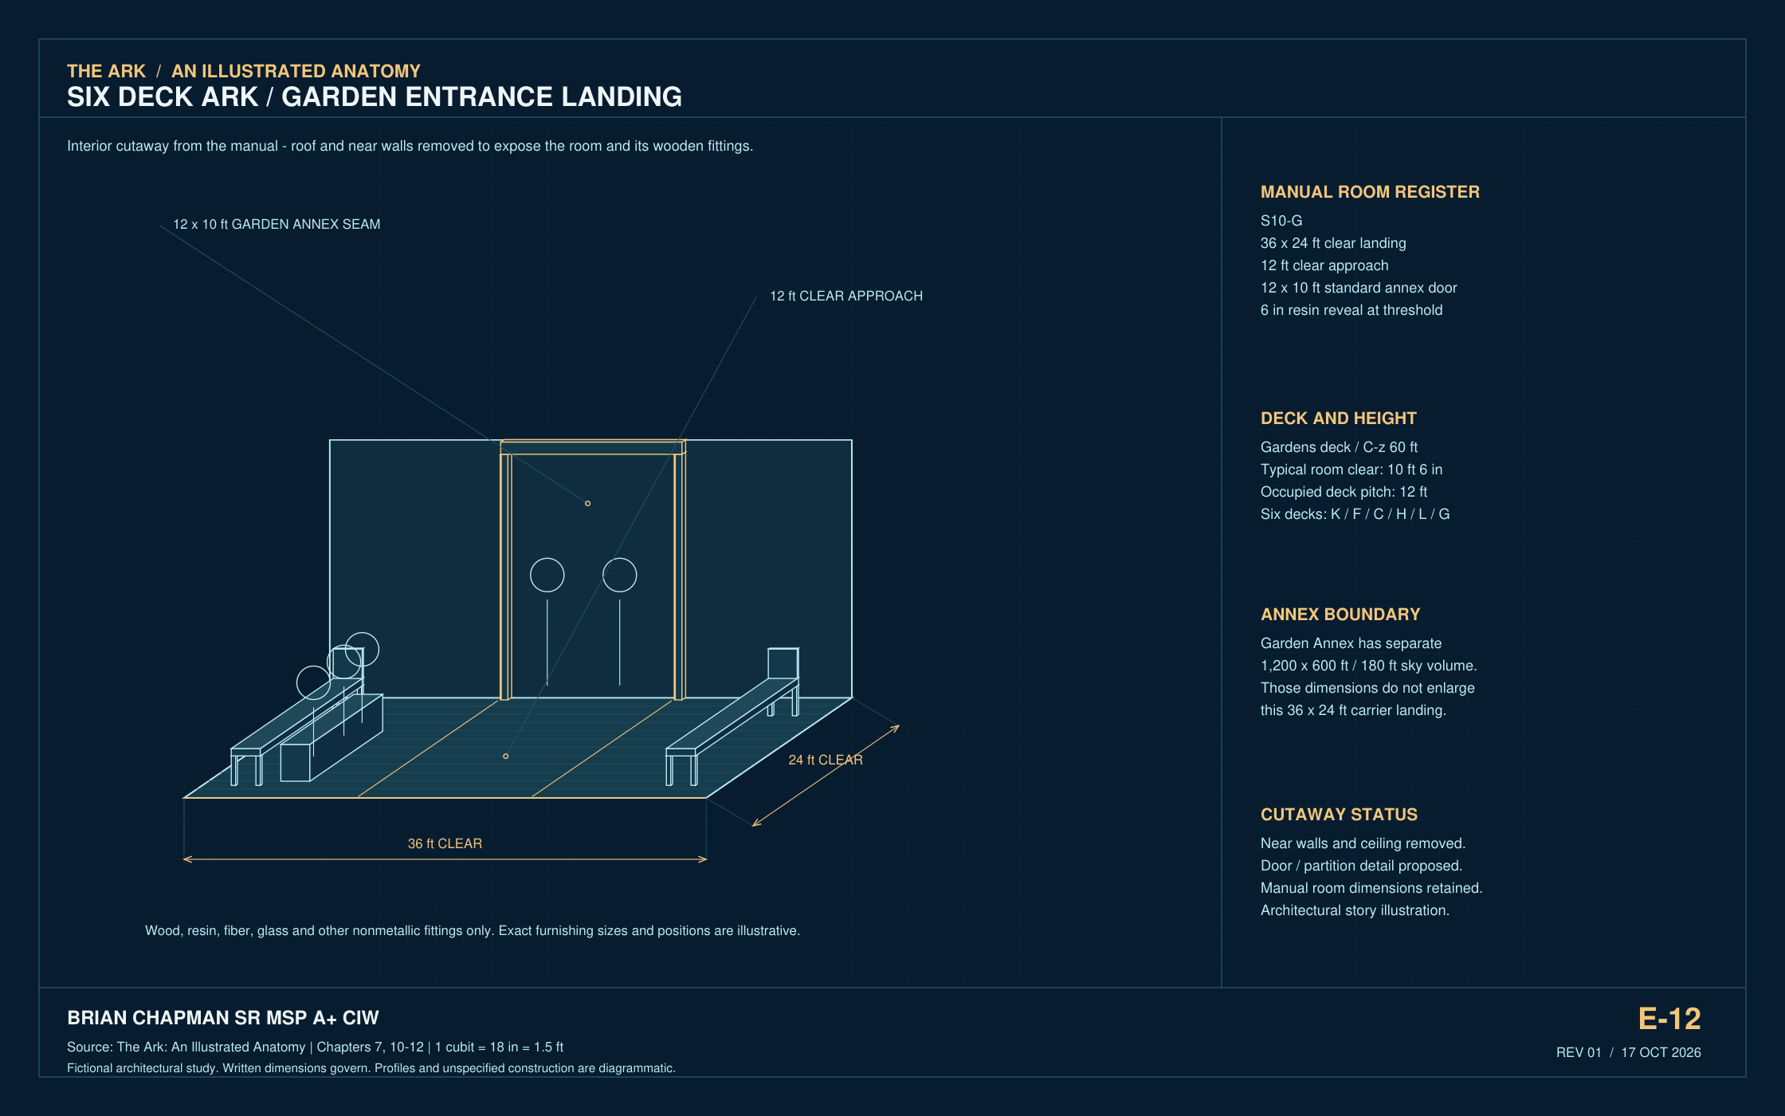
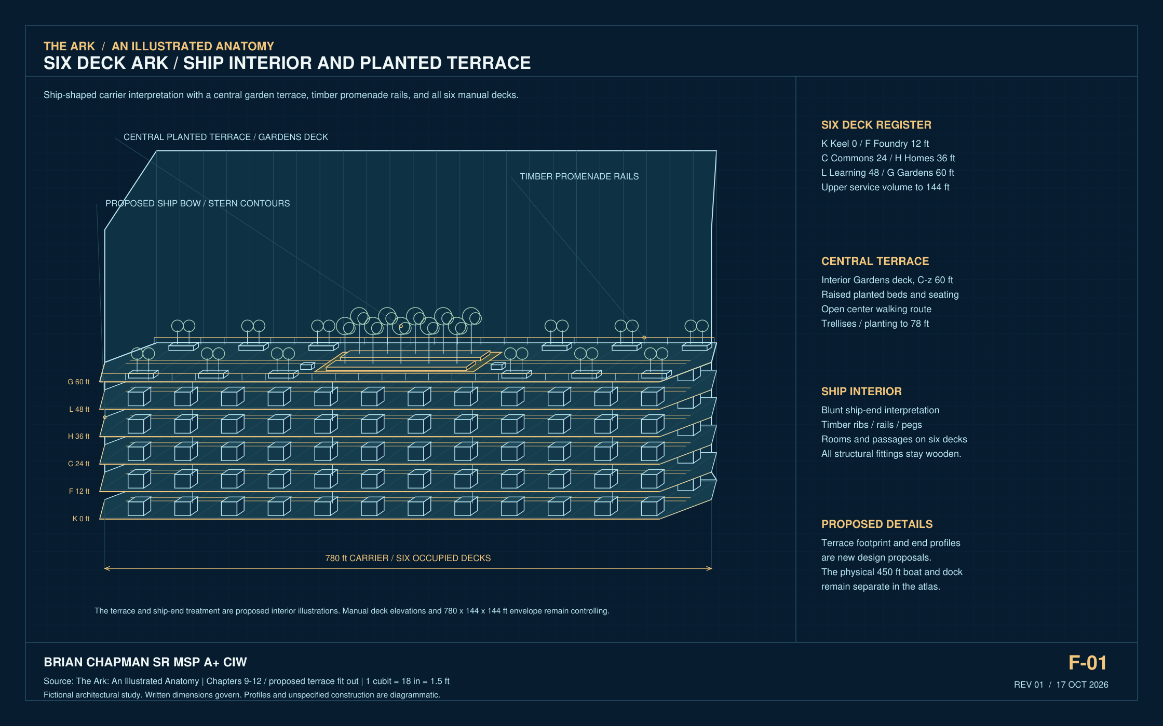
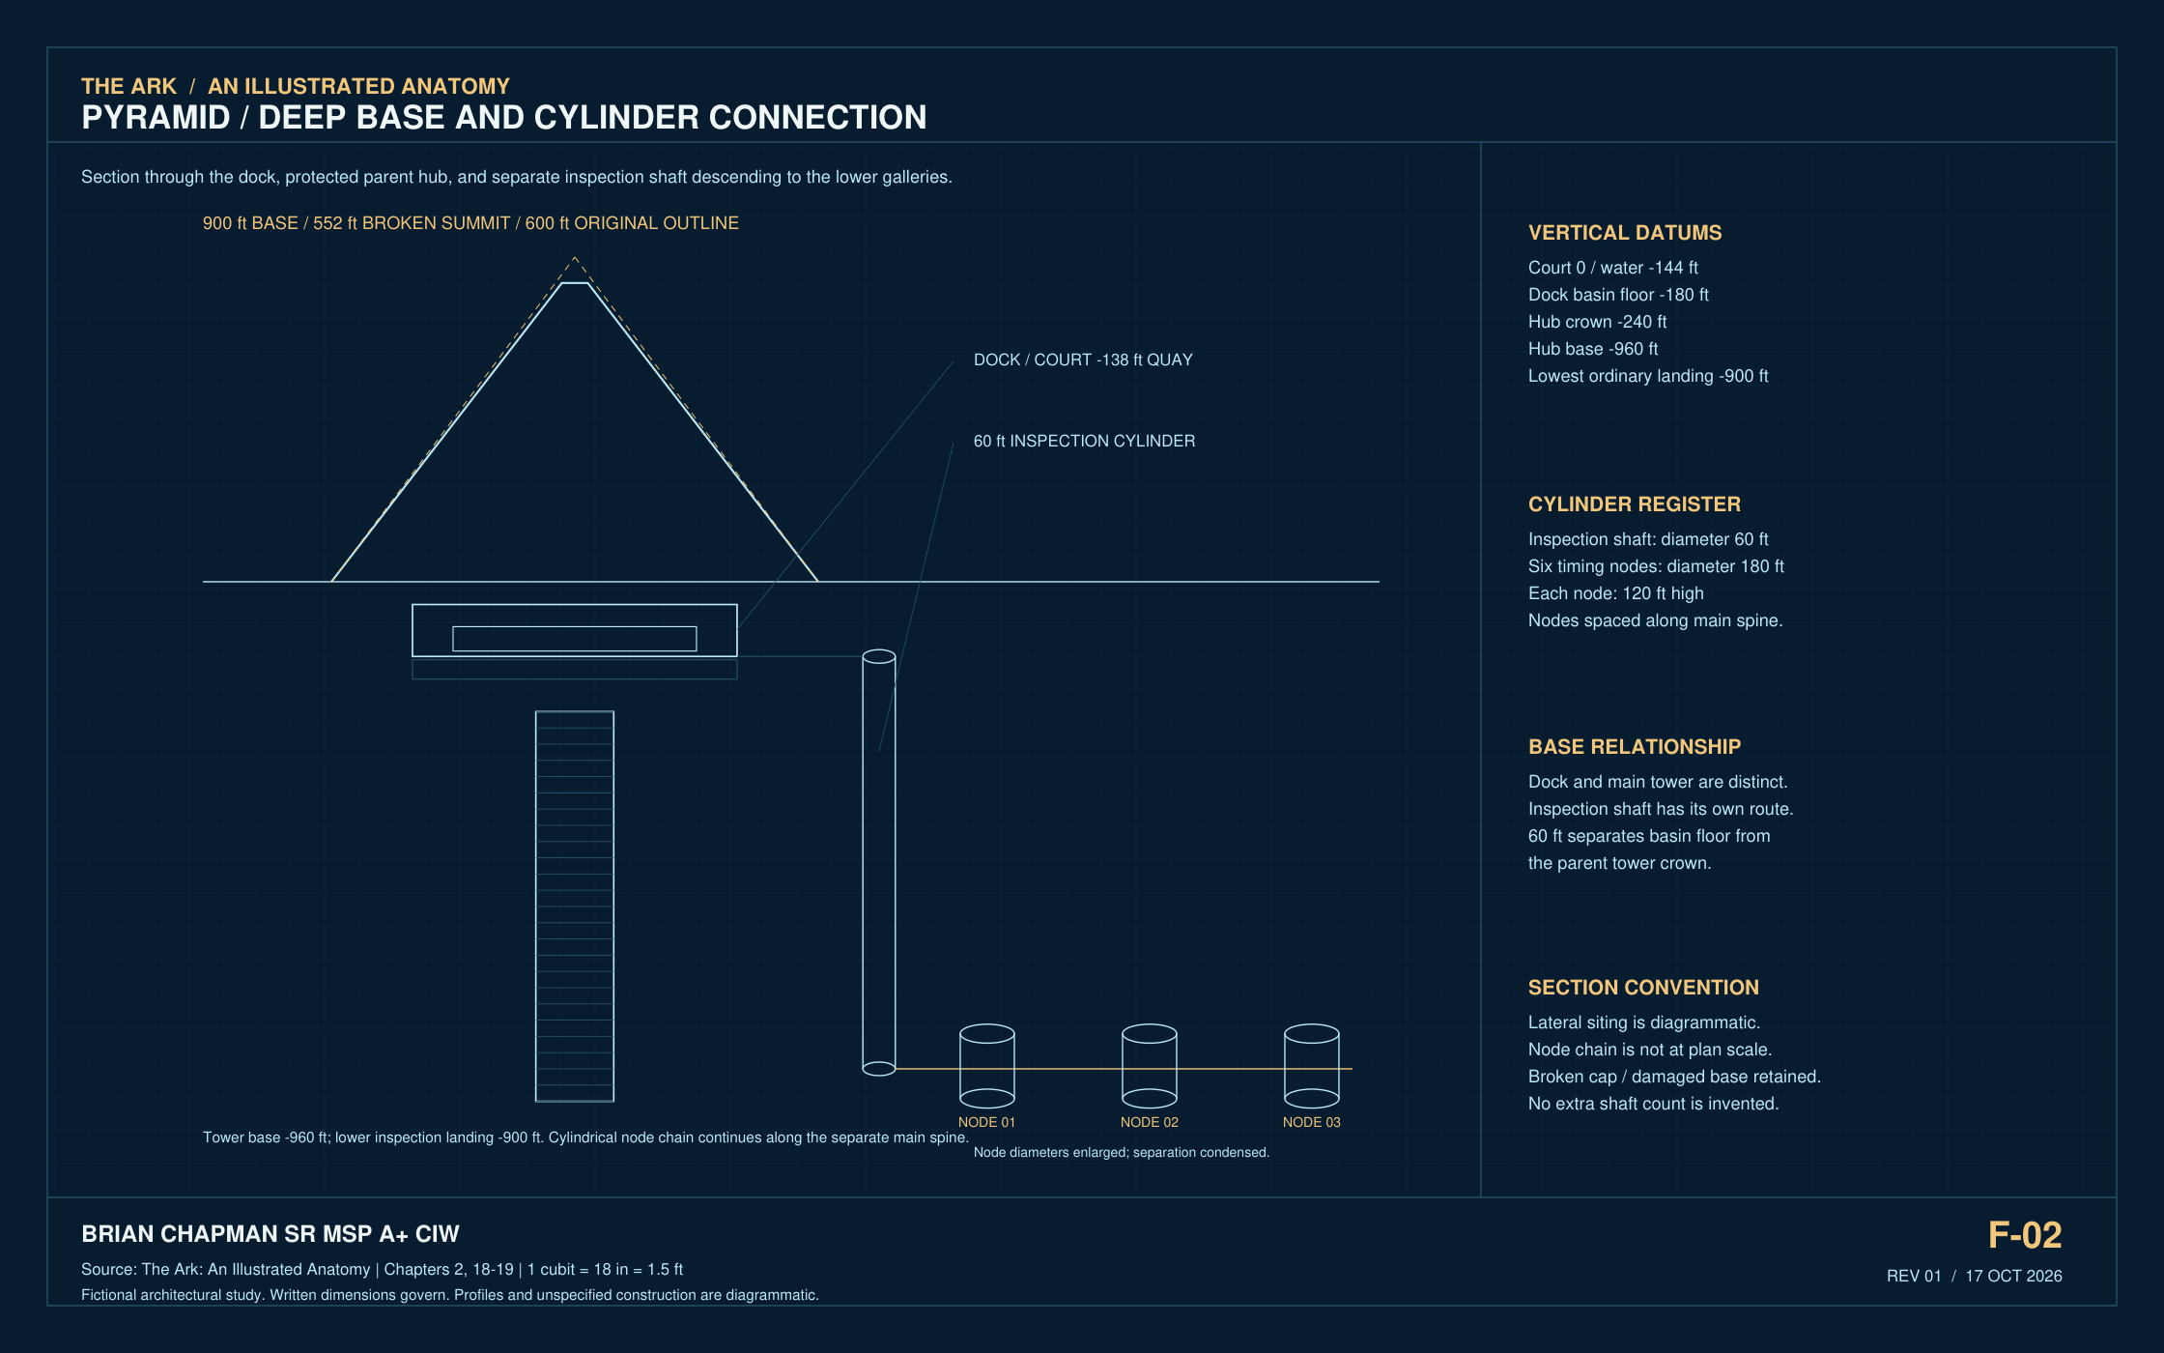
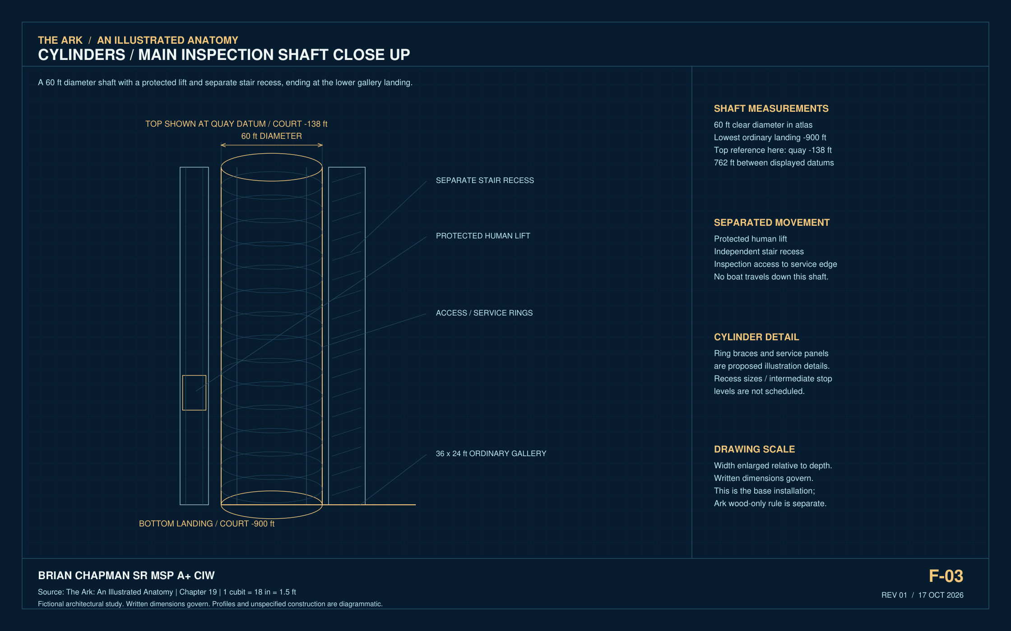
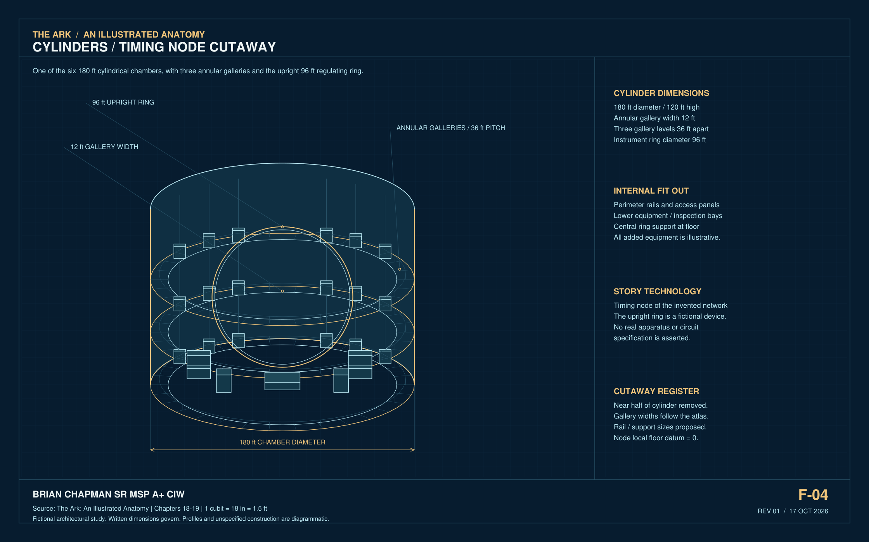
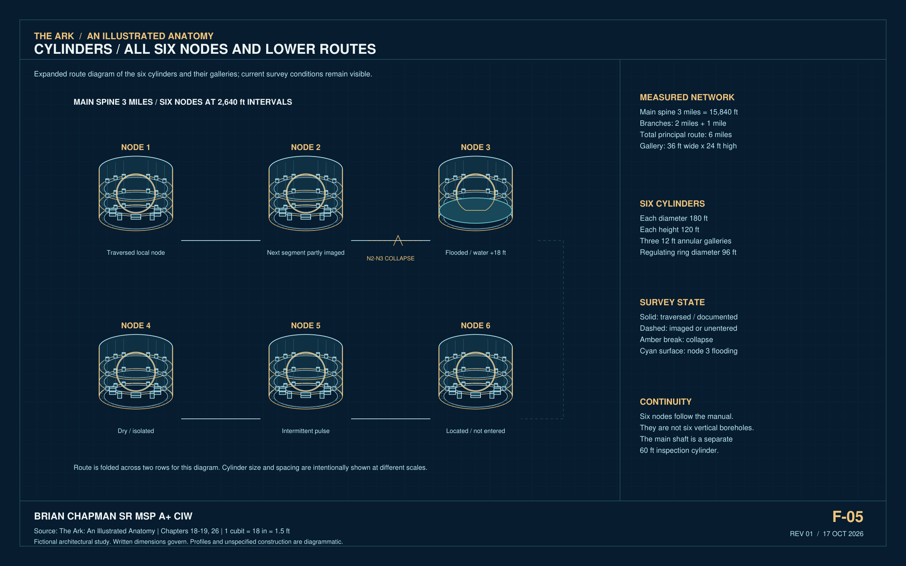
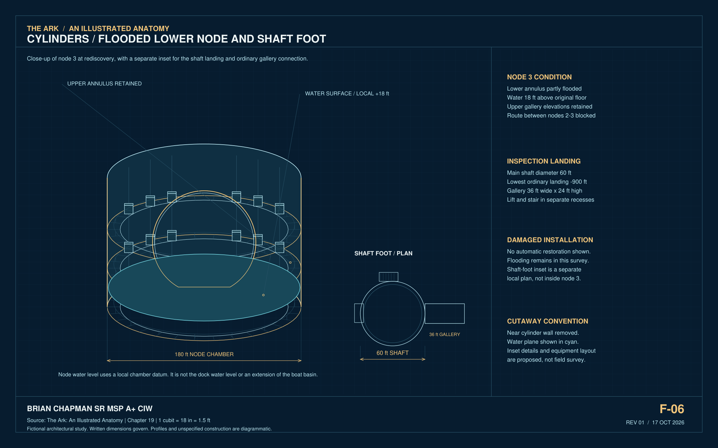
CAD study 55 Ark Commons door and bridge threshold
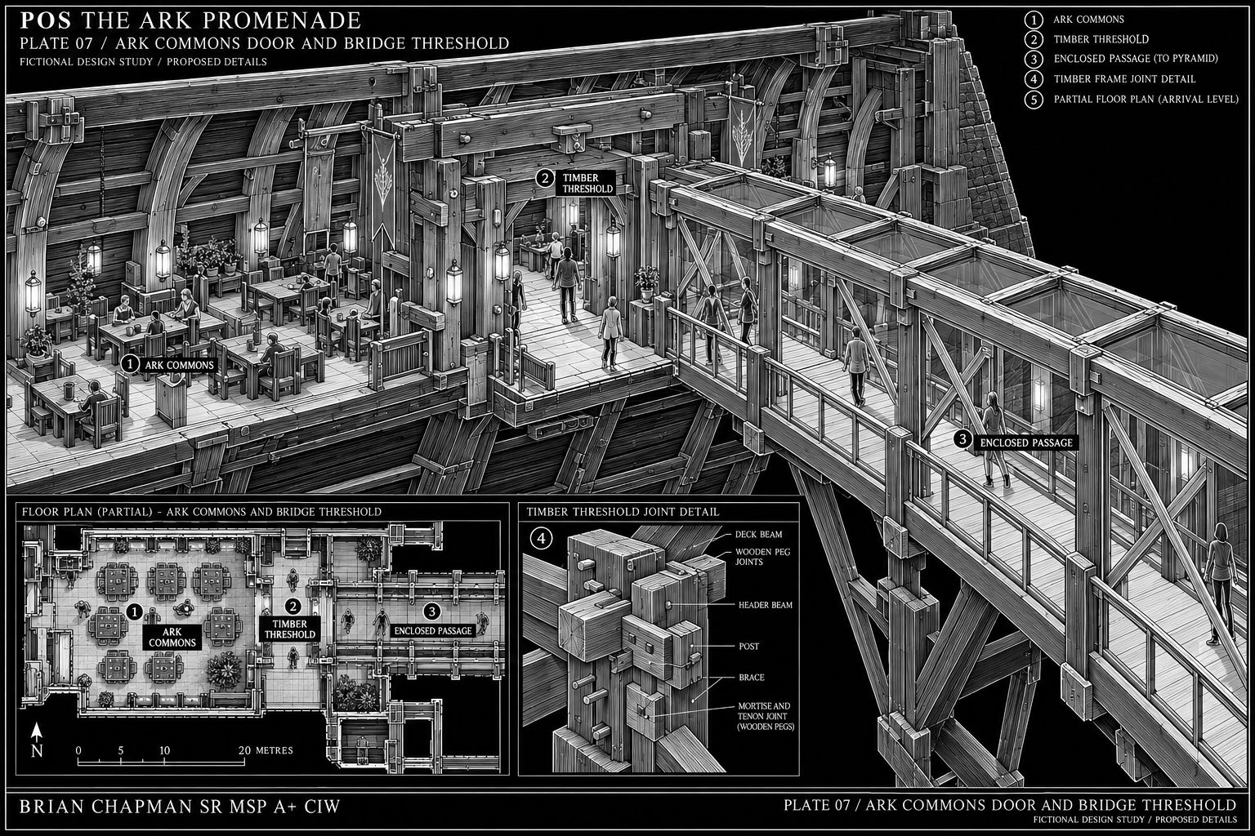
BRIAN CHAPMAN SR MSP A+ CIW
Concept study. Written dimensions, floor names and nonmetallic Ark construction rules in the atlas govern.
CAD study 56 Pyramid entrance and arrival court
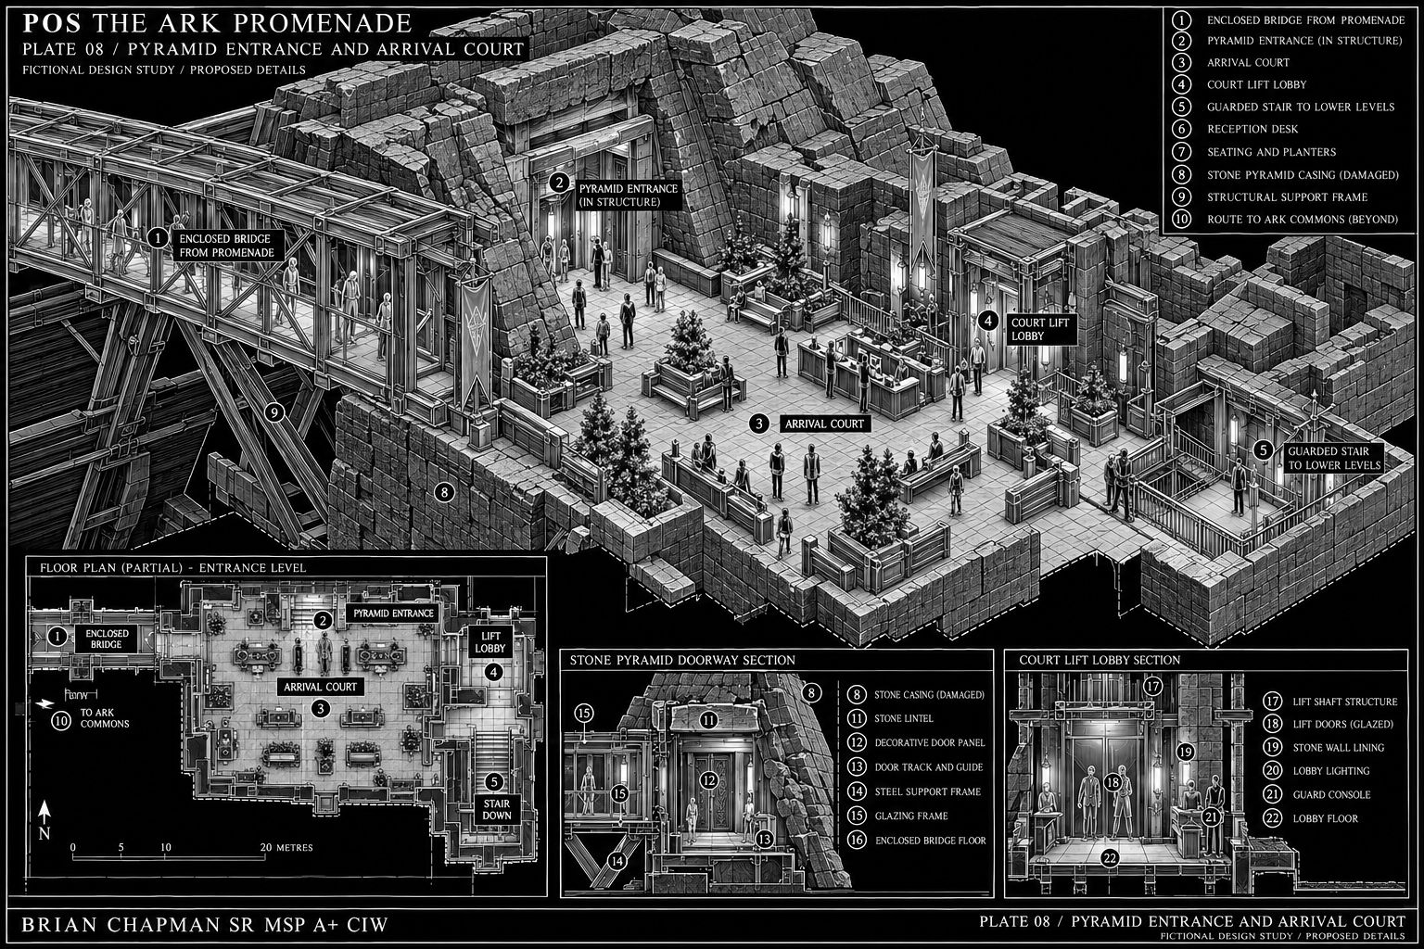
BRIAN CHAPMAN SR MSP A+ CIW
Concept study. Written dimensions, floor names and nonmetallic Ark construction rules in the atlas govern.
CAD study 57 Guarded court lift and buried shaft
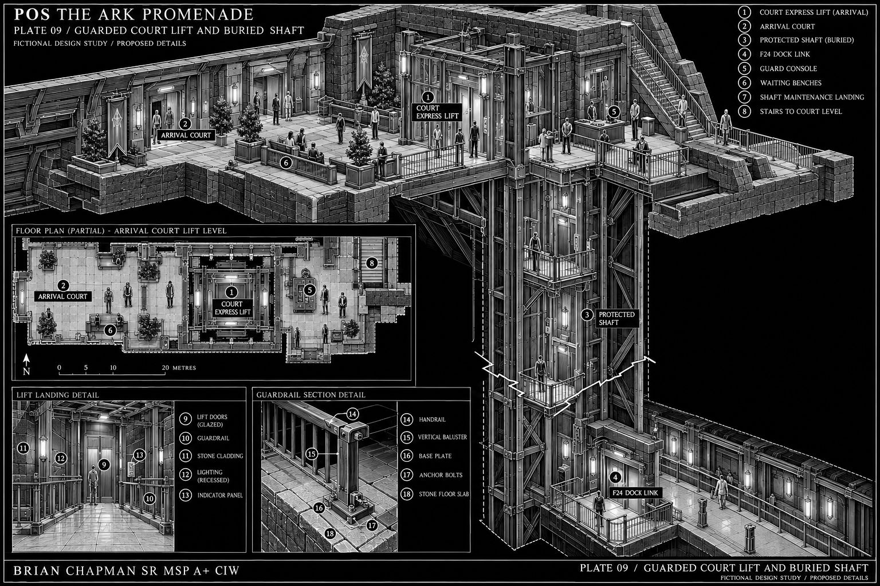
BRIAN CHAPMAN SR MSP A+ CIW
Concept study. Written dimensions, floor names and nonmetallic Ark construction rules in the atlas govern.
CAD study 58 Switchback stair court
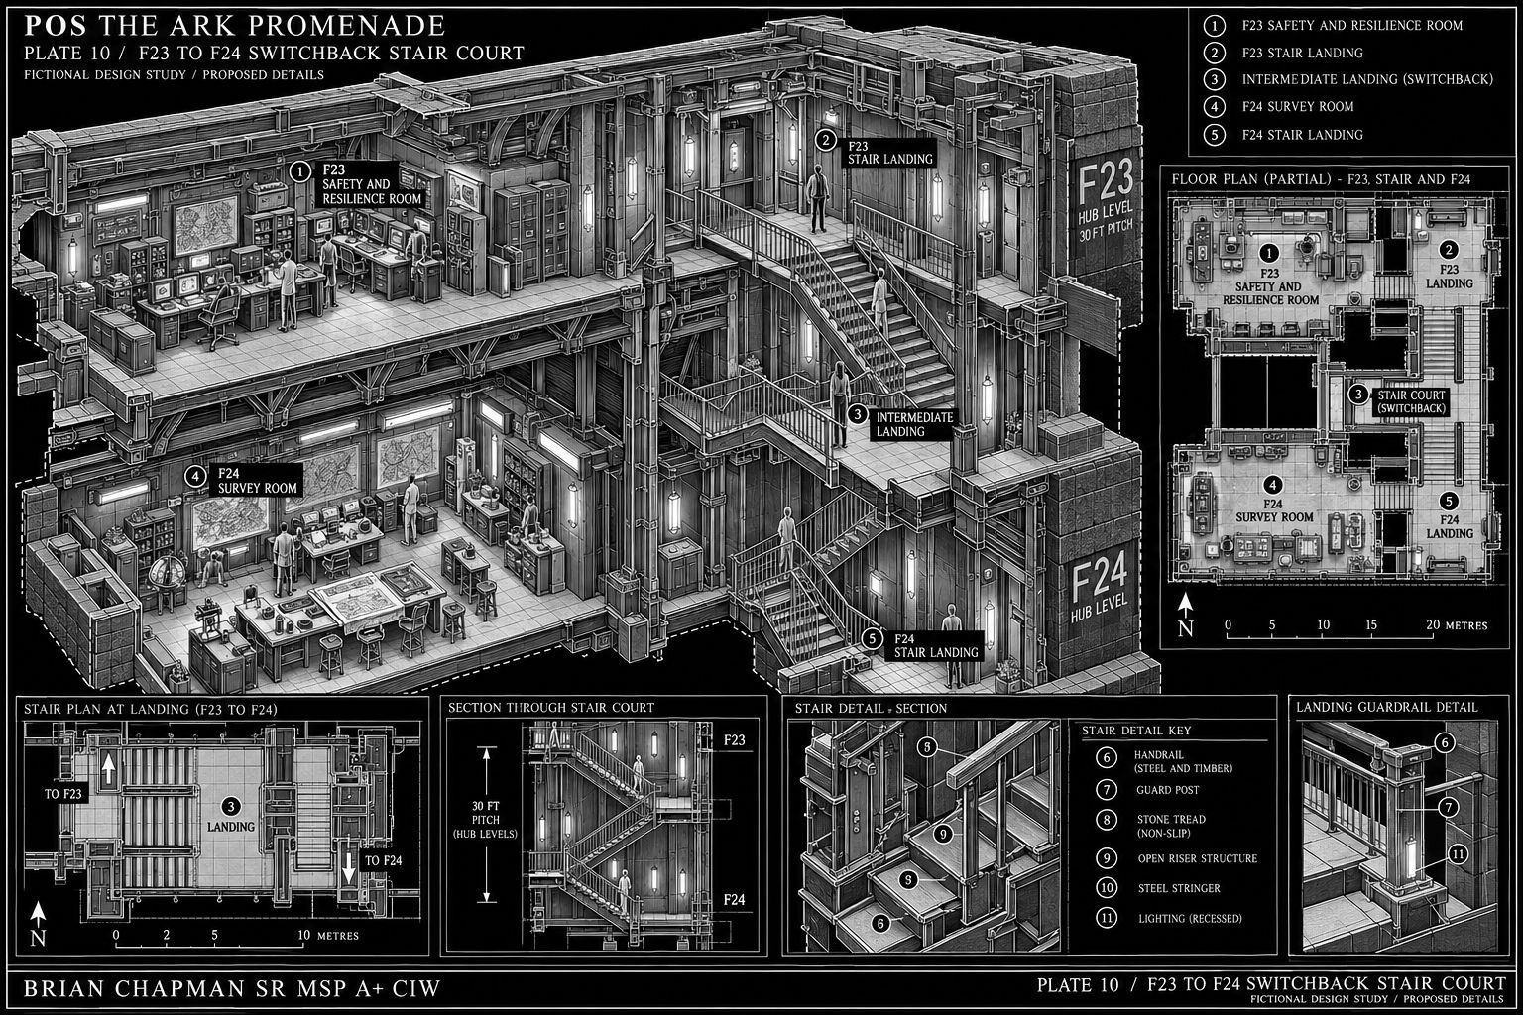
BRIAN CHAPMAN SR MSP A+ CIW
Concept study. Written dimensions, floor names and nonmetallic Ark construction rules in the atlas govern.
CAD study 59 Dock link and survey
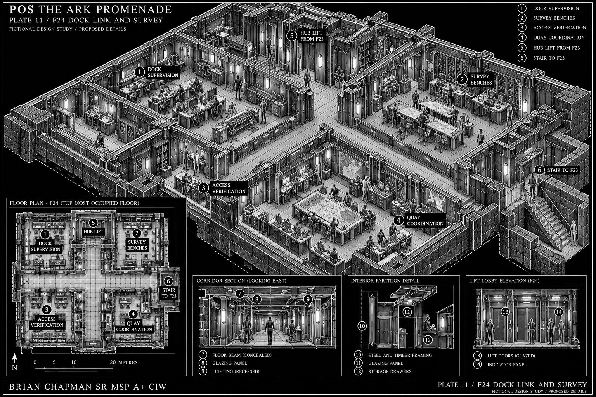
BRIAN CHAPMAN SR MSP A+ CIW
Concept study. Written dimensions, floor names and nonmetallic Ark construction rules in the atlas govern.
CAD study 60 Ark remote interface and return passage
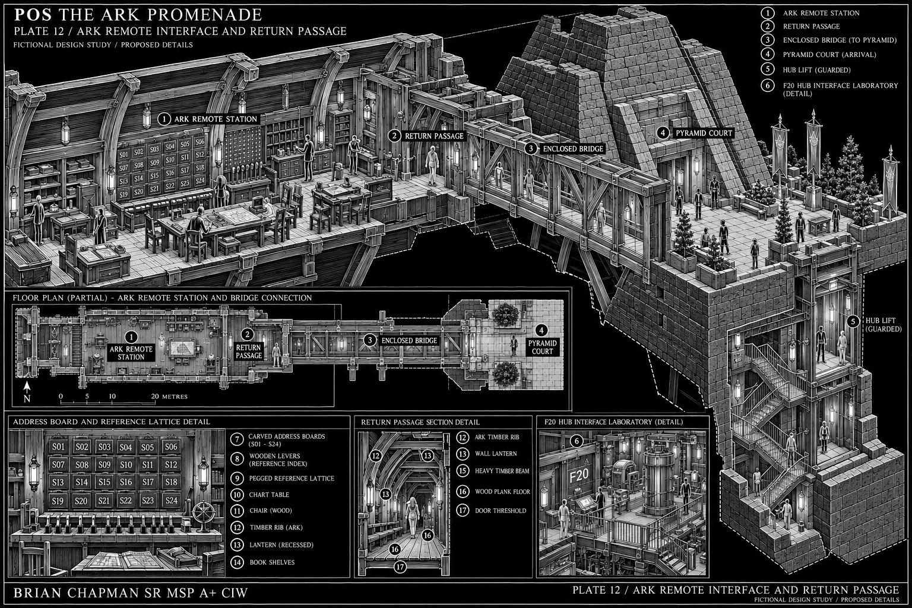
BRIAN CHAPMAN SR MSP A+ CIW
Concept study. Written dimensions, floor names and nonmetallic Ark construction rules in the atlas govern.
CAD study 61 Twisted arrival court spatial variation
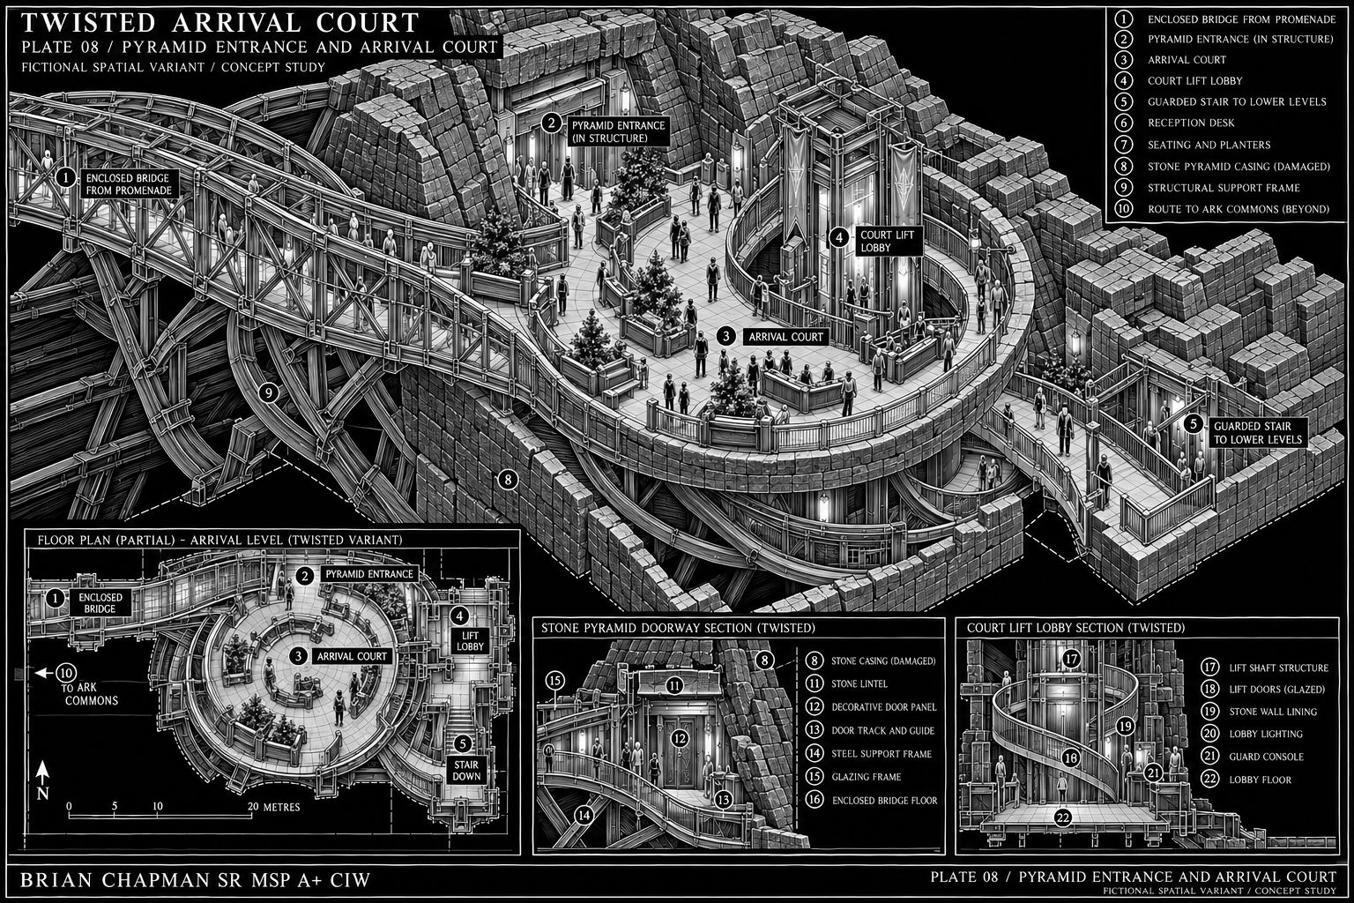
BRIAN CHAPMAN SR MSP A+ CIW
Fictional spatial variation. Original measured architecture remains unchanged.

